
Infoview Ad-Hoc Reports Reference – Revised Reports
  - Updated Oct. 27, 2026
Reference information for Infoview reports updated since transition to WINNIE.

Table of Contents
Infoview Ad-Hoc Reports Reference – Revised Reports 1
Table of Contents 1
Agency Management 7
Certs and MCAs with Age and Optional Local Use Answer 7
Completed Certs & MCAs with Three Optional Local Use Answers 8
Pending Proof and Issued More than One Benefit Set 11
Pending Proof of Income, Identity, and/or Residency with Optional Local Use Answer 13
Resource Management 14
Agency Management >> Audits/Chart Reviews 18
Certifications Completed by One Staff Member 18
Grantee, Agency, County, City, and Zip Codes 19
Incomplete MCAs 19
MCAs Completed or Not and Benefits Issued 20
ME Chart Audits 22
New Households/Participants and Whether Substance Abuse NE Topics and/or Material Was Provided 23
No Signatures at Certification 25
Not Assigned 400 (Dietary) Risk Factors at Cert 27
Participants for Chart Audits 28
Presumptive Eligibility and Documentation 28
Women with Unlinked or One Way Linked Infants 30
Agency Management >> Due/Overdue 32
Due for Cert, MCA, or Nutrition Visit with Two Optional Local Use Answers 32
Due, or One Month Overdue, for Cert, MCA or Nutrition Visit with Optional Local Use Answer 36
Appointments 39
Daily Appointments by Participants and Households with Optional Local Use Answers 39
Kept Appointments List with Optional Local Use Answers 41
No Shows by Day and Time 42
Staff Who Scheduled Appointments 44
Unfilled Appointment Intervals 45
Benefits 48
Missed Nutrition Visits by Last Clinic Issued 48
Benefits >> Agency Management 50
Returned Formula 50
WIC Contacts and Benefits Not Issued 50
Counts 52
Count of Contacts by WIC Type, Race, and Clinic for Grantee & Agency and Statewide by Agency 52
Count of Three Optional Local Use Answers and Referrals Given at Any Time 54
VOC Documents Produced 56
Counts >> Monthly Participation 58
Average Monthly Participation by Congressional District 58
Monthly Participation by Age and Race Ethnicity 59
Monthly Participation by City of Residence and Race Ethnicity 61
Monthly Participation by City of Residence, WIC Category and BF Amount 63
Monthly Participation by County of Residence and Race Ethnicity 64
Monthly Participation by County of Residence, WIC Category and BF Amount 66
Monthly Participation by Infant BF Amount and Age in Months 68
Monthly Participation by Specified Zip Code(s) 70
Monthly Participation by WIC Category, BF Amount, and Age 72
Monthly Participation by WIC Category, BF Amount, and Race Ethnicity 74
Monthly Participation by Zip Code of Residence and Race Ethnicity 77
Monthly Participation by Zip Code of Residence, WIC Category and BF Amount 78
Year-to-Date Participation 80
Year-to-Date Participation – Statewide by Agency 81
Demographics 83
Medical Clinics & Providers Lists 83
Food & Formula 84
Food and Formula by PFDTU 84
Medical Formulas & Staff Who Created Rx 87
Medical Formula by RX End Date 88
Height/Weight/Blood 90
Hemoglobin Measurements 90
Low Hemoglobin 91
High Risk 94
High Risk at Certs & MCAs by Staff 94
High Risk Certs and MCAs with and without Follow-up Documented within 30-120 Days 95
High Risk Contacts without Specified Note(s) 97
High Risk Participants Due for Additional Education Contact with Optional Local Use Answer 98
Income 101
Income and Adjunctive Eligibility 101
Pending Proof Not Toggled On 103
Presumptive Eligibility 104
Proof of Income 105
Initial Contacts 107
Incomplete Initial Contacts 107
Initial Contact Requirements Not Met 108
Initial Contacts 109
Local Use Questions 111
Due for Additional Education Contact with Local Use Answer 111
Household List with Local Use Answers Selected during Same Time Period as Cert or MCA 112
Notes 114
No Note Written for Participants Issued Benefits 114
Notes and Documentation 115
Notes by Subject with Optional Local Use Answer 116
Nutrition Education 121
Additional Nutrition Education Contacts 121
Nutrition Education Topics List 122
One Call 124
One Call: Children Who Haven’t Returned to WIC 124
One Call: Future Appointments 125
One Call: Missed Appointments 126
One Call: Roster 127
Outreach & Retention 129
Count of Infants Recertified at One Year 129
Participants 131
Certified Participants 131
Currently Certified 133
Participants >> Breastfeeding 136
Currently Certified BF Women 136
Participants >> Infants and Children 137
Currently Certified Infants and Children by Age 137
Participants >> Pregnant 141
Pregnant by Expected Delivery Date 141
Referrals 143
Certs and MCAs and Specified Referral(s) Never Given 143
Certs and MCAs with Specified Referral(s) Given 144
Certs and MCAs without Any Referrals Given 145
Certs and MCAs without Specified Referral(s) Given 147
Certs With and Without Specified Referral(s) Given 148
Child Recerts by Age at Recert and Specified Referral Given at Least Once 151
Referrals by Topic – Agency and State 152
Specified Referral(s) Given at Least Once with Current Age 153
Specified Referral(s) Given during Specified Dates with Age at Referral 154
Specified Referral(s) Given during Specified Dates with Current Age 157
Risk Factors 160
Risk Factor Assigned at Certification 160
Staff Management 164
Active WIC Staff 164
Certs & MCAs Completed by the Specified Staff Person 165
Interpreter Needed Certs & MCAs Completed by Specified Staff Person 165
Daily Staff Productivity 166
Staff & Clinic Productivity 168
State Use Questions >> Cultural Identity 172
Participation Month with Race/Ethnicity or Cultural Identity and Optional Local Use Answer 172
Cultural Identity – Height/Weight and Completed Cert or MCA 173
Cultural Identity – New Participants 176
State Use Questions >> Breastfeeding Exclusivity 178
No Answer to Breastfeeding & Formula Supplementation State Use Question 178
Terminated/Ineligible 180
Terminated for Failure to Pick Up 180
Vendor 183
Stores & Pharmacies by County 183
WIC App 185
WIC App & Household Registrations 185
WIC App & Counts of Household Registrations by Language 186

Agency Management

Certs and MCAs with Age and Optional Local Use Answer
Created Oct. 26, 2026 (using previous agency-specific template – OLMSTED: CTC & Participants Under 21 y.o.)

Overview
A list and cross-tab counts of participants with certifications and mid-certification assessments (MCAs) completed at the specified agency during the specified date range. The list is grouped by the optional local use answers if answer ID(s) are entered into the prompt; the list is not grouped if no answer ID(s) are entered. The list also includes a distinct count of households and participants. The cross-tab counts provide agency totals and totals by Local Use answers, Contact Type (certs or MCAs), and WIC Type. Optional input controls allow you to filter each tab individually: references by whether the questions and answers are active; participant list by age in years, contact type, and local use answers; and counts by age in years and contact type.
The IDs for the Answer ID(s) prompt are listed in the Reference tab and should be entered as shown. This is a required prompt. If you are using the report and NOT using local use questions, enter 9999999 (7 nines) into the prompt.

Some uses
Outreach based on local user answers or age.

Prompts
- Agency ID - agency where certification or MCA completed.
- Start Date - first date in time period when certification or MCA completed.
- End Date - last date in time period when certification or MCA completed.
- Answer IDs associated with specific local use question.

Report outputs
Tab 1 – Reference
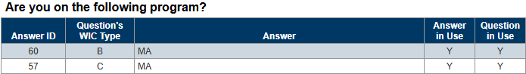
Columns: Answer ID, Question’s WIC Type, Answer, Answer in Use, Question in Use.
Grouped by: Local Use questions.
Tab 2 – List
Page 1
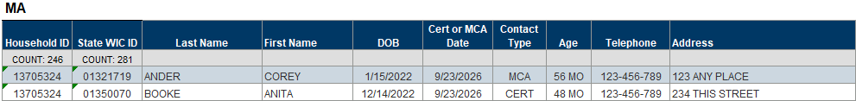
Page 2
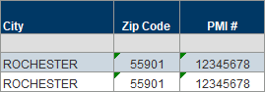
Columns: Page 1 – Household ID, State WIC ID, Last Name, First Name, DOB, Cert or MCA Date, Contact Type, Age, Telephone Address. Page 2 – City, Zip Code, PMI #.
Grouped by: Local Use answers.
Tab 3 – Counts
Table 1
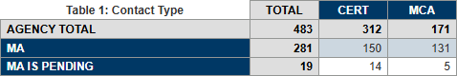
Columns: TOTAL, contact type (CERT or MCA)
Rows: AGENCY TOTAL, Local Use answers.
Table 2
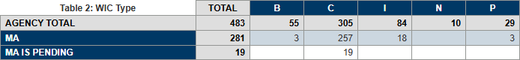
Columns: TOTAL, WIC type.
Rows: AGENCY TOTAL, Local Use answers.

Completed Certs & MCAs with Three Optional Local Use Answers
Revised Dec. 3, 2025

Overview
A list and count of participants who have been certified or had a Mid-certification Assessment (MCA) completed during the specified dates and at the specified agency and clinic(s). The output includes contact information (auth rep and telephone), who completed the cert/MCA (certifier), PMI # and Insurance Type (collected in Demographics), and the answers to three different Local Use questions (optional). All participants display regardless of whether Local Use answers have been selected. Table breaks and counts occur so that participants who have the same answers are grouped together. Tab 3 provides a combined count of certs/MCAs completed for participants and households and a count based on each of the answers selected.
Do you want answers to a local use question to display?
YES - If you want answers to a local use question to display, you will need to enter the Answer IDs. To do this, enter the Agency ID into the prompt, leaving the rest of the prompts as-is, and run the report. Refer to the Reference-Answer IDs tab for the Answer IDs. All Answer IDs must be 4 digits and entered as they are listed in this tab (with preceding 0s).
NO - If you do not want answers to a local use question to display, the “Enter 4-digit Answer ID(s)” prompt is still required. Enter 9999999 (7 nines) into the prompt. This will meet the prompt requirement and ensure no answers are pulled into your output.

Some uses
- Identify participants with a cert or MCA completed that have certain answers selected for two different Local Use Questions.
- Obtain a count of participants with specific answers selected.
- Obtain a total count of participants certified or with a completed MCA during specified dates.

Prompts
- Agency ID - agency where certification or MCA completed.
- Clinic ID – clinic where certification or MCA completed.
- Start Date - first date in time period when certification or MCA completed.
- End Date - last date in time period when certification or MCA completed.
- Answer IDs for first local use question.
- Answer IDs for second local use question.
- Answer IDs for third local use question.

Report outputs
Tab 1 – Reference-Answer IDs
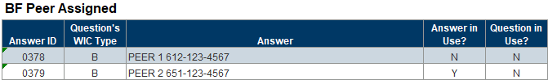
Columns: Answer ID, Question’s WIC Type, Answer, Answer in Use?, Question in Use?
Grouped by: Local Use Question
Tab 2 – Participant List
Page 1
Page 2
Page 3
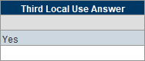
Columns: Household ID, State WIC ID, Visit Date, Participant Name, DOB, PMI #, Authorized Rep’s Name, Telephone 1, Comment 1, Telephone 2, Comment 2, Clinic ID, Certifier, Insurance Type, Language 1, First Local Use Answer, Second Local Use Answer, Third Local Use Answers
Counts: Households and participants.
Tab 3 - Counts
Table 1
Table 2
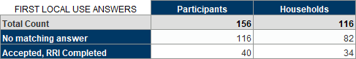
Table 3
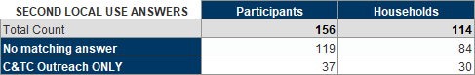
Table 4
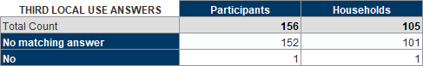
Columns: Participants, Households.
Rows: Total Distinct Counts, Total Count (for local use answers 1, 2, and 3), first local use answer, second local use answer, third local use answer.

Pending Proof and Issued More than One Benefit Set
Revised July 23, 2026

Overview
A list of participants certified at the specified agencies whose most recent certification was completed during the specified date range and who had a set of benefits issued with a First Date to Use (FDTU) in the month following the certification and one of the following proofs selected for identification, residency, income, and/or adjunctive income:
- Identification: Other-Write Note or ** PENDING PROOF **
- Residency: Other-Write Note or ** PENDING PROOF **
- Income: Other-Write Note or **PENDING PROOF**
- Adjunctive: Pending Proof – 30 Day
The default is to run the report for all agencies. An optional input control allows you to filter all outputs by agency and proofs.
Some uses
- Identify participants issued more than one month of benefits when pending proof for identification, residency, or income.
- Identify staff who incorrectly issued benefits when participants were pending proof.
- Identify staff who did not toggle on Pending Proof for income and adjunctive records, which is how the system limits issuance to one month.

Prompts
- Agency ID(s) or 0 for ALL – agency where participants currently belong.
- Start Date – first date in date range during which participants were most recently certified.
- End Date – date in date range during which participants were most recently certified.

Report outputs
Tab 1 – Identification
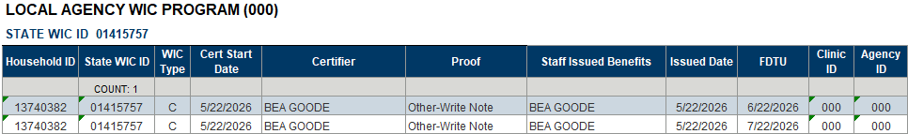
Columns: Household ID, State WIC ID, WIC Type, Cert Start Date, Certifier, Proof, Staff Issued Benefits, Issued Date, FDTU, Clinic ID, Agency ID.
Grouped by: Agency name, State WIC ID.
Tab 2 – Residence
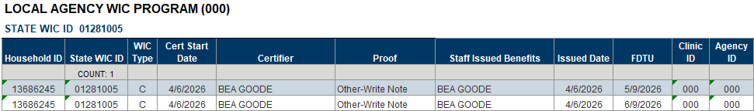
Columns: Household ID, State WIC ID, WIC Type, Cert Start Date, Certifier, Proof, Staff Issued Benefits, Issued Date, FDTU, Clinic ID, Agency ID.
Grouped by: Agency name, State WIC ID.
Tab 3 – Income
Page 1
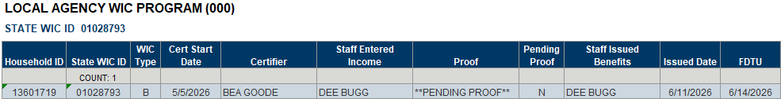
Page 2
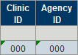
Columns: Household ID, State WIC ID, WIC Type, Cert Start Date, Certifier, Proof, Staff Issued Benefits, Issued Date, FDTU, Clinic ID, Agency ID.
Grouped by: Agency name, State WIC ID.
Tab 4 – Adjunctive
Page 1
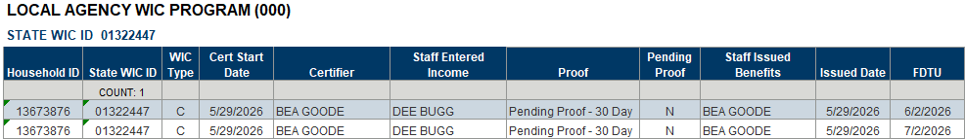
Page 2
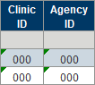
Columns: Household ID, State WIC ID, WIC Type, Cert Start Date, Certifier, Proof, Staff Issued Benefits, Issued Date, FDTU, Clinic ID, Agency ID.
Grouped by: Agency name, State WIC ID.

Pending Proof of Income, Identity, and/or Residency with Optional Local Use Answer
Revised July 22, 2025

Overview
A list and count of currently certified participants who belong to the specified agency with a Last Date to Use (LDTU) during the specified dates who are pending proof of income, identity or residency. The report user can filter the output by clinic ID using the optional Input Control.
The report output also displays selected answers to a local use question (agencies do not have to use local use questions to use this report).
Do you want answers to a local use question to display?
YES - If you want answers to a local use question to display, you will need to enter the Answer IDs. To do this, enter the Agency ID into the prompt, leaving the rest of the prompts as-is, and run the report. Refer to the Reference-Answer IDs tab for the Answer IDs. All Answer IDs must be 4 digits and entered as they are listed in this tab (with preceding 0s).
NO - If you do not want answers to a local use question to display, the “Enter 4-digit Answer ID(s)” prompt is still required. Enter 9999999 (7 nines) into the prompt. This will meet the prompt requirement and ensure no answers are pulled into your output.
Some uses
- Identify participants with a cert or MCA completed that have certain answers selected for two different local use questions.
- Obtain a count of participants with specific answers selected.
- Obtain a total count of participants certified or with a completed MCA during specified dates.

Prompts
- Agency ID – agency where participants currently belong.
- Start Date – first date in time period during which the LDTU falls.
- End Date – last date in time period during which the LDTU falls.
- Answer IDs – the codes associated with specific answers to a local use question. 9999999 is the code if not using local use questions.

Report outputs
Tab 1 – Reference-Answer IDs
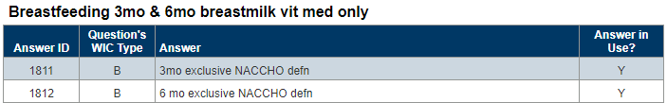
Columns: Answer ID, Question’s WIC Type, Answer, Answer in Use?
Grouped by: Local use question.
Tab 2 – Participant List
Columns: Household ID, State WIC ID, Proof Required, Cert Start Date, Last LDTU, Authorized Rep’s Name, Telephone #, Comment, Local Use Answer.
Counts: Households and participants.
Tab 3 - Counts
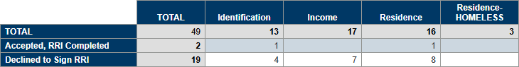
Columns: TOTAL, Identification, Income, Residence, Residence – HOMELESS.
Rows: TOTAL, local use answers.

Resource Management
Revised June 2, 2026

Overview
This report provides information based on the number of participants who currently belong to the specified agency and are due for a recertification, mid-certification assessment (MCA), Nutrition Visit (NV) and/or becoming categorically ineligible during the specified future date range. A past date range can be entered to count the number of participants initially certified at the specified agency. The output includes summary counts by WIC type; resources needed per day based on 7 hour days and 30, 20, 15, 10, and 5 minutes appointments; number of appointments needed per day; and the percentage by clinic of due, categorically ineligible, and new participants. An optional input control allows the report user to filter all tabs by clinic ID.
Some uses
Forecast resource requirements based on the number of participants due for appointments and nutrition visits and the number of new certifications recently performed.

Prompts
- Agency ID – where the participant currently belongs (due and categorically ineligible); where certified (new certs)
- Start Date – the first date in time period during which the cert end date (recerts), due date (MCA), last set’s LDTU (NV), and categorical ineligibility date fall.
- End Date – the last date in time period during which the cert end date (recerts), due date (MCA), last set’s LDTU (NV), and categorical ineligibility date fall.
- New Certs – Enter Start Date (in past) – the first date in the time period during which participants were initially certified.
- New Certs – Enter End Date (in past) – the last date in the time period during which participants were initially certified.
- Appt Days – Enter Start Date – the first date in the time period during which resources are scheduled (used to calculate the number of appointment days for calculations).
- Appt Days – Enter End Date – the last date in the time period during which resources are scheduled (used to calculate the number of appointment days for calculations).

Report outputs
Tab 1 – Counts
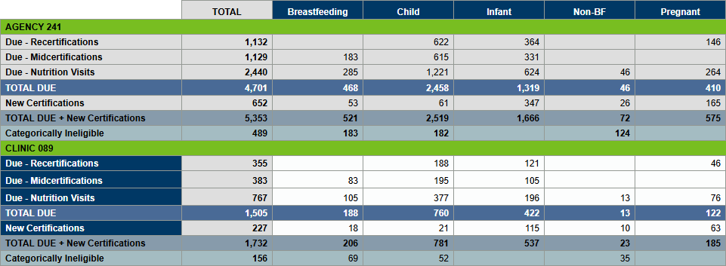
Columns: TOTAL, WIC Type
Rows: Agency ID, Due – Recertifications, Due – Midcertifications, Due – Nutrition Visits, TOTAL DUE, New Certifications, TOTAL DUE + New Certifications, Categorically Ineligible, and clinic ID.
Grouped by: Agency ID and Clinic ID within the table.
Tab 2 – Resources
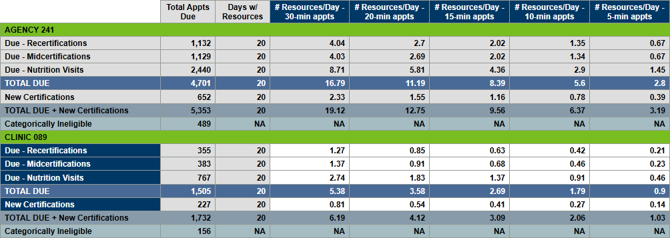
Columns: Total Appts Due, Days w/Resources, # Resources/Day – 30-min appts, # Resources/Day – 20-min appts, # Resources/Day – 15-min appts, # Resources/Day – 10-min appts, # Resources/Day – 5-min appts,
Rows: Agency ID, Due – Recertifications, Due – Midcertifications, Due – Nutrition Visits, TOTAL DUE, New Certifications, TOTAL DUE + New Certifications, Categorically Ineligible, and clinic ID.
Grouped by: Agency ID and Clinic ID within the table.
Tab 3 – Appts
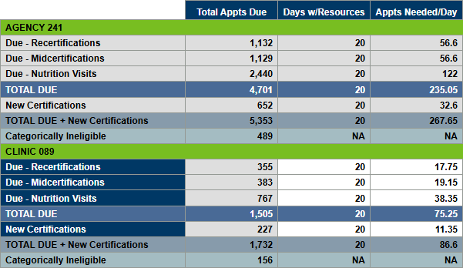
Columns: Total Appts Due, Days w/Resources, Appts Needed/Day.
Rows: Agency ID, Due – Recertifications, Due – Midcertifications, Due – Nutrition Visits, TOTAL DUE, New Certifications, TOTAL DUE + New Certifications, Categorically Ineligible, and clinic ID.
Grouped by: Agency ID and Clinic ID within the table.
Tab 4 - Percentages
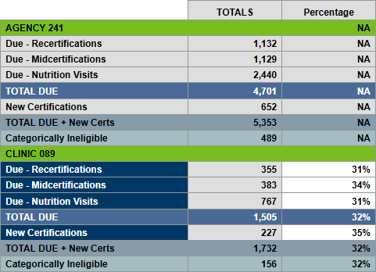
Columns: TOTALS, Percentage.
Rows: Agency ID, Due – Recertifications, Due – Midcertifications, Due – Nutrition Visits, TOTAL DUE, New Certifications, TOTAL DUE + New Certifications, Categorically Ineligible, and clinic ID.
Grouped by: Agency ID and Clinic ID within the table.

Agency Management >> Audits/Chart Reviews

Certifications Completed by One Staff Member
Revised Jan. 13, 2025

Overview
NOTE: Removed specification of “WINNIE Only” since roll-out was completed in April 2024 (HuBERT template was archived).
A list and count of participants certified at the specified agency and clinic(s) during the specified time period for which one staff person was recorded for each required step of the certification. Participants are excluded from the report output if a “Separation of Duties (SOD) – Income” note has been written within 21 days prior to, on, or within 14 days after the certification by a different staff person than the certifier.

Some uses
Assist agencies with meeting the SOD auditing requirements for participants certified by one staff person.

Prompts
- Agency ID – agency where participants were certified.
- Clinic ID(s) – agency where participants were certified.
- Start Date – first date in time period during which participants were certified.
- End Date – last date in time period during which participants were certified.

Report outputs
Tab 1 – SOD-No Reviewed Note
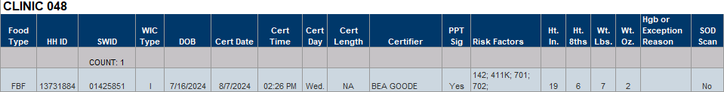
Columns: Food Type, Household ID (HHID), State WIC ID (SWID), WIC Type (at cert), DOB, Cert Date, Cert Time, Cert Day, Cert Length, Certifier, PPT Sig (participant signature), Risk Factors, Ht. In. (height in inches), Ht. 8ths (height 8ths of inch), Wt. Lbs. (weight in pounds), Wt. Oz. (weight ounces of pound), Hgb (hemoglobin) or Exception Reason, SOD Scan.
Grouped by: Clinic ID.
Tab 2 – SOD-Reviewed Note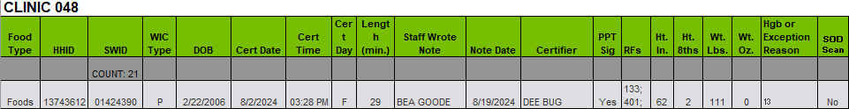
Columns: Food Type, Household ID (HHID), State WIC ID (SWID), WIC Type (at cert), DOB, Cert Date, Cert Time, Cert Day, Cert Length (min.), Staff Wrote Note, Note Date, Certifier, PPT Sig (participant signature), RFs (risk factors), Ht. In. (height in inches), Ht. 8ths (height 8ths of inch), Wt. Lbs. (weight in pounds), Wt. Oz. (weight ounces of pound), Hgb (hemoglobin) or Exception Reason, SOD Scan.
Grouped by: Clinic ID.

Grantee, Agency, County, City, and Zip Codes
Created May 20, 2026

Overview
A list of Grantee ID, Grantee, Agency ID, Agency, County Codes, Counties, City Codes, Cities, and Zip Codes. Breaks occur in the list on change of Grantee ID.

Some uses
Identifying cities and zip codes associated with grantees and agencies.

Prompts
None

Report outputs
Tab 1 – LIST
Columns: Grantee ID, Grantee, Agency ID, Agency, County Code, County, City Code, City, Zip Code.

Incomplete MCAs
Revised Oct. 15, 2024

Overview
Provides a list and count of participants who currently belong to the specified agency and have a Mid-Certification Assessment (MCA) that was started on or after the specified date and never completed.

Some uses
Identify participants for whom the MCA was not completed correctly in order to fix the record prior to the next certification.

Prompts
- Agency ID(s) – agency where participants currently belong.
- Start Date – date on or after which the incomplete MCAs were started.

Report output
Tab 1 – Incomplete MCAs
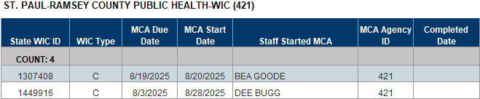
Columns: State WIC ID, WIC Type, MCA Due Date, MCA Start Date, Staff Started MCA, MCA Agency ID, Completed Date.
Counts: Participants.
Grouped by: Agency ID.

MCAs Completed or Not and Benefits Issued
Revised Nov. 14, 2024

Overview
A listing and count of participants who belong to the specified agency and are due for a Mid-Certification Assessment (MCAs) during the specified time period, and whether the MCA was completed, and benefits were issued. MCA appointments are identified by “mid” being part of the appointment name. Report users will need to input their agency’s Appointment Type IDs associated with MCAs, which are provided in the Reference Tab. This output includes an OPTIONAL input control that allows the report user to filter Tab 2 – MCAs (listing of participant) by clinic. (NOTE: the input controls selections are removed whenever the report is refreshed, and the output will again include all clinics.)

Some uses
- Identify participants with MCAs, whether an appointment was scheduled/kept, who completed the MCA, the number of sets issued after the MCA Due (regardless of whether completed) and staff who issued the benefits.
- Identify the number of MCAs due during a specified time period.
- Determine the number and percentage of completed MCAs.
- Determine the number and percentage of MCA appointments, scheduled and kept, for the agency and its clinics.
- Identify staff who may be issuing benefits, and the number of sets, to participants after their MCA Due date who have not had their MCA completed.

Prompts
- Agency ID – agency where participants currently belong.
- MCA Appointment Type ID – the ID associated with the MCA appointments.
- Start Date – the first date in the time period during which the MCA Due dates fall.
- End Date – the last date in the time period during which the MCA Due dates fall.

Report outputs
Tab 1 – Reference
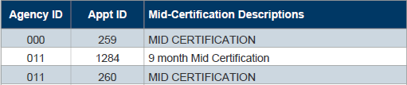
Columns: Agency ID, Appt ID, Mid-certification Descriptions.
Tab 2 – MCAs
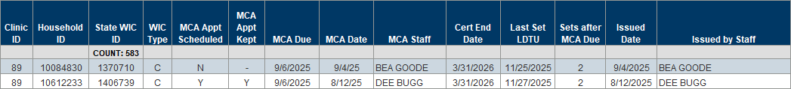
Columns: Clinic ID, Household ID, State WIC ID, WIC Type, MCA Appt Scheduled, MCA Appt Kept, MCA Due, MCA Date, MCA Staff, Cert End Date, Last Set LDTU, Sets after MCA Date, Issued Date, Issued by Staff.
Counts: Participants.
Tab 3 – Staff Counts
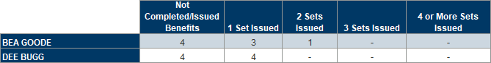
Columns: Not Completed/Issued Benefits, 1 Set Issued, 2 Sets Issued, 3 Sets Issued, 4 or More Sets Issued.
Row: Staff names.
Tab 4 – Counts
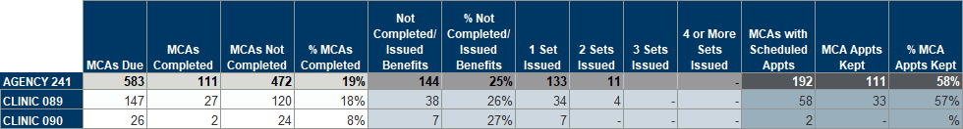
Columns: MCAs Due, MCAs Completed, MCAs Not Completed, % MCAs Complete, Not Completed/Issued Benefits, % Not Completed/Issued Benefits, 1 Set Issued, 2 Sets Issued, 3 Sets Issued, 4 or More Sets Issued, MCAs with Scheduled Appts, MCA Appts Kept, % MCA Appts Kept.
Rows: AGENCY ID, CLINIC ID(s).

ME Chart Audits
Revised Sept. 24, 2026

Overview
A list of participants with benefits issued at the specified agency during the specified issuance dates and for the specified participation month. The list includes a distinct count of participants and households. Three optional input controls allow you to filter the output by Income Type, Physical Presence, and CPA Signature.

Some uses
Assist with identifying records for management evaluations.

Prompts
- Agency ID – agency where benefits were issued.
- Participation Month – month benefits were counted for.
- Start Date – the first date in the date range during which benefits were issued.
- End Date – the last date in the date range during which benefits were issued.

Report outputs
Tab 1 – List
Page 1
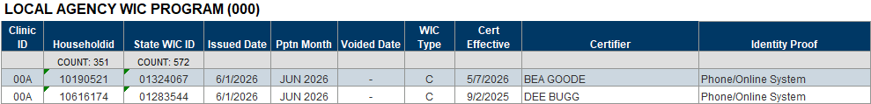
Columns: Clinic ID, Household ID, State WIC ID, Issue Date, Pptn Month, Voided Date, WIC Type, Cert Effective, Certifier, Identity Proof.
Counts: Households and participants.
Page 2
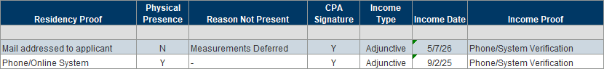
Columns: Residency Proof, Physical Presence, Reason Not Present, CPA Signature, Income Type, Income Date, Income Proof.
Tab 3 – Staff Counts
Columns: Not Completed/Issued Benefits, 1 Set Issued, 2 Sets Issued, 3 Sets Issued, 4 or More Sets Issued.
Row: Staff names.
Tab 4 – Counts
Columns: MCAs Due, MCAs Completed, MCAs Not Completed, % MCAs Complete, Not Completed/Issued Benefits, % Not Completed/Issued Benefits, 1 Set Issued, 2 Sets Issued, 3 Sets Issued, 4 or More Sets Issued, MCAs with Scheduled Appts, MCA Appts Kept, % MCA Appts Kept.
Rows: AGENCY ID, CLINIC ID(s).

New Households/Participants and Whether Substance Abuse NE Topics and/or Material Was Provided
Revised March 10, 2025

Overview
This report provides a list of new households and participants certified at the specified agency during the specified dates. It is based on whether the “Dangers of Substance Abuse” Nutrition Education (NE) topic and/or the “Alcohol, Tobacco, and Other Drugs” material was documented in the Nutrition Education tab by the certifier as having been provided as part of the certification.

Some uses
- Identify new households who received the required substance abuse information at their initial certification.
- Identify staff who may not be providing, or documenting, the substance abuse information to new households for further training.

Prompts
- Agency ID – agency where the participants were certified.
- Start Date – the first date in the time period during which participants were certified.
- End Date – the last date in the time period during which participants were certified.

Report outputs
Tab 1 – New HHs
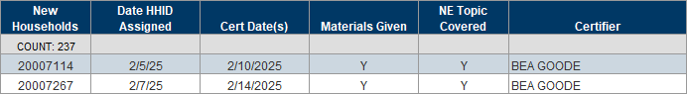
Columns: New Households, Date HHID (household ID) Assigned, Cert Date(s), Materials Given, NE (nutrition education) Topic Covered, Certifier.
Counts: New households.
Tab 2 – New HHs Without
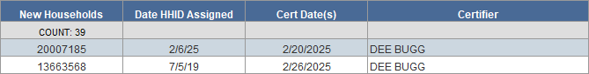
Columns: New Households, Date HHID (household ID) Assigned, Cert Date(s), Certifier.
Count: New households.
Tab 3 – HH Counts
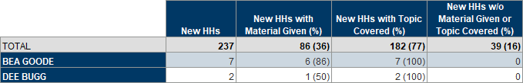
Columns: New HH (households), New HHs with Material Given (%), New HHs with Topic Covered (%), New HHs w/o Material Given or Topic Covered (%).
Rows: TOTAL, staff name.
Tab 4 – New Ppts
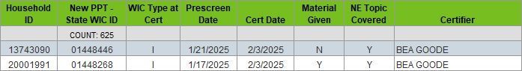
Columns: Household ID, New PPT (participant) – State WIC ID, WIC Type at Cert, Prescreen Date, Cert Date, Material Given, NE (nutrition education) Topic Covered, Certifier.
Counts: New participants.

No Signatures at Certification
Revised March 11, 2025

Overview
Provides a list and count by certifier of participant records missing the CPA’s signature, missing the participant’s signature, or missing both signatures for certifications completed at the specified agency. It also includes a statewide count of certs missing the CPA signature.

Some uses
- Identify certifications missing signatures for audits or chart reviews.
- Compare the number of missing signatures between agencies, which may help identify agencies using an alternative method for collecting signatures outside of the Information System.

Prompts
- Agency ID – agency where the participants were certified.
- Start Date – the first date in the time period during which participants were certified.
- End Date – the last date in the time period during which participants were certified.

Report outputs
Tab 1 – Count-Missing Signatures
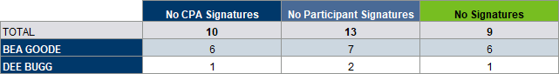
Columns: No CPA Signatures, No Participant Signatures, No Signatures.
Rows: TOTAL, staff names.
Tab 2 – No CPA Signature
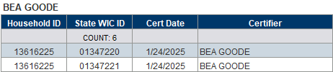
Columns: Household ID, State WIC ID, Cert Date, Certifier.
Count: Participants.
Grouped by: Staff name.
Tab 3 – No Ppt Signature
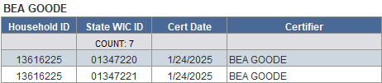
Columns: Household ID, State WIC ID, Cert Date, Certifier.
Count: Participants.
Grouped by: Staff name.
Tab 4 – No Signatures
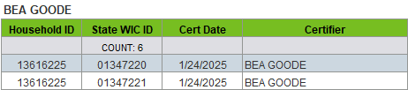
Columns: Household ID, State WIC ID, Cert Date, Certifier.
Count: Participants.
Grouped by: Staff name.
Tab 5 – State – Count No CPA Signature
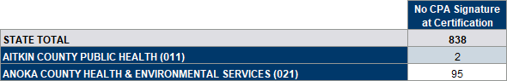
Columns: No CPA Signature at Certification.
Rows: STATE TOTAL, AGENCY NAME (ID)

Not Assigned 400 (Dietary) Risk Factors at Cert
Revised March 13, 2026

Overview
A list and count of participants certified at the specified agency during the specified time period who were not assigned a 400-risk factor. The output provides both a list of the risk factors that were assigned at the cert and the certifier’s name, along with a count and percentage of certifications missing 400-risk factors. (The output excludes infants younger than 4 months old at the time of the cert since they do not required a 400-risk factor to be assigned at certification.)

Some uses
- Assess whether staff are assigning a 400-risk factor as required by policy.
- Identify staff who may need further training or guidance about risk factor requirements.

Prompts
- Agency ID – agency where the participants were certified.
- Start Date – the first date in the time period during which participants were certified.
- End Date – the last date in the time period during which participants were certified.

Report outputs
Tab 1 – List
Columns: Household ID, State WIC ID, WIC Type, Cert Start Date, Certifier, Assigned Risk Factors, Clinic ID, Agency ID.
Tab 2 – Counts
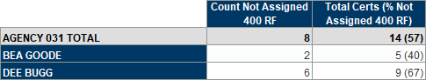
Columns: Count Not Assigned 400 RF, Total Certs (% Not Assigned 400 RF).
Count: AGENCY <ID> TOTAL, Certifier.

Participants for Chart Audits
Revised March 18, 2025

Overview
Provides an unduplicated list of participants certified during the specified dates and by specified agency, clinics, and WIC Categories.

Some uses
Auditing purposes.

Prompts
- Agency ID – agency where participants were certified.
- Clinic ID(s) – clinic where participants were certified.
- Start Date – the first date during the time period during which participants were certified.
- End Date – the last date during the time period during which participants were certified.
- WIC Type(s) – the WIC type at the time the participants were certified.

Report output
Tab 1 – Participant List
Columns: WIC Type, Household ID, State WIC ID, First Name, Last Name, Date of Birth, High Risk, Certifier.
Grouped by: Clinic name and WIC type.

Presumptive Eligibility and Documentation
Revised May 20, 2026

Overview
A list and count of participants who were certified at the specified agencies during the specified time period and for whom Presumptive Eligibility – 90 Days was selected as Proof of MHCP-MA or MHCP-MN Care.
- Tab 1 – PE List displays the date Presumptive Eligibility (PE) was selected for the MHCP income record and if another MA/MN Care income record was entered within 120 days of the Cert Start Date. It also includes the Staff ID of the user that created the PE income record and if benefits were issued after 6 months.
- Tab 2 – Notes, displays the PE/SOD-Income notes written within 7 days of the Cert Date and whether a follow-up note was written between 1 and 120 days after the cert.
- Tab 3 – Missing Notes, indicates if no PE/SOD-Income note was written and/or if no follow-up note was written and whether benefits were issued after 6 months.
- Tab 4 – PE State provides a statewide count by agency of participants with PE selected who were certified during the specified time period.

Some uses
- Audit PE records to ensure documentation is occurring correctly.
- Identify if benefits are being issued without documentation that supports further issuance.
- Identify potential needs for further training on PE and its documentation.
- Identify agencies within the state that had PE selected for participant income records.

Prompts
- Agency ID(s) – agency where participants were certified.
- Start Date – the first date in the time period during which participants were certified and a PE income record was created.
- End Date – the last date in the time period during which participants were certified and a PE income record was created.

Report output
Tab 1 – PE List
Columns: Agency ID, Household ID, State WIC ID, Created PE Record, Cert Start Date, PE + Next Record(s), MA or MN Care, Income Proof, Benefits > 6 months.
Grouped by: Agency name and ID.
Tab 2 – Notes
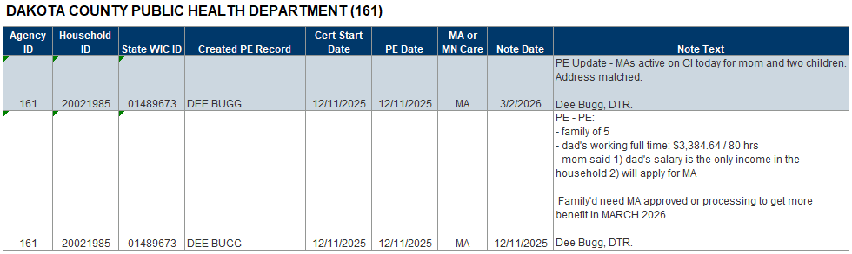
Columns: Agency ID, Household ID, State WIC ID, Created PE Record, Cert Start Date, PE Date, MA or MN Care, Note Date, Note Text.
Grouped by: Agency name and ID.
Tab 3 – Missing Notes
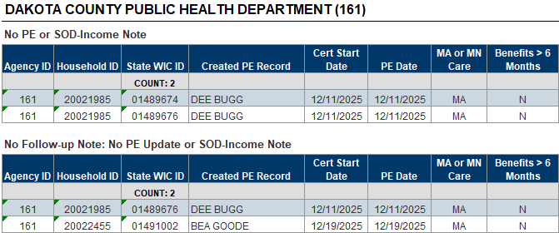
Table 1 and 2 - Columns: Agency ID, Household ID, State WIC ID, Created PE Record, Cert Start Date, PE Date, MA or MN Care, Benefits > 6 months.
Grouped by: Agency name and ID.
Tab 4 – PE State
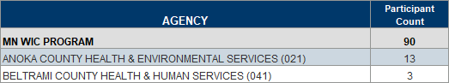
Rows: MN WIC PROGRAM, agency name and ID.
Columns: AGENCY, Participant Count.

Women with Unlinked or One Way Linked Infants
Revised Feb. 20, 2025

Overview
A list of currently certified women who belong to the specified agency and do not have a two-way link to their infant’s record. Also provides the name of the staff person who completed the certification.

Some uses
Food packages and breastfeeding amounts will not update correctly if only a one-way link exists between the mom’s and infant’s records. If no link exists, the participant that doesn’t receive benefits in the breastfeeding dyad will not be counted in the participation count.

Prompts
- Agency ID – agency where the participants currently belong.
- Start Date – the first date in the time period during which both the woman’s certification occurred, and the infant was born.
- End Date – the last date in the time period during which both the woman’s certification occurred, and the infant was born.

Report output
Tab 1 – Women
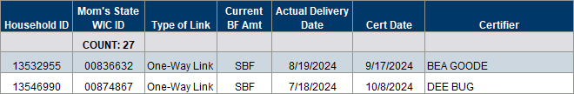
Columns: Household ID, Mom’s State WIC ID, Type of Link, Current BF Amt, Actual Delivery Date, Cert Date, Certifier.
Counts: Participants.

Agency Management >> Due/Overdue

Due for Cert, MCA, or Nutrition Visit with Two Optional Local Use Answers
Revised Dec. 15, 2025

Overview
A list of participants due for certification, MCA or nutrition visit (NV - benefit pick-up) during a specified time period who currently belong to the specified agency and clinics. The report output displays whether a participant has a future appointment scheduled, contact information, and the answers to different local use questions (optional). Total counts by agency are found at the top of each type of contact “Due” tab and a total by agency, clinics, and contacts are included in tab 9 – Totals. Agencies do not need to use local use questions to use this report. All participants display regardless of whether local use answers have been selected.
Do you want answers to a local use question to display?
YES - If you want answers to a local use question to display, you will need to enter the Answer IDs. To do this, enter the Agency ID into the prompt, leaving the rest of the prompts as-is, and run the report. Refer to the Reference-Answer IDs tab for the Answer IDs. All Answer IDs must be 4 digits and entered as they are listed in this tab (with preceding 0s).
NO - If you do not want answers to a local use question to display, the “Enter Answer ID(s)” prompt is still required. Enter 9999999 (7 nines) into the prompt. This will meet the prompt requirement and ensure no answers are pulled into your output.

Some uses
- Identify participants due for certs or MCAs who don’t have an appointment scheduled.
- Create mailing labels for reminders about scheduled appointments or to schedule an appointment.
- Provide contact information for reminder calls/texts and outreach.
- Provide language/interpreter needs for scheduled appointments.
- Obtain total due for certs, MCAs, and NVs for caseload management and scheduling resources for the agency and by clinic.

Prompts
- Agency ID – agency where the participants currently belong.
- Clinic ID(s) – clinic where the participants currently belong.
- Start Date – the first date in the time period during which the cert end date, MCA due date, or Last Date to Use falls.
- End Date – the last date in the time period during which the cert end date, MCA due date, or Last Date to Use falls.
- Question 1 – Answer ID(s): IDs associated with specific answers to a local use question. 9999999 is the code if not using local use questions.
- Question 2 – Answer ID(s): IDs associated with specific answers to a second local use question. 9999999 is the code if not using local use questions.

Report outputs
Tab 1 – Reference-Answer IDs
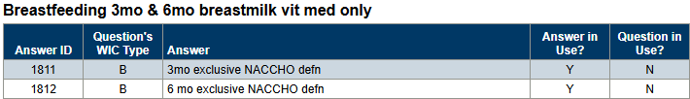
Columns: Answer ID, Question’s WIC Type, Answer, Answer in Use?, Question in Use?
Grouped by: Local use question.
Tab 2 – Certs Due
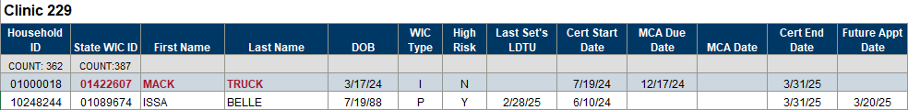
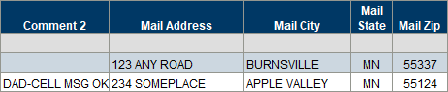
Columns: Household ID, State WIC ID, First Name, Last Name, DOB, WIC Type, High Risk, Last Set’s LDTU, Cert Start Date, MCA Due Date, MCA Date, Cert End Date, Future Appt Date, Short Appt Description, Language, Interpreter Needed, Local Use Answer 1, Local Use Answer 2 Authorized Rep’s Name, Telephone #, Comment 1, Telephone 2, Comment 2, Mail Address, Mail City, Mail State, Mail Zip.
Grouped by: Clinic ID.
Counts: Households and participants.
Tab 3 – Cert Labels
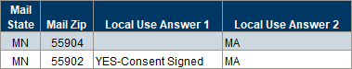
Columns: Clinic ID, Household ID, State WIC ID, Future Appt Date, Appointment Description, Participant’s Name, Authorized Rep’s Name, Mail Address, Mail City, Mail State, Mail Zip, Local Use Answer 1, Local Use Answer 2.
Tab 4 – MCAs Due
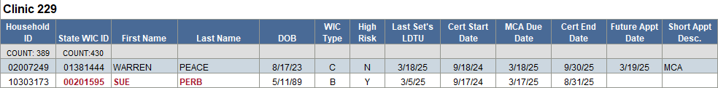
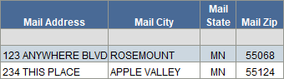
Columns: Household ID, State WIC ID, First Name, Last Name, DOB, WIC Type, High Risk, Last Set’s LDTU, Cert Start Date, MCA Due Date, MCA Date, Cert End Date, Future Appt Date, Short Appt Description, Language, Interpreter Needed, Local Use Answer 1, Local Use Answer 2, Authorized Rep’s Name, Telephone #, Comment 1, Telephone 2, Comment 2, Mail Address, Mail City, Mail State, Mail Zip
Grouped by: Clinic ID.
Counts: Households and participants.
Tab 5 – MCA Labels
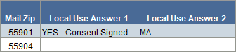
Columns: Clinic ID, Household ID, State WIC ID, Future Appt Date, Appointment Description, Participant’s Name, Authorized Rep’s Name, Mail Address, Mail City, Mail State, Mail Zip, Local Use Answer 1, Local Use Answer 2.
Tab 6 – NVs Due
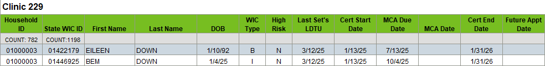
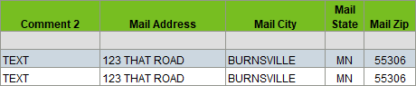
Columns: Household ID, State WIC ID, First Name, Last Name, DOB, WIC Type, High Risk, Last Set’s LDTU, Cert Start Date, MCA Due Date, MCA Date, Cert End Date, Future Appt Date, Short Appt Description, Language, Interpreter Needed, Local Use Answer 1, Local Use Answer 2, Authorized Rep’s Name, Telephone #, Comment 1, Telephone 2, Comment 2, Mail Address, Mail City, Mail State, Mail Zip
Grouped by: Clinic ID.
Counts: Households and participants.
Tab 7 – NV Labels
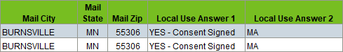
Columns: Clinic ID, Household ID, State WIC ID, Future Appt Date, Appointment Description, Participant’s Name, Authorized Rep’s Name, Mail Address, Mail City, Mail State, Mail Zip, Local Use Answer 1, Local Use Answer 2.
Tab 8 – Households Due
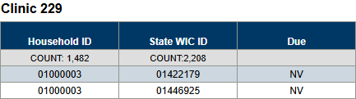
Columns: Household ID, State WIC ID, Due (contact type: cert, MCA, NV).
Grouped by: Clinic ID.
Tab 9 - Totals
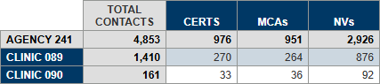
Columns: TOTAL CONTACTS, CERTS, MCAs, NVs.
Rows: AGENCY <ID>, CLINIC <ID>

Due, or One Month Overdue, for Cert, MCA or Nutrition Visit with Optional Local Use Answer
Revised Nov. 11, 2025

Overview
A list of participants who currently belong to the specified agency and clinic(s) and whose last set’s Last Date to Use (LDTU) falls within the specified dates, as well as being due for a certification or Mid-certification Assessment (MCA) either during the specified dates or during the month previous. Participants due for a Nutrition Visit (NV) have a last set’s LDTU within the specified dates and no other household members due or overdue for a cert or MCA. Participants are excluded from the outputs if they, or anyone in their household, have an appointment scheduled for today or any future date.
The report output also displays selected answers to a local use question (agencies do not have to use local use questions to use this report).
Do you want answers to a local use question to display?
- YES - If you want answers to a local use question to display, you will need to enter the Answer IDs. To do this, enter the Agency ID into the prompt, leaving the rest of the prompts as-is, and run the report. Refer to the Reference-Answer IDs tab for the Answer IDs. All Answer IDs must be 4 digits and entered as they are listed in this tab (with preceding 0s).
- NO - If you do not want answers to a local use question to display, the “Enter 4-digit Answer ID(s)” prompt is still required. Enter 9999999 (7 nines) into the prompt. This will meet the prompt requirement and ensure no answers are pulled into your output.

Some uses
Provide contact information for reminder calls/texts and outreach.

Prompts
- Agency ID – agency where the participants currently belong.
- Clinic ID(s) – clinic where the participants currently gelong.
- Start Date – the first date in the time period during which the cert, last set’s last date to use (LDTU), or MCA Due dates fall.
- End Date – the last date in the time period during which the cert, last set’s last date to use (LDTU), or MCA Due dates fall.
- Answer ID(s) – the codes associated with specific answers to a local use question. 9999999 is the code if not using local use questions.

Report outputs
Tab 1 – Reference-Answer IDs
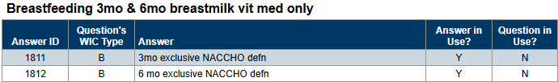
Columns: Answer ID, Question’s WIC Type, Answer, Answer in Use?, Question in Use?
Sorted by: Answer ID (asc).
Grouped by: Local use question.
Tab 2 – Certs & MCAs
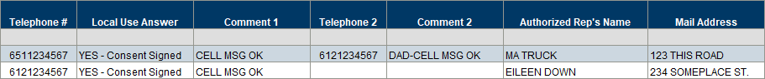
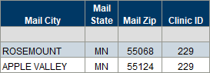
Columns: Household ID, State WIC ID, First Name, Last Name, DOB (date of birth), WIC Type, Last Set’s LDTU, Cert Start Date, MCA Due Date, MCA Date, Cert End Date, Language, Telephone #, Local Use Answer, Comment 1, Telephone 2, Comment 2, Authorized Rep’s Name, Mail Address, Mail City, Mail State, Mail Zip, Clinic ID.
Sorted by: Household ID (asc); State WIC ID (asc).
Counts: Households and participants.
Tab 3 – Nutrition Visits
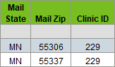
Columns: Household ID, State WIC ID, First Name, Last Name, DOB (date of birth), WIC Type, Last Set’s LDTU, Cert Start Date, MCA Due Date, MCA Date, Cert End Date, Language, Telephone #, Local Use Answer, Authorized Rep’s Name, Comment 1, Telephone 2, Comment 2, Mail Address, Mail City, Mail State, Mail Zip, Clinic ID.
Sorted by: Household ID (asc); State WIC ID (asc).
Counts: Households and participants.
Tab 4 – Simple HH-Certs & MCAs
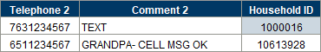
Columns: Telephone 2, Comment 2, and Household ID.
Sorted by: Household ID (asc).
Tab 5 – Simple HH-Nut. Visits
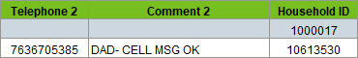
Columns: Telephone 2, Comment 2, and Household ID.
Sorted by: Household ID (asc).

Appointments

Daily Appointments by Participants and Households with Optional Local Use Answers
Revised Feb. 6, 2025

Overview
A list of participants and households with appointments scheduled at the specified agency and clinic(s) on the specified date. The participant and household lists are grouped by clinic. Counts are provided by Appointment Type and Resource for the agency and each clinic. The last tab can be used to create household labels by the authorized rep.
The report output also displays selected answers to a local use question (agencies do not have to use local use questions to use this report).
Do you want answers to a local use question to display?
YES - If you want answers to a local use question to display, you will need to enter the Answer IDs. To do this, enter the Agency ID into the prompt, leaving the rest of the prompts as-is, and run the report. Refer to the Reference-Answer IDs tab for the Answer IDs. All Answer IDs must be 4 digits and entered as they are listed in this tab (with preceding 0s).
NO - If you do not want answers to a local use question to display, the “Enter 4-digit Answer ID(s)” prompt is still required. Enter 9999999 (7 nines) into the prompt. This will meet the prompt requirement and ensure no answers are pulled into your output.

Some uses
- Provide a list of participants or households for outreach or appointment reminders.
- Obtain a count of the types of appointments scheduled for each resource and at each clinic.
- Create household-level labels for appointments scheduled on a specific date.

Prompts
- Agency ID – agency where the appointments are scheduled.
- Clinic ID(s) – clinic where the appointments are scheduled.
- Appointment Date – the date the appointments are scheduled for.
- Answer ID(s) – the codes associated with specific answers to a local use question. 9999999 is the code if not using local use questions.

Report outputs
Tab 1 – Reference-Answer IDs
Columns: Answer ID, Question’s WIC Type, Answer, Answer in Use?
Grouped by: Local use question.
Tab 2 – Participant Appts
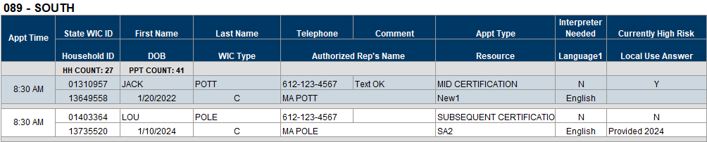
Columns: Row 1 - Appt Time, State WIC ID, First Name, Last Name, Telephone, Comment, Appt Type, Interpreter Needed, Currently High Risk. Row 2 - Household ID, DOB (date of birth), WIC Type, Authorize Rep’s Name, Resource, Language 1, Local Use Answer.
Grouped by: Clinic ID.
Counts: Households and participants.
Tab 3 – Household Appts
Columns: Appt Type, Appt Date, Appt Time, Household ID, Telephone #, Language, Local Use Answer, Clinic Name.
Grouped by: Clinic ID.
Tab 4 – Counts
Table 1
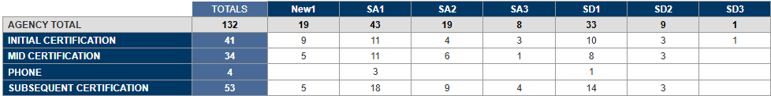
Table 2
Demographic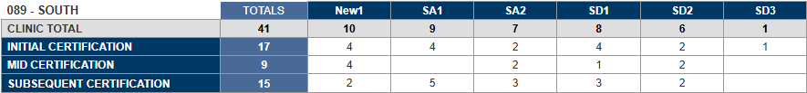
Columns: TOTALS, resources.
Rows: AGENCY TOTAL (Table 1), CLINIC TOTAL (Table 2), appointment types.
Tab 5 – HH Labels
Columns: Householdid, Authrepfirstname, Authreplastname, Mailaddress, Mailcity, Mailstate, Mailzip.

Kept Appointments List with Optional Local Use Answers
Revised Nov. 13, 2025

Overview
A list of participants that kept an appointment scheduled at the specified agency during the specified time period. The report output also displays selected answers to a local use question (agencies do not have to use local use questions to use this report).
Do you want answers to a local use question to display?
- YES - If you want answers to a local use question to display, you will need to enter the Answer IDs. To do this, enter the Agency ID into the prompt, leaving the rest of the prompts as-is, and run the report. Refer to the Reference-Answer IDs tab for the Answer IDs. All Answer IDs must be 4 digits and entered as they are listed in this tab (with preceding 0s).
- NO - If you do not want answers to a local use question to display, the “Enter 4-digit Answer ID(s)” prompt is still required. Enter 9999999 (7 nines) into the prompt. This will meet the prompt requirement and ensure no answers are pulled into your output.

Some uses
- Outreach – list for participant satisfaction survey.
- Texting outreach.

Prompts
- Agency ID – agency where local use questions are collected, and appointment were scheduled.
- Start Date – the first date in the time period during which appointments were scheduled/kept.
- End Date – the last date in the time period during which appointments were scheduled/kept.
- Answer ID(s) – the code(s) associated with a specific answer to a local use question. 9999999 is the code if not using local use questions.

Report outputs
Tab 1 – Reference-Answer IDs
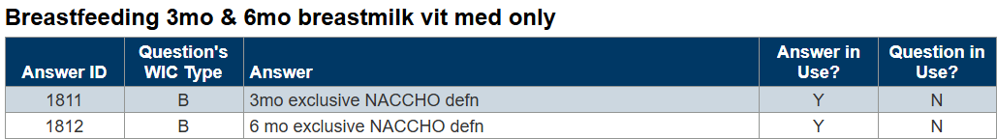
Columns: Answer ID, Question’s WIC Type, Answer, Answer in Use, and Question in Use.
Tab 2 – Kept Appointments
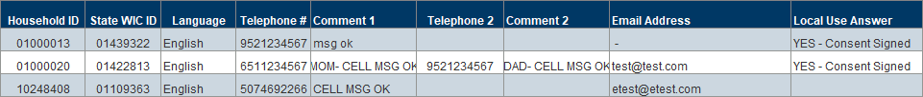
Columns: Household ID, State WIC ID, Language, Telephone #, Comment 1, Telephone 2, Comments 2, Email Address, and Local Use Answer.
Tab 3 – Simple Household
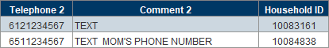
Columns: Telephone 2, Comment 2, and Household ID.

No Shows by Day and Time
Revised July 15, 2025

Overview
Provides a count and percentage of appointment no shows by day of week, hour of day, appointment times, and appointment date, as well as totals by resource. This report has three optional input controls, which allow the user to filter the output by Clinic, Appointment Type, and Resource.

Some uses
- Assess no-show rates by date, week-day, hour, appointment times, and resource.
- Identify days or times that have the lowest or highest no-show rates.
- Compare no-show rates between clinics and/or resources.

Prompts
- Agency ID – agency where the appointments were scheduled.
- Start Date – the first date in the time period during which appointments were scheduled.
- End Date – the last date in the time period during which appointments were scheduled.

Report outputs
Tab 1 – Resource Totals
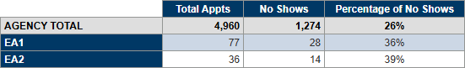
Columns: Total Appts, No Shows, Percentage of No Shows.
Rows: AGENCY TOTAL, resources.
Tab 2 – Day
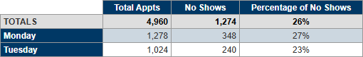
Columns: Total Appts, No Shows, Percentage of No Shows.
Rows: TOTALS, days of the week.
Tab 3 – Hour
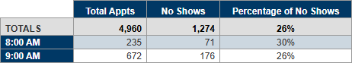
Columns: Total Appts, No Shows, Percentage of No Shows.
Rows: TOTALS, time (hourly).
Tab 4 – Appt Time
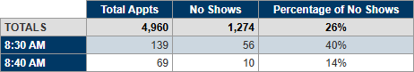
Columns: Total Appts, No Shows, Percentage of No Shows.
Rows: TOTALS, appointment times.
Tab 5 – Appt Date
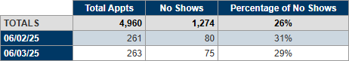
Columns: Total Appts, No Shows, Percentage of No Shows.
Rows: TOTALS, appointment dates.

Staff Who Scheduled Appointments
Revised July 24, 2025

Overview
This report provides two different sets of lists and counts of appointments scheduled by staff at the specified agency and for the specified time period. One set is based on the date the appointments were created by the staff person; the other is based on the date the appointments were scheduled for. An optional input control allows the user to filter the report outputs by the clinic where the participants are scheduled to attend their appointments.

Some uses
- Identify staff who scheduled specific appointments.
- Obtain count of appointments scheduled for a specific date.
- Obtain a list of appointments scheduled for a specific date.

Prompts
- Agency ID – agency where the participants are scheduled to attend the appointment.
- Start Date – the first date in the time period during which the staff person scheduled the appointments and the dates the participants are scheduled to attend the appointment.
- End Date – the last date in the time period during which the staff person scheduled the appointments and the dates the participants are scheduled to attend the appointment.

Report outputs
Tab 1 – List-Created
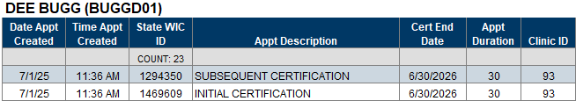
Columns: Date Appt Created, Time Appt Created, State WIC ID, Appt Description, Cert End Date, Appt Duration, Clinic ID.
Grouped by: Staff name (username).
Tab 2 – Count-Created
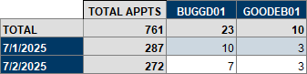
Columns: TOTAL APPTS, staff username.
Rows: TOTAL, appointment dates.
Tab 3 – List-Appt
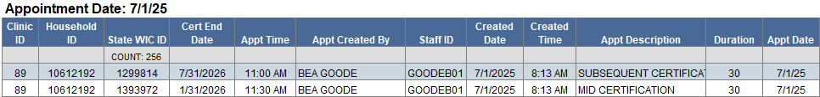
Columns: Clinic ID, Household ID, State WIC ID, Cert End Date, Appt Time, Appt Created by, Staff ID, Created Date, Created Time, Appt Description, Duration, Appt Date.
Counts: Participants.
Grouped by: Appointment date.
Tab 4 – Count-Appt
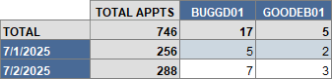
Columns: TOTAL APPTS, staff username.
Rows: TOTAL, appointment dates.

Unfilled Appointment Intervals
Revised Feb. 2, 2026

Overview
Provides information about appointments scheduled at the specified agency during the specified time period based on 30, 20, 15, and 10-minute time intervals for appointments. The report includes a count of unallotted “blocks”, allotted, scheduled, and unscheduled intervals, as well as the percentage of allotted intervals that were scheduled and unscheduled. There are four tabs for each time interval: totals by agency and clinic, by resource, by clinic, and a summary by resource and clinic. An optional input control allows the report user to filter all outputs by resource.

Some uses
- Identify days/clinics that tend to have multiple unfilled appointment blocks.
- Assess staffing for appointments.

Prompts
- Agency ID – agency where the appointment, resource, blocks, and events were scheduled.
- Start Date – the first date in the time period during which the appointment, resource, block or event was scheduled.
- End Date – the last date in the time period during which the appointment, resource, block or event was scheduled.

Report outputs
There are 4 tabs for each interval. These 4 tabs are the same except for the difference in interval length and colors (30-green; 20-medium blue; 15-red; and 10-orange). The following shows images only for the 30-minute tabs.
Tab 1 – 30-Min TOTALS
Table 1 – Agency
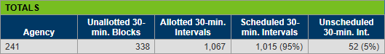
Columns: Agency, Unallotted 30-min. Blocks, Allotted 30-min. Intervals, Scheduled 30-min. Intervals, Unscheduled 30-min. Int. (intervals).
Table 2 – Clinics
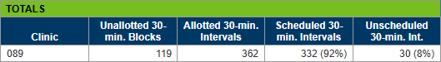
Columns: Clinic, Unallotted 30-min. Blocks, Allotted 30-min. Intervals, Scheduled 30-min. Intervals, Unscheduled 30-min. Int. (intervals).
Tab 2 - 30-Min Resource
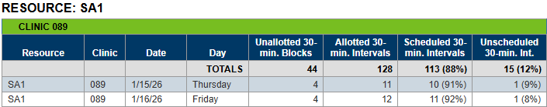
Columns: Resource, Clinic, Date, Day, Unallotted 30-min. Blocks, Allotted 30-min. Intervals, Scheduled 30-min. Intervals, Unscheduled 30-min. Int. (intervals).
Counts: TOTALS.
Grouped by: Resource and clinic ID.
Tab 3 – 30-Min Clinic
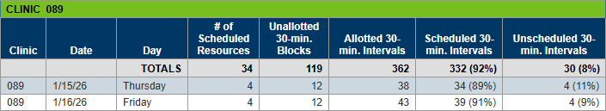
Columns: Clinic, Date, Day, # of Scheduled Resources, Unallotted 30-min. Blocks, Allotted 30-min. Intervals, Scheduled 30-min. Intervals, Unscheduled 30-min. Intervals.
Counts: TOTALS.
Grouped by: Clinic ID.
Tab 4 – 30-Min Summary
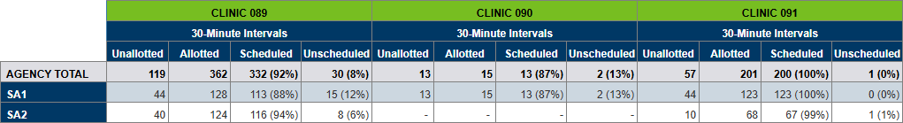
Columns: Unallotted, Allotted, Scheduled, Unscheduled.
Rows: AGENCY TOTAL, resources.
Grouped by: Clinic ID (30 Minutes Intervals).
Tab 17 - Events
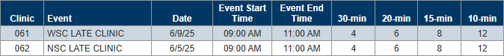
Columns: Clinic, Event, Date, Event Start Time, Event End Time, 30-min, 20-min, 15-min, 10-min.
If a resource’s start and or end time overlaps an event, you will have to manually adjust their time intervals to reflect this.

Benefits

Missed Nutrition Visits by Last Clinic Issued
Revised Oct. 23. 2024

Overview
A list of participants whose last set of benefits were issued at the specified agency and clinic(s) who are eligible to receive benefits and who have missed a nutrition visit/benefit pick-up based on their last set’s LDTU being during a specified time period. The report also provides the last appointment scheduled, which could be in the past or future, and excludes those not eligible for issuance.

Some uses
Identify participants who missed a nutrition visit for outreach.

Prompts
- Agency ID – agency where the participants currently belong.
- Clinic ID(s) – clinic where the participants were last issued benefits.
- Last Set’s LDTU (Start) – the first date in the time period during which the participant’s last set’s LDTU falls.
- Last Set’s LDTU (End) – the last date in the time period during which the participant’s last set’s LDTU falls.

Report outputs
Tab 1 – Participant Details
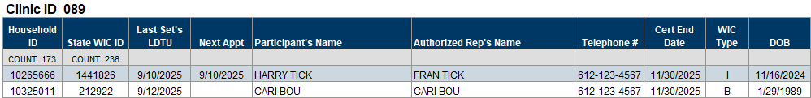
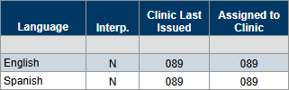
Columns: Household ID, State WIC ID, Last Set’s LDTU, Next Appt, Participant’s Name, Authorized Rep’s Name, Telephone #, Cert End Date, WIC Type, DOB, Language, Interp. (interpreter), Clinic Last Issued, Assigned to Clinic.
Counts: Households and participants.
Grouped by: Clinic where last set of benefits were issued.
Tab 2 – Labels by Household
Columns: Clinic Last Issued, Assigned to Clinic, Household ID, Authorized Rep’s Name, Mailing Address, City, State, Zip Code.
Tab 3 – Labels by Participant
Columns: Clinic Last Issued, Assigned to Clinic, Household ID, State WIC ID, Participant’s Name, Mailing Address, City, State, Zip Code.

Benefits >> Agency Management

Returned Formula
Created June 6, 2025

Overview
A list of participants with returned formula originally issued at the specified agency and returned during the specified dates.

Some uses
Assist with tracking returned formula.

Prompts
- Agency ID – agency where the participants currently belong.
- Start Date – the first date in the time period during which formula was returned.
- End Date – the last date in the time period during which formula was returned.

Report output
Tab 1 – List
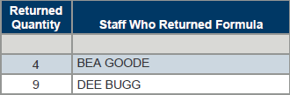
Columns: Clinic ID, Household ID, State WIC ID, First Name, Last Name, DOB (date of birth), WIC Type, Issued Date, FDTU (first date to use), Returned Date, Returned Formula.
Counts: Participants.

WIC Contacts and Benefits Not Issued
Revised July 7, 2025

Overview
A list of participants who belong to the specified agency and had a WIC contact (Cert, MCA, documented Nutrition Education Contact or documented Note) during the specified date range and have a last Last Date to Use (LDTU) before the contact date, the same as the contact date, or within 15 days after the contact date. A second tab provides a count of contacts by certifier/staff person. This report also has optional input controls to filter the output by contact types and note subjects.

Some uses
Identify and address instances where staff complete contacts but fail to issue benefits.

Prompts
- Agency ID – agency where the participants currently belong.
- Start Date – the first date in the time period during which the contact (cert, MCA, documented NE contact or note) occurred.
- End Date – the last date in the time period during which the contact (cert, MCA, documented NE contact or note) occurred.

Report output
Tab 1 – Participant List
Columns: Household ID, State WIC ID, WIC Type, Contact Type, Contact Date, Last Set’s LDTU, Issuance Status (not issued or issued), Currently High Risk, Authorized Rep’s Name, Telephone #, Comment, Username, Certifier/Staff Person.
Counts: Participants.
Tab 2 – Counts
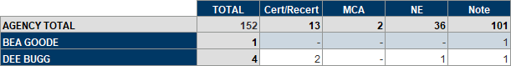
Columns: TOTAL, Cert/Recert, MCA, NE, Note.
Rows: AGENCY TOTAL, staff names.

Counts

Count of Contacts by WIC Type, Race, and Clinic for Grantee & Agency and Statewide by Agency
Revised Nov. 5, 2025

Overview
A count of new certifications, recertifications, Mid-certification Assessments (MCAs) and Nutrition Education Contacts (NECs) by WIC type, race/ethnicity, and clinic for the specified grantee and its agencies during the specified date range. The output also provides statewide counts by WIC type and race/ethnicity for the MN WIC Program and each agency. NOTE: the Grantee ID is entered into the prompts (not the Agency ID).

Some uses
- Assess and compare productivity of grantees, agencies, or clinics.
- Obtain counts of participants provided WIC services by WIC type and race/ethnicity.

Prompts
- Start Date – the first date in the time period during which the contact (new cert, recert, MCA, or NECs) occurred.
- End Date – the last date in the time period during which the contact (new cert, recert, MCA, or NECs) occurred.
- Grantee ID – the grantee ID associated with the agency ID where the contact was completed.

Report outputs
Tab 1 – Grantee-Agency-Clinic
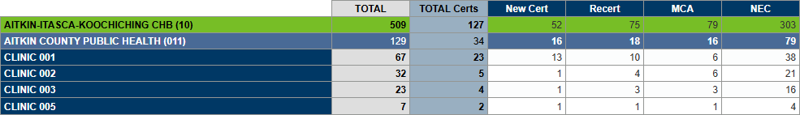
Columns: TOTAL, TOTAL Certs, New Cert, Recert, MCA, NEC.
Rows: Grantee name (ID), agency name (ID), CLINIC IDs.
Tab 2 – WIC Type
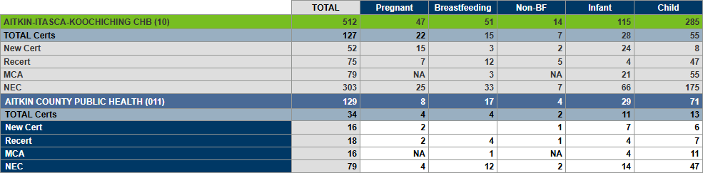
Columns: TOTAL, Pregnant, Breastfeeding, Non-BF, Infant, Child.
Rows: Grantee name (ID), TOTAL Certs, New Cert, Recert, MCA, NEC, agency name (ID), TOTAL Certs, New Cert, Recert, MCA, NEC.
Tab 3 – Race Ethnicity
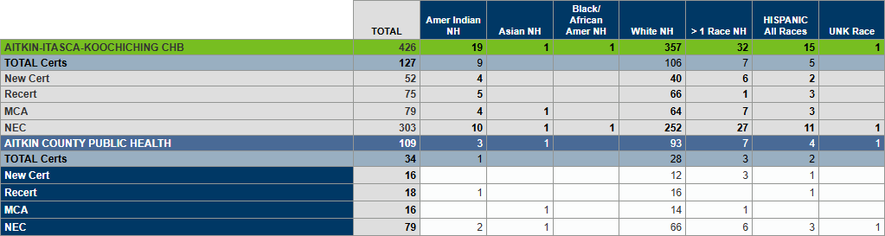
Columns: TOTAL, Amer Indian NH, Asian NH, Black/African Amer NH, White NH, >1 Race NH, HISPANIC All Races, UNK Race.
Rows: Grantee name (ID), TOTAL Certs, New Cert, Recert, MCA, NEC, agency name (ID), TOTAL Certs, New Cert, Recert, MCA, NEC.
Tab 4 – State-Agency
Columns: TOTAL, TOTAL Certs, New Cert, Recert, MCA, NEC.
Rows: Grantee name (ID), agency name (ID), CLINIC IDs.
Tab 5 – State-WIC Type
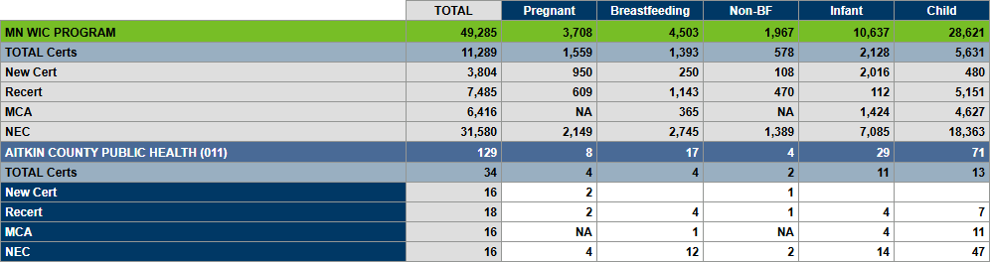
Columns: TOTAL, Pregnant, Breastfeeding, Non-BF, Infant, Child.
Rows: MN WIC PROGRAM, TOTAL Certs, New Cert, Recert, MCA, NEC, agency name (ID), TOTAL Certs, New Cert, Recert, MCA, NEC.
Tab 6 – State-Race Ethnicity
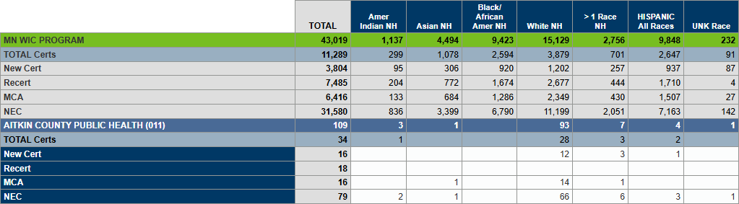
Columns: TOTAL, Amer Indian NH, Asian NH, Black/African Amer NH, White NH, >1 Race NH, HISPANIC All Races, UNK Race.
Rows: MN WIC PROGRAM, TOTAL Certs, New Cert, Recert, MCA, NEC, agency name (ID), TOTAL Certs, New Cert, Recert, MCA, NEC.

Count of Three Optional Local Use Answers and Referrals Given at Any Time
Created Oct. 27, 2026

Overview
Two cross-tab counts, optional Local Use answers and specified referrals, for participants who have had a specified Local Use answer selected or a referral given at any time. For Local Use, answers to up to three questions can be entered into the prompts. Participants are counted if they have an answer, based on the question’s WIC type, selected at any time that matches the IDs entered into the prompts. Percentages of the total by WIC Type and Local Use answer are included. For referrals, the participant is counted if they’ve received the specified referral(s) at any time (or at least once) during their participation in the WIC Program.
The answer IDs for the optional Local Use Answer prompt are listed in the Reference-Answer IDs tab. This is a required prompt. If you are not using Question 2 and/or Question 3, enter 9999999 (7 nines) into the Local Use prompt(s).

Some uses
- Provide counts of all selected Local Use answers by WIC Type for a study or program intervention.
- Provide a total count of specified referrals given to participants at any time. Used by requesting agency to track whether a specific referral was completed or not.

Prompts
- %AgencyID% - agency associated with referrals.
- Agency ID - agency associated with the Local Use question; the agency where the participant currently belongs; and the agency where the participant belonged when the referral was given.
- Question 1-Answer ID(s) – IDs associated with answers to the first Local Use question.
- Question 2-Answer ID(s) – IDs associated with answers to the second Local Use question.
- Question 3-Answer ID(s) – IDs associated with answers to the third Local Use question.
- Referral ID(s) – IDs associated with referrals.

Report outputs
Tab 1 – Reference-Answer IDs
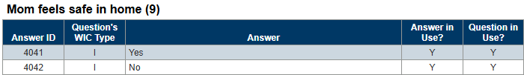
Columns: Answer ID, Question’s WIC Type, Answer, Answer in Use, Question in Use
Grouped by: Local Use questions
Tab 2 – Reference-Referral IDs
Columns: Referral ID, Referral, Active
Tab 3 – Counts-Local Use
Table 1 – QUESTION 1
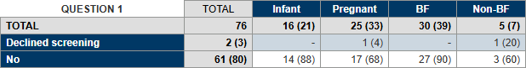
Rows: TOTAL, Question 1 Local Use answers
Columns: TOTAL, WIC types associated with Local Use question (1)
Table 2 – QUESTION 2
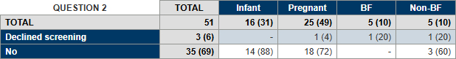
Rows: TOTAL, Question 2 Local Use answers
Columns: TOTAL, WIC types associated with Local Use question (2)
Table 3 – QUESTION 3
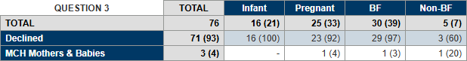
Rows: TOTAL, Question 3 Local Use answers
Columns: TOTAL, WIC types associated with Local Use question (3)
Tab 4 – Counts-Referrals
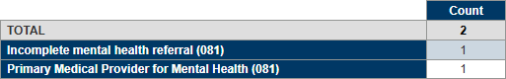
Rows: TOTAL, referrals
Columns: Count

VOC Documents Produced
Created Aug. 12, 2026

Overview
Statewide counts (all and distinct) by agency of participants for whom a VOC document was produced during the specified time period. Counts are by Race/Ethnicity or Cultural Identity.

Some uses
Obtain count of VOC documents being produced by agency and/or Race Ethnicity/Cultural Identity.

Prompts
- Start Date – first date in date range during which a VOC document was produced.
- End Date – last date in date range during which a VOC document was produced.

Report outputs*
Tab 1 – All (VOC Documents)
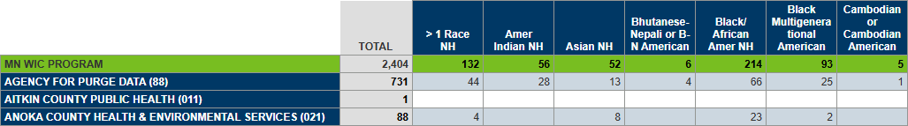
Rows: MN WIC Program, agencies
Columns: TOTAL, race ethnicities or cultural identity
Tab 2 – Distinct (Participants) 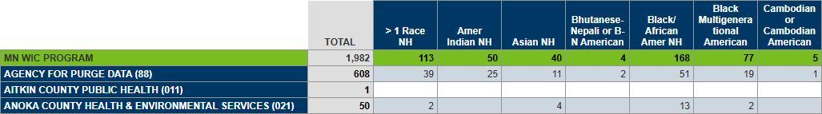
*Images do not reflect the actual number of columns in the report output. All applicable race/ethnicities and cultural identities display.
Rows: MN WIC Program, agencies
Columns: TOTAL, race ethnicities or cultural identity

Counts >> Monthly Participation

Average Monthly Participation by Congressional District
Created April 7, 2026

Overview
Provides the average monthly participation by congressional district for the specified calendar year. The districts are assigned based on clinic location.

Some uses
Obtain the average monthly participation by congressional district for fact sheets.

Prompts
- Enter YYYY01: – The first month in the calendar year during which participants were counted.
- Enter Same Year YYYY12: – The last month in the calendar year during which participants were counted.

Report outputs
Tab 1 – Ave. Mo. PPTN
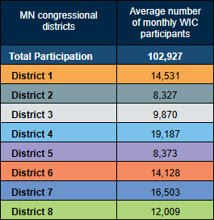
Columns: MN congressional districts, Average number of monthly WIC participants.
Rows: Total Participation, District 1, District 2, District 3, District 4, District 5, District 6, District 7, District 8.
Tab 2 – Clinics & Cong. Dist.
Columns: Clinic ID, Clinic Name, Grantee ID, Agency ID, Agency Name.

Monthly Participation by Age and Race Ethnicity
Revised April 22, 2026

Overview
A count of participants by age categories (0-<1, 1-3, 4-5, 6-8, 9-11 mo; 12 mo. infant; 12-23, 24-25, 36-47, 48-60 mo.; and <=17, 18-20, 21-35, >35 y.o.) and race ethnicity for the specified participation month and specified grantee. Counts include total participation and are provided for the state, specified grantee, and its agencies and clinics.

Some uses
- Identify trends in monthly participation by age and race ethnicity.
- Obtain counts of participants in a specific age group or race ethnicity.

Prompts
- Enter 3-digit Grantee ID: – The grantee the agency and clinic where the participant was issued benefits (or was counted) belongs to.
- Enter YYYYMM: – The year and month the participant was counted.

Report outputs
Tab 1 – State
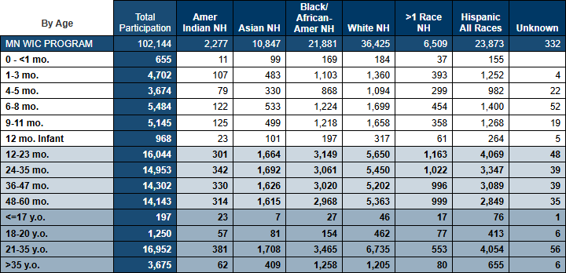
Columns: Total Participation, Amer Indian NH, Asian NH, Black/African-Amer NH, White NH, >1 Race NH, Hispanic All Races, Unknown.
Rows: MN WIC PROGRAM, 0 - <1 mo, 1-3 mo., 4-5 mo., 6-8 mo., 9-11 mo., 12 mo. Infant, 12-23 mo., 24-35 mo., 36-47 mo., 48-60 mo., <=17 y.o., 18-20 y.o., 21-35 y.o., > 35 y.o.
Tab 2 – Grantee
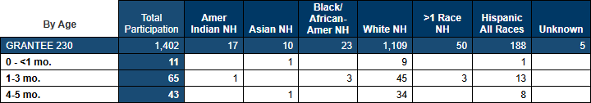
Columns: Total Participation, Amer Indian NH, Asian NH, Black/African-Amer NH, White NH, >1 Race NH, Hispanic All Races, Unknown.
Rows: GRANTEE ID, 0 - <1 mo, 1-3 mo., 4-5 mo., 6-8 mo., 9-11 mo., 12 mo. Infant, 12-23 mo., 24-35 mo., 36-47 mo., 48-60 mo., <=17 y.o., 18-20 y.o., 21-35 y.o., > 35 y.o.
Tab 3 – Agency
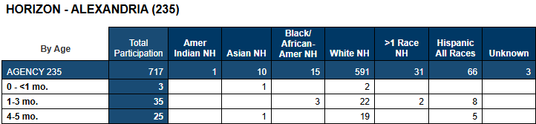
Grouped by: Agency name.
Columns: Total Participation, Amer Indian NH, Asian NH, Black/African-Amer NH, White NH, >1 Race NH, Hispanic All Races, Unknown.
Rows: AGENCY ID, 0 - <1 mo, 1-3 mo., 4-5 mo., 6-8 mo., 9-11 mo., 12 mo. Infant, 12-23 mo., 24-35 mo., 36-47 mo., 48-60 mo., <=17 y.o., 18-20 y.o., 21-35 y.o., > 35 y.o.
Tab 4 – Clinic
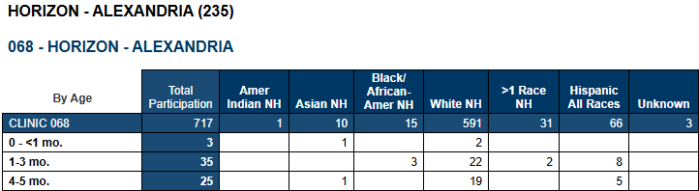
Grouped by: Agency name and clinic name.
Columns: Total Participation, Amer Indian NH, Asian NH, Black/African-Amer NH, White NH, >1 Race NH, Hispanic All Races, Unknown.
Rows: CLINIC ID, 0 - <1 mo, 1-3 mo., 4-5 mo., 6-8 mo., 9-11 mo., 12 mo. Infant, 12-23 mo., 24-35 mo., 36-47 mo., 48-60 mo., <=17 y.o., 18-20 y.o., 21-35 y.o., > 35 y.o.

Monthly Participation by City of Residence and Race Ethnicity
Revised April 22, 2026

Overview
A count of participants by their current city of residence and race ethnicity for the specified participation month and specified grantee. Counts include total participation and are provided for the state, specified grantee, and its agencies and clinics.

Some uses
- Identify cities with predominant cultures to assist with services.
- Identify cities being served by a grantee, agency, or clinic.

Prompts
- Enter 3-digit Grantee ID: – The grantee the agency and clinic where the participant was issued benefits (or was counted) belongs to.
- Enter YYYYMM: – The year and month the participant was counted.

Report outputs
Tab 1 – State
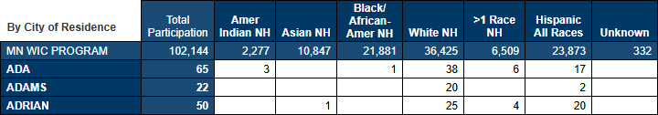
Columns: Total Participation, Amer Indian NH, Asian NH, Black/African-Amer NH, White NH, >1 Race NH, Hispanic All Races, Unknown.
Rows: MN WIC PROGRAM, city of residence.
Tab 2 – Grantee
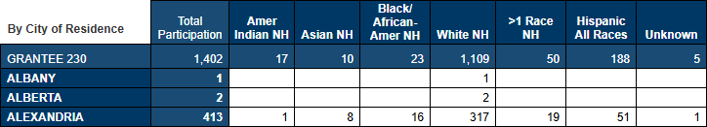
Columns: Total Participation, Amer Indian NH, Asian NH, Black/African-Amer NH, White NH, >1 Race NH, Hispanic All Races, Unknown.
Rows: GRANTEE ID, city of residence.
Tab 3 – Agency
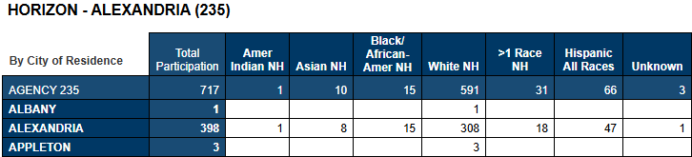
Grouped by: Agency name.
Columns: Total Participation, Amer Indian NH, Asian NH, Black/African-Amer NH, White NH, >1 Race NH, Hispanic All Races, Unknown.
Rows: AGENCY ID, city of residence.
Tab 4 – Clinic
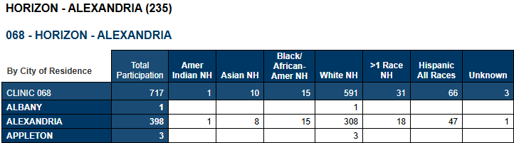
Grouped by: Agency name and clinic name.
Columns: Total Participation, Amer Indian NH, Asian NH, Black/African-Amer NH, White NH, >1 Race NH, Hispanic All Races, Unknown.
Rows: CLINIC ID, city of residence.

Monthly Participation by City of Residence, WIC Category and BF Amount
Revised April 22, 2026

Overview
A count of participants by their current city of residence, WIC Category, and breastfeeding amount for the specified participation month and specified grantee. Counts include total participation and are provided for the state, specified grantee, and its agencies and clinics.

Some uses
- Identify trends in participation based on cities.
- Identify cities being served by a grantee, agency, or clinic.

Prompts
- Enter 3-digit Grantee ID: – The grantee the agency and clinic where the participant was issued benefits (or was counted) belongs to.
- Enter YYYYMM: – The year and month the participant was counted.

Report outputs
Tab 1 – State
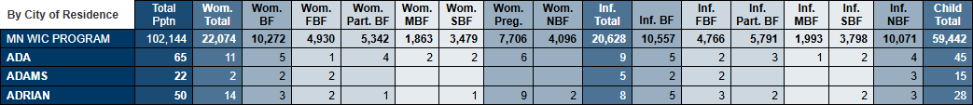
Columns: Total Pptn, Wom. Total, Wom. BF, Wom. Part. BF, Wom. MBF, Wom. SBF, Wom. Preg., Wom. NBF, Inf. Total, Inf. BF, Inf. FBF, Inf. Part. BF, Inf. MBF, Inf. SBF, Inf. NBF, Child Total.
Rows: MN WIC PROGRAM, city of residence.
Tab 2 – Grantee
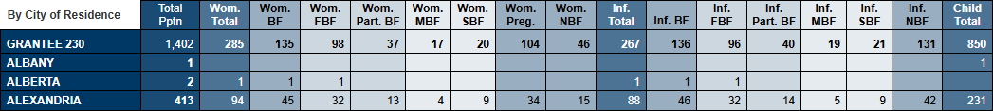
Columns: Total Pptn, Wom. Total, Wom. BF, Wom. Part. BF, Wom. MBF, Wom. SBF, Wom. Preg., Wom. NBF, Inf. Total, Inf. BF, Inf. FBF, Inf. Part. BF, Inf. MBF, Inf. SBF, Inf. NBF, Child Total.
Rows: GRANTEE ID, city of residence.
Tab 3 – Agency
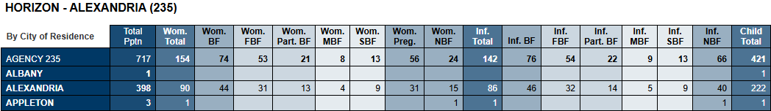
Grouped by: Agency name.
Columns: Total Pptn, Wom. Total, Wom. BF, Wom. Part. BF, Wom. MBF, Wom. SBF, Wom. Preg., Wom. NBF, Inf. Total, Inf. BF, Inf. FBF, Inf. Part. BF, Inf. MBF, Inf. SBF, Inf. NBF, Child Total.
Rows: AGENCY ID, city of residence.
Tab 4 – Clinic
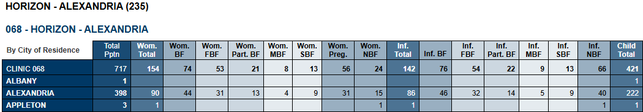
Grouped by: Agency name and clinic name.
Columns: Total Pptn, Wom. Total, Wom. BF, Wom. Part. BF, Wom. MBF, Wom. SBF, Wom. Preg., Wom. NBF, Inf. Total, Inf. BF, Inf. FBF, Inf. Part. BF, Inf. MBF, Inf. SBF, Inf. NBF, Child Total.
Rows: CLINIC ID, city of residence.

Monthly Participation by County of Residence and Race Ethnicity
Revised April 22, 2026

Overview
A count of participants by their current county of residence and race ethnicity for the specified participation month and specified grantee. Counts include total participation and are provided for the state, specified grantee, and its agencies and clinics.

Some uses
- Identify counties with predominant cultures to assist with services.
- Identify counties being served by a grantee, agency, or clinic.

Prompts
- Enter 3-digit Grantee ID: – The grantee the agency and clinic where the participant was issued benefits (or was counted) belongs to.
- Enter YYYYMM: – The year and month the participant was counted.

Report outputs
Tab 1 – State
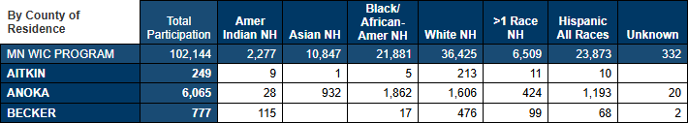
Columns: Total Participation, Amer Indian NH, Asian NH, Black/African-Amer NH, White NH, >1 Race NH, Hispanic All Races, Unknown.
Rows: MN WIC PROGRAM, county of residence.
Tab 2 – Grantee
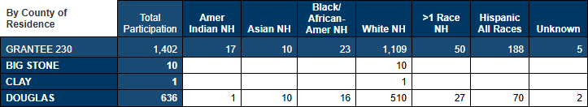
Columns: Total Participation, Amer Indian NH, Asian NH, Black/African-Amer NH, White NH, >1 Race NH, Hispanic All Races, Unknown.
Rows: GRANTEE ID, county of residence.
Tab 3 – Agency
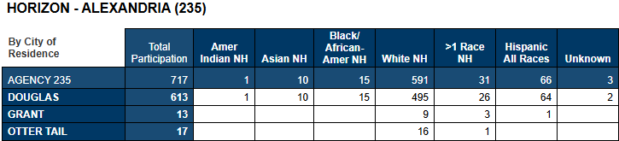
Grouped by: Agency name.
Columns: Total Participation, Amer Indian NH, Asian NH, Black/African-Amer NH, White NH, >1 Race NH, Hispanic All Races, Unknown.
Rows: AGENCY ID, county of residence.
Tab 4 – Clinic
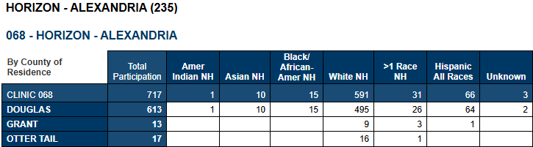
Grouped by: Agency name and clinic name.
Columns: Total Participation, Amer Indian NH, Asian NH, Black/African-Amer NH, White NH, >1 Race NH, Hispanic All Races, Unknown.
Rows: CLINIC ID, county of residence.

Monthly Participation by County of Residence, WIC Category and BF Amount
Revised April 22, 2026

Overview
A count of participants by their current county of residence, WIC Category, and breastfeeding amount for the specified participation month and specified grantee. Counts include total participation and are provided for the state, specified grantee, and its agencies and clinics.

Some uses
- Identify trends in participation based on counties.
- Identify counties being served by a grantee, agency, or clinic.

Prompts
- Enter 3-digit Grantee ID: – The grantee the agency and clinic where the participant was issued benefits (or was counted) belongs to.
- Enter YYYYMM: – The year and month the participant was counted.

Report outputs
Tab 1 – State
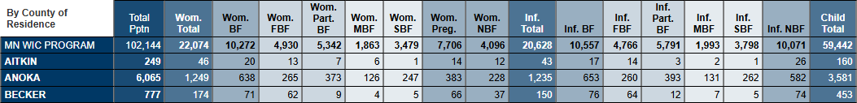
Columns: Total Pptn, Wom. Total, Wom. BF, Wom. Part. BF, Wom. MBF, Wom. SBF, Wom. Preg., Wom. NBF, Inf. Total, Inf. BF, Inf. FBF, Inf. Part. BF, Inf. MBF, Inf. SBF, Inf. NBF, Child Total.
Rows: MN WIC PROGRAM, county of residence.
Tab 2 – Grantee
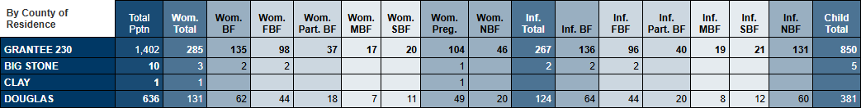
Columns: Total Pptn, Wom. Total, Wom. BF, Wom. Part. BF, Wom. MBF, Wom. SBF, Wom. Preg., Wom. NBF, Inf. Total, Inf. BF, Inf. FBF, Inf. Part. BF, Inf. MBF, Inf. SBF, Inf. NBF, Child Total.
Rows: GRANTEE ID, county of residence.
Tab 3 – Agency
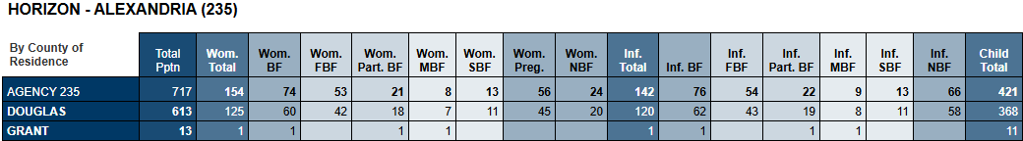
Grouped by: Agency name.
Columns: Total Pptn, Wom. Total, Wom. BF, Wom. Part. BF, Wom. MBF, Wom. SBF, Wom. Preg., Wom. NBF, Inf. Total, Inf. BF, Inf. FBF, Inf. Part. BF, Inf. MBF, Inf. SBF, Inf. NBF, Child Total.
Rows: AGENCY ID, county of residence.
Tab 4 – Clinic
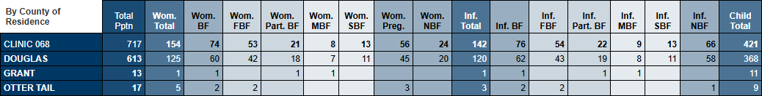
Grouped by: Agency name and clinic name.
Columns: Total Pptn, Wom. Total, Wom. BF, Wom. Part. BF, Wom. MBF, Wom. SBF, Wom. Preg., Wom. NBF, Inf. Total, Inf. BF, Inf. FBF, Inf. Part. BF, Inf. MBF, Inf. SBF, Inf. NBF, Child Total.
Rows: CLINIC ID, county of residence.

Monthly Participation by Infant BF Amount and Age in Months
Revised April 22, 2026

Overview
A count and percentage of infants by breastfeeding amount and age in months for the specified participation month and specified grantee. Counts and percentages include total participation and are provided for the state, specified grantee, and its agencies and clinics.

Some uses
- Identify trends in infant participation based on age.
- Identify trends in breastfeeding based on age.
- Compare grantee trends to statewide trends.
- Obtain percentage of total infants by age.

Prompts
- Enter 3-digit Grantee ID: – The grantee the agency and clinic where the participant was issued benefits (or was counted) belongs to.
- Enter YYYYMM: – The year and month the participant was counted.

Report outputs
Tab 1 – State
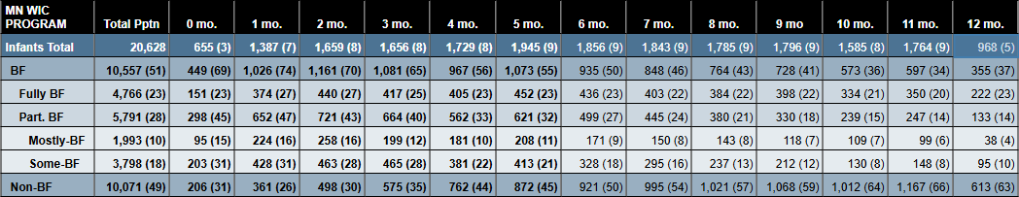
Columns: Total Pptn, 0 mo., 1 mo., 2 mo., 3 mo., 4 mo., 5 mo., 6 mo., 7 mo., 8 mo., 9 mo., 10 mo., 11 mo., 12 mo.
Rows: Infants Total, BF, Fully BF, Part. BF, Mostly-BF, Some-BF, Non-BF.
Tab 2 – Grantee
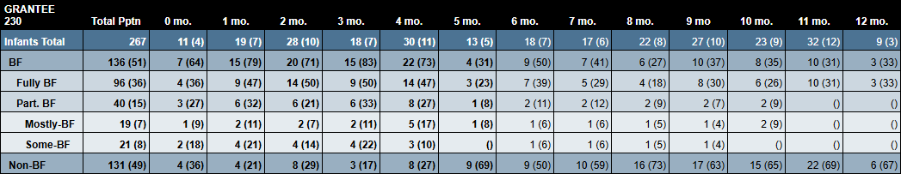
Columns: Total Pptn, 0 mo., 1 mo., 2 mo., 3 mo., 4 mo., 5 mo., 6 mo., 7 mo., 8 mo., 9 mo., 10 mo., 11 mo., 12 mo.
Rows: Infants Total, BF, Fully BF, Part. BF, Mostly-BF, Some-BF, Non-BF.
Tab 3 – Agency
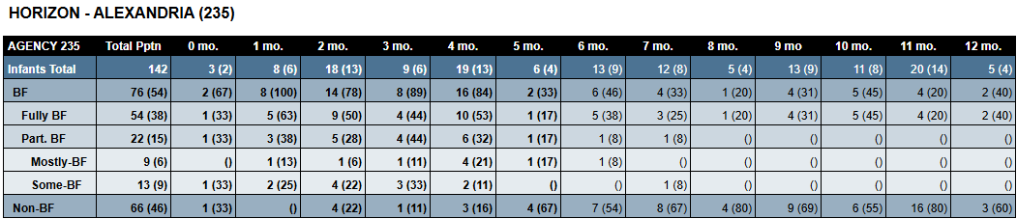
Grouped by: Agency name.
Columns: Total Pptn, 0 mo., 1 mo., 2 mo., 3 mo., 4 mo., 5 mo., 6 mo., 7 mo., 8 mo., 9 mo., 10 mo., 11 mo., 12 mo.
Rows: Infants Total, BF, Fully BF, Part. BF, Mostly-BF, Some-BF, Non-BF.
Tab 4 – Clinic
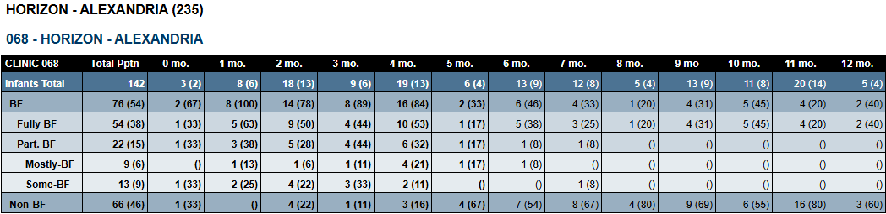
Grouped by: Agency name and clinic name.
Columns: Total Pptn, 0 mo., 1 mo., 2 mo., 3 mo., 4 mo., 5 mo., 6 mo., 7 mo., 8 mo., 9 mo., 10 mo., 11 mo., 12 mo.
Rows: Infants Total, BF, Fully BF, Part. BF, Mostly-BF, Some-BF, Non-BF.

Monthly Participation by Specified Zip Code(s)
Revised June 3, 2026

Overview
Counts and lists of participants and household for the specified participation month and zip code(s). The output displays the agency and county where the participants/households were counted and their current zip code of residence. A participant list and household list provide demographic information for outreach. Optional input controls allow the report user to filter all tabs by the county where the participant/household lives; the agency where the participant or household was counted for the specified participation month; and the lists by language.

Some uses
- Identify participants or households being served by other agencies or counties for outreach.
- Obtain a count of participants being served by other agencies or counties.

Prompts
- Enter YYYYMM: – The year and month the participant was counted.
- Enter 5-digit Zip Code(s): - the zip code of the participant’s current residence.

Report outputs
Tab 1 – Agency-PPT
Columns: Total Pptn, specified zip codes.
Rows: TOTAL, agency name (ID).
Tab 2 – Agency-HH
Columns: Total Pptn, specified zip codes.
Rows: TOTAL, agency name (ID).
Tab 3 – County-PPT
Columns: Total Pptn, specified zip codes.
Rows: TOTAL, county (of residence).
Tab 4 – County-HH
Columns: Total Pptn, specified zip codes.
Rows: TOTAL, county (of residence).
Tab 5 – Participant List
Page 1
Page 2
Columns: Agency ID (counted), County (PPT lives), Household ID, State WIC ID, WIC Type, Cert End Date, Ppt First Name, Ppt Last Name, Auth Rep FN, Auth Rep LN, Mail Address, Mail City, Mail State, Mail Zip Code, Telephone, Comment, Language, Needs Interpreter.
Tab 6 – Household List
Page 1
Page 2
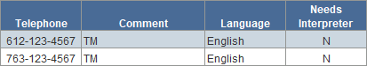
Columns: Agency ID (counted), County (HH lives), Household ID, Auth Rep FN, Auth Rep LN, Mail Address, Mail City, Mail State, Mail Zip Code, Telephone, Comment, Language, Needs Interpreter.

Monthly Participation by WIC Category, BF Amount, and Age
Revised April 22, 2026

Overview
A count of participants by WIC category, breastfeeding amount, and age categories (0-<1, 1-3, 4-5, 6-8, 9-11 mo; 12 mo. infant; 12-23, 24-25, 36-47, 48-60 mo.; and <=17, 18-20, 21-35, >35 y.o.) for the specified participation month and specified grantee. Counts include total participation and are provided for the state, specified grantee, and its agencies and clinics.

Some uses
- Identify trends in participation based on age categories.
- Identify trends in breastfeeding based on age categories.
- Compare grantee trends to statewide trends.

Prompts
- Enter 3-digit Grantee ID: – The grantee the agency and clinic where the participant was issued benefits (or was counted) belongs to.
- Enter YYYYMM: – The year and month the participant was counted.

Report outputs
Tab 1 – State
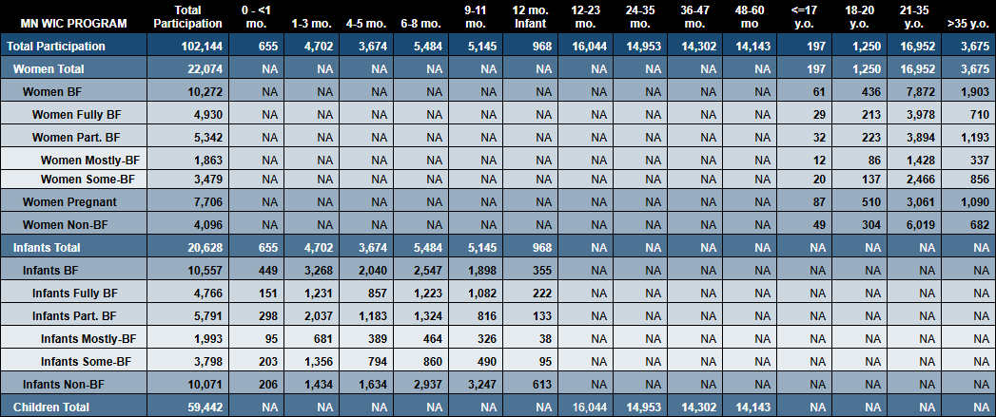
Columns: Total Participation, 0 - <1 mo, 1-3 mo., 4-5 mo., 6-8 mo., 9-11 mo., 12 mo. Infant, 12-23 mo., 24-35 mo., 36-47 mo., 48-60 mo., <=17 y.o., 18-20 y.o., 21-35 y.o., > 35 y.o.
Rows: Total Participation, Women Total, Women BF, Women Fully BF, Women Part. BF, Women Mostly-BF, Women Some-BF, Women Pregnant, Women Non-BF, Infants Total, Infants BF, Infants Part. BF, Infants Mostly-BF, Infants Some-BF, Infants Non-BF, Children Total.
Tab 2 – Grantee
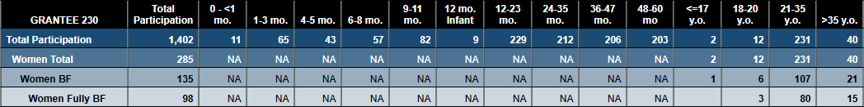
Columns: Total Participation, 0 - <1 mo, 1-3 mo., 4-5 mo., 6-8 mo., 9-11 mo., 12 mo. Infant, 12-23 mo., 24-35 mo., 36-47 mo., 48-60 mo., <=17 y.o., 18-20 y.o., 21-35 y.o., > 35 y.o.
Rows: Total Participation, Women Total, Women BF, Women Fully BF, Women Part. BF, Women Mostly-BF, Women Some-BF, Women Pregnant, Women Non-BF, Infants Total, Infants BF, Infants Part. BF, Infants Mostly-BF, Infants Some-BF, Infants Non-BF, Children Total.
Tab 3 – Agency
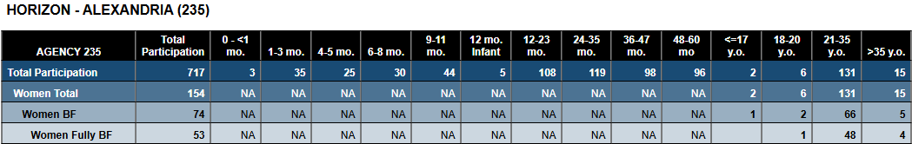
Grouped by: Agency name.
Columns: Total Participation, 0 - <1 mo, 1-3 mo., 4-5 mo., 6-8 mo., 9-11 mo., 12 mo. Infant, 12-23 mo., 24-35 mo., 36-47 mo., 48-60 mo., <=17 y.o., 18-20 y.o., 21-35 y.o., > 35 y.o.
Rows: Total Participation, Women Total, Women BF, Women Fully BF, Women Part. BF, Women Mostly-BF, Women Some-BF, Women Pregnant, Women Non-BF, Infants Total, Infants BF, Infants Part. BF, Infants Mostly-BF, Infants Some-BF, Infants Non-BF, Children Total.
Tab 4 – Clinic
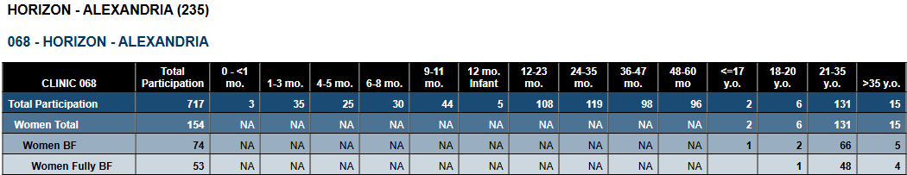
Grouped by: Agency name and clinic name.
Columns: Total Participation, 0 - <1 mo, 1-3 mo., 4-5 mo., 6-8 mo., 9-11 mo., 12 mo. Infant, 12-23 mo., 24-35 mo., 36-47 mo., 48-60 mo., <=17 y.o., 18-20 y.o., 21-35 y.o., > 35 y.o.
Rows: Total Participation, Women Total, Women BF, Women Fully BF, Women Part. BF, Women Mostly-BF, Women Some-BF, Women Pregnant, Women Non-BF, Infants Total, Infants BF, Infants Part. BF, Infants Mostly-BF, Infants Some-BF, Infants Non-BF, Children Total.

Monthly Participation by WIC Category, BF Amount, and Race Ethnicity
Revised April 22, 2026

Overview
A count of participants by WIC category, breastfeeding amount, and race ethnicity for the specified participation month and specified grantee. Counts include total participation and are provided for the state, specified grantee, and its agencies and clinics.

Some uses
- Identify trends in participation based on race ethnicity.
- Identify trends in breastfeeding based on race ethnicity.
- Compare grantee trends to statewide trends.

Prompts
- Enter 3-digit Grantee ID: – The grantee the agency and clinic where the participant was issued benefits (or was counted) belongs to.
- Enter YYYYMM: – The year and month the participant was counted.

Report outputs
Tab 1 – State
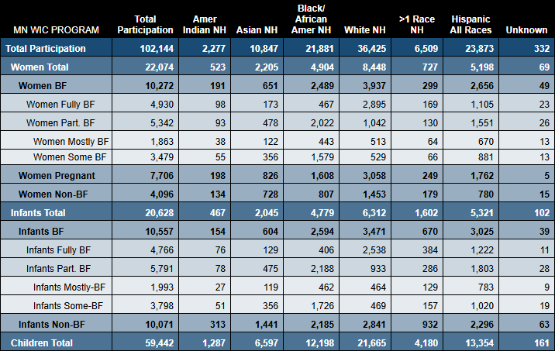
Columns: Total Participation, Amer Indian NH, Asian NH, Black/African-Amer NH, White NH, >1 Race NH, Hispanic All Races, Unknown.
Rows: Total Participation, Women Total, Women BF, Women Fully BF, Women Part. BF, Women Mostly-BF, Women Some-BF, Women Pregnant, Women Non-BF, Infants Total, Infants BF, Infants Part. BF, Infants Mostly-BF, Infants Some-BF, Infants Non-BF, Children Total.
Tab 2 – Grantee
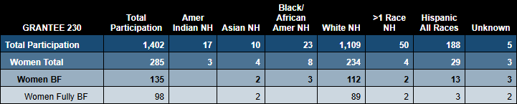
Columns: Total Participation, Amer Indian NH, Asian NH, Black/African-Amer NH, White NH, >1 Race NH, Hispanic All Races, Unknown.
Rows: Total Participation, Women Total, Women BF, Women Fully BF, Women Part. BF, Women Mostly-BF, Women Some-BF, Women Pregnant, Women Non-BF, Infants Total, Infants BF, Infants Part. BF, Infants Mostly-BF, Infants Some-BF, Infants Non-BF, Children Total.
Tab 3 – Agency
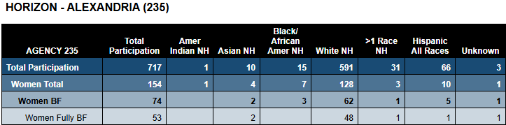
Grouped by: Agency name.
Columns: Total Participation, Amer Indian NH, Asian NH, Black/African-Amer NH, White NH, >1 Race NH, Hispanic All Races, Unknown.
Rows: Total Participation, Women Total, Women BF, Women Fully BF, Women Part. BF, Women Mostly-BF, Women Some-BF, Women Pregnant, Women Non-BF, Infants Total, Infants BF, Infants Part. BF, Infants Mostly-BF, Infants Some-BF, Infants Non-BF, Children Total.
Tab 4 – Clinic
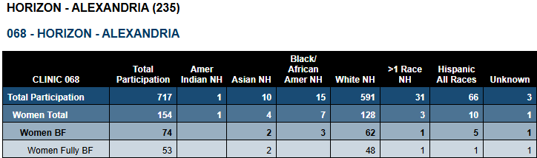
Grouped by: Agency name and clinic name.
Columns: Total Participation, Amer Indian NH, Asian NH, Black/African-Amer NH, White NH, >1 Race NH, Hispanic All Races, Unknown.
Rows: Total Participation, Women Total, Women BF, Women Fully BF, Women Part. BF, Women Mostly-BF, Women Some-BF, Women Pregnant, Women Non-BF, Infants Total, Infants BF, Infants Part. BF, Infants Mostly-BF, Infants Some-BF, Infants Non-BF, Children Total.

Monthly Participation by Zip Code of Residence and Race Ethnicity
Revised April 22, 2026

Overview
A count of participants by their current zip code of residence and race ethnicity for the specified participation month and specified grantee. Counts include total participation and are provided for the state, specified grantee, and its agencies and clinics.

Some uses
- Identify zip codes with predominant cultures to assist with services.
- Identify zip codes being served by a grantee, agency, or clinic.

Prompts
- Enter 3-digit Grantee ID: – The grantee the agency and clinic where the participant was issued benefits (or was counted) belongs to.
- Enter YYYYMM: – The year and month the participant was counted.

Report outputs
Tab 1 – State
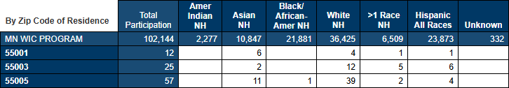
Columns: Total Participation, Amer Indian NH, Asian NH, Black/African-Amer NH, White NH, >1 Race NH, Hispanic All Races, Unknown.
Rows: MN WIC PROGRAM, zip codes of residence.
Tab 2 – Grantee
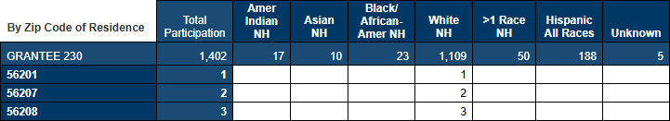
Columns: Total Participation, Amer Indian NH, Asian NH, Black/African-Amer NH, White NH, >1 Race NH, Hispanic All Races, Unknown.
Tab 3 – Agency
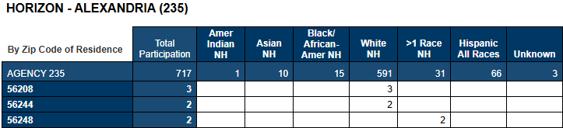
Grouped by: Agency name.
Columns: Total Participation, Amer Indian NH, Asian NH, Black/African-Amer NH, White NH, >1 Race NH, Hispanic All Races, Unknown.
Rows: AGENCY ID, zip codes of residence.
Tab 4 – Clinic
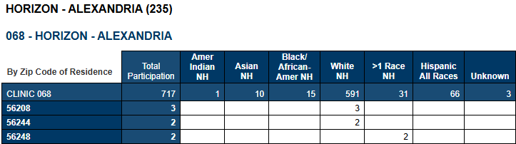
Grouped by: Agency name and clinic name.
Columns: Total Participation, Amer Indian NH, Asian NH, Black/African-Amer NH, White NH, >1 Race NH, Hispanic All Races, Unknown.
Rows: CLINIC ID, zip codes of residence.

Monthly Participation by Zip Code of Residence, WIC Category and BF Amount
Revised April 22, 2026

Overview
A count of participants by their current zip code of residence, WIC Category, and breastfeeding amount for the specified participation month and specified grantee. Counts include total participation and are provided for the state, specified grantee, and its agencies and clinics.

Some uses
- Identify trends in participation based on zip codes.
- Identify zip codes being served by a grantee, agency, or clinic.

Prompts
- Enter 3-digit Grantee ID: – The grantee the agency and clinic where the participant was issued benefits (or was counted) belongs to.
- Enter YYYYMM: – The year and month the participant was counted.

Report outputs
Tab 1 – State
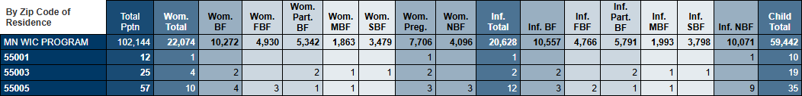
Columns: Total Pptn, Wom. Total, Wom. BF, Wom. Part. BF, Wom. MBF, Wom. SBF, Wom. Preg., Wom. NBF, Inf. Total, Inf. BF, Inf. FBF, Inf. Part. BF, Inf. MBF, Inf. SBF, Inf. NBF, Child Total.
Rows: MN WIC PROGRAM, zip code of residence.
Tab 2 – Grantee
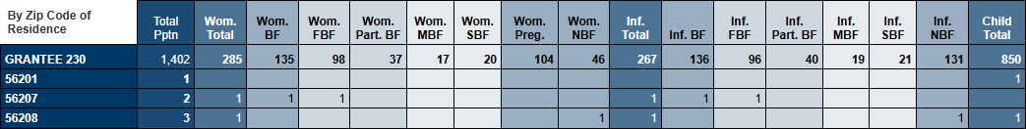
Columns: Total Pptn, Wom. Total, Wom. BF, Wom. Part. BF, Wom. MBF, Wom. SBF, Wom. Preg., Wom. NBF, Inf. Total, Inf. BF, Inf. FBF, Inf. Part. BF, Inf. MBF, Inf. SBF, Inf. NBF, Child Total.
Rows: GRANTEE ID, zip code of residence.
Tab 3 – Agency
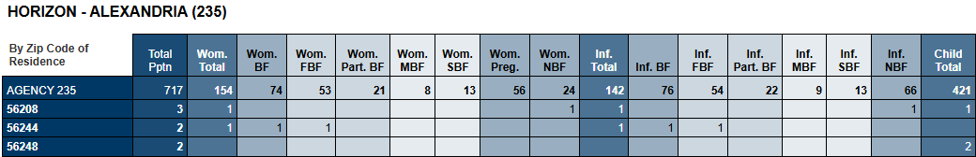
Grouped by: Agency name.
Columns: Total Pptn, Wom. Total, Wom. BF, Wom. Part. BF, Wom. MBF, Wom. SBF, Wom. Preg., Wom. NBF, Inf. Total, Inf. BF, Inf. FBF, Inf. Part. BF, Inf. MBF, Inf. SBF, Inf. NBF, Child Total.
Rows: AGENCY ID, zip code of residence.
Tab 4 – Clinic
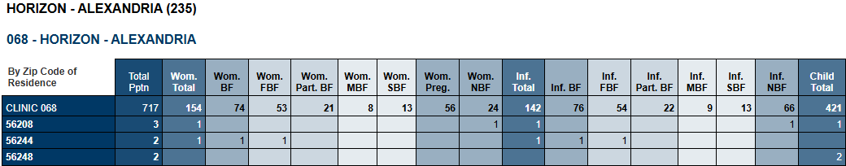
Grouped by: Agency name and clinic name.
Columns: Total Pptn, Wom. Total, Wom. BF, Wom. Part. BF, Wom. MBF, Wom. SBF, Wom. Preg., Wom. NBF, Inf. Total, Inf. BF, Inf. FBF, Inf. Part. BF, Inf. MBF, Inf. SBF, Inf. NBF, Child Total.
Rows: CLINIC ID, zip code of residence.

Year-to-Date Participation
Revised Oct. 27, 2026

Overview
Participation count by WIC category and breastfeeding amount for the State, specified Grantee, its agencies, and clinics for a specified Federal Fiscal Year (October-September). An additional tab, Agency by Clinic, provides the participation count for each clinic in the specified agency. The count is year-to-date if run for the current federal fiscal year.

Some uses
- Assist with monitoring and managing daily caseload for state, grantee, agency, or clinic.
- Obtain counts of participants by WIC Type and Breastfeeding Amount.

Prompts
- Enter 3-digit Grantee ID – grantee the agency and clinic where the participant was counted belongs to.
- Enter YYYY10 – October, the first month of the Federal Fiscal Year in which participants were counted.
- Enter Following Year YYYY09 – September, the last month of the Federal Fiscal Year in which participants were counted.

Report outputs
Tabs 1 – 4 (State, Grantee, Agency, Clinic) have the same output except the Agency and Clinic tabs have section headers.)
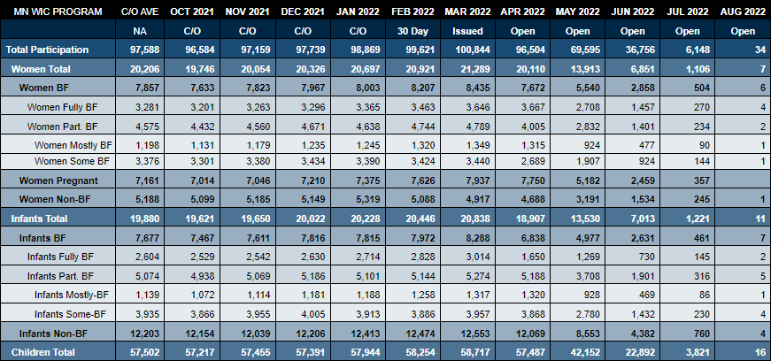
Columns: C/O AVE, MONTH YEAR
Rows: Total Participation, Women Total, Women BF, Women Fully BF, Women Part. BF, Women Mostly BF, Women Some BF, Women Pregnant, Women Non-BF, Infants Totals, Infants BF, Infants Fully BF, Infants Part. BF, Infants Mostly-BF, Infants Some-BF, Infants Non-BF, Children Total.
Tabs 5 – Agency by Clinic
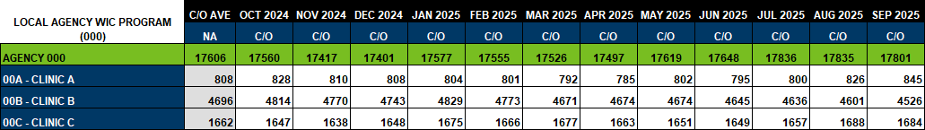
Columns: C/O AVE, MONTH YEAR
Rows: AGENCY ID, clinic names.

Year-to-Date Participation – Statewide by Agency
Created March 3, 2026

Overview
A participation count for all agencies by total participation, total women/infants/children, and amount breastfeeding for a specified Federal Fiscal Year (October-September).

Some uses
- Assist with monitoring agency counts.
- Obtain counts of participants by WIC Type and Breastfeeding Amount for each agency.

Prompts
- Enter YYYY10: (CLC-S) – October, the first month of the Federal Fiscal Year, in which participants were issued benefits. (NOTE: The (CLC-S) references the query where these PROMPTS are used.)
- Enter Following Year YYYY09: (CLC-S) – September, the last month of the Federal Fiscal Year, in which participants were issued benefits.
- Enter YYYY10: (FIS-S) – October, the first month of the Federal Fiscal Year, in which participants were issued benefits.
- Enter Following Year YYYY09: (FIS-S) – September, the last month of the Federal Fiscal Year, in which participants were issued benefits.

Report outputs
Tab 1 – Agency
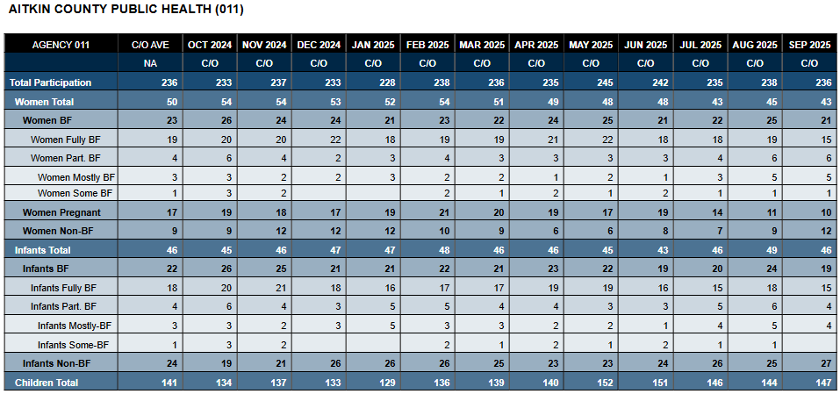
Columns: C/O AVE, MONTH YEAR
Rows: Total Participation, Women Total, Women BF, Women Fully BF, Women Part. BF, Women Mostly BF, Women Some BF, Women Pregnant, Women Non-BF, Infants Totals, Infants BF, Infants Fully BF, Infants Part. BF, Infants Mostly-BF, Infants Some-BF, Infants Non-BF, Children Total.

Demographics

Medical Clinics & Providers Lists
Created April 22, 2025
Overview
A list of all active and inactive medical clinics and medical providers entered into the Information System by the specified agency.

Some uses
Obtain a list of current medical clinics/providers.

Prompts
Agency ID – agency that entered the medical clinics and providers into the information system.

Report outputs
Tab 1 – Medical Clinics List
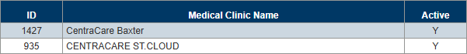
Columns: ID, Medical Clinic Name, Active.
Tab 2 – Medical Providers Lists
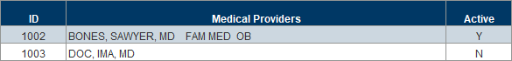
Columns: ID, Medical Providers, Active.

Food & Formula

Food and Formula by PFDTU
Revised May 7, 2026

Overview
Lists and counts of women, infants, and children who belong to the specified agencies and were issued the specified foods or formulas on benefits with a Printed First Date to Use (PFDTU) during the specified date range. The Infants, Children, and Women tabs provide a summed quantity (initial and if adjusted) for a participant’s benefits with the same PFDTU, indicates if the participant’s last income was adjunctive (SNAP, MFIP, MA, or MNCare), and displays the household language. The Count and Staff Count tabs group counts by food/formula item and WIC Type for each agency and issuing staff person, respectively. The Counts All and Staff Counts All tabs combine counts for all specified foods/formulas. Both Staff Counts tabs and the Staff List include all records without combining quantities. Input Controls on each tab allow the report user to filter the contents on that specific tab: Reference by Active; all list and count tabs by Quantity and Food/Formula; and Labels by Food/Formula.

Some uses
- Identify participants issued specific food or formula items for contact/outreach.
- Identify participants issued incorrect amounts of food/formula items when changes occur.
- Identify staff who may need more training or assistance with issuing correct food/formula items.

Prompts
- Agency ID(s) – agencies where the benefits were issued. Enter 0 to run for all agencies.
- Start Date – the first date in the date range during which the PFDTU falls.
- End Date – the last date in the date range during which the PFDTU falls.
- Food item ID(s) – the ID(s) associated with an issued food or formula item.

Report outputs
Tab 1 – Reference
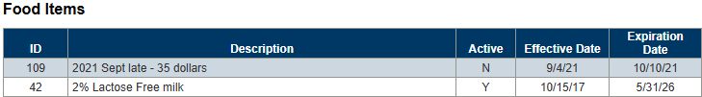
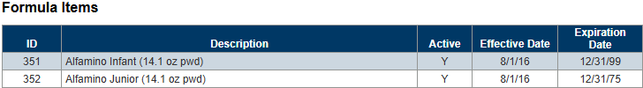
Columns: ID, Description, Active, Effective Date, Expiration Date.
Grouped by: Food Items and Formula Items.
Tab 2 - Infants
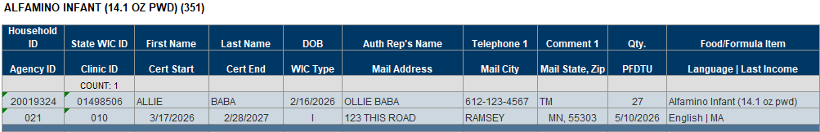
Columns: Household ID, State WIC ID, First Name, Last Name, DOB, Auth Rep’s Name, Telephone 1, Comment 1, Qty., Food/Formula Item, Agency ID, Clinic ID, Cert Start, Cert End, WIC Type, Mail Address, Mail City, Mail State, Zip, PFDTU, Language | Last Income.
Grouped by: Food/formula item description.
Tab 3 - Children
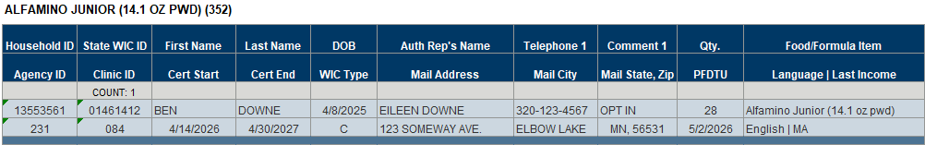
Columns: Household ID, State WIC ID, First Name, Last Name, DOB, Auth Rep’s Name, Telephone 1, Comment 1, Qty., Food/Formula Item, Agency ID, Clinic ID, Cert Start, Cert End, WIC Type, Mail Address, Mail City, Mail State, Zip, PFDTU, Language | Last Income.
Grouped by: Food/formula item description.
Tab 4 - Women
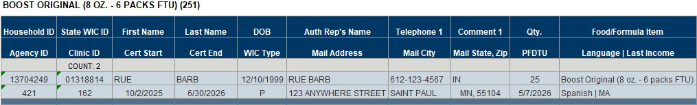
Columns: Household ID, State WIC ID, First Name, Last Name, DOB, Auth Rep’s Name, Telephone 1, Comment 1, Qty., Food/Formula Item, Agency ID, Clinic ID, Cert Start, Cert End, WIC Type, Mail Address, Mail City, Mail State, Zip, PFDTU, Language | Last Income.
Grouped by: Food/formula item description.
Tab 5 – Labels
Columns: Food/Formula ID, Agency ID, Clinic ID, First Name, Last Name, Auth Rep First Name, Auth Rep Last Name, Mail Address, Mail City, Mail State, Mail Zip Code.
Tab 6 – Count-by Item
Columns: TOTAL, WIC Type.
Rows: MN WIC PROGRAM TOTAL (if 0 entered into prompt) or TOTAL, Agency name and ID
Grouped by: Food/formula item description.
Tab 7 – Count-All Items
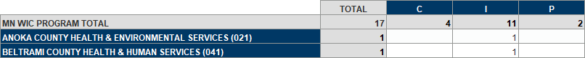
Columns: TOTAL, WIC Type.
Rows: MN WIC PROGRAM TOTAL (if 0 entered into prompt) or TOTAL, Agency name and ID
Tab 8 – Staff Count-by Item
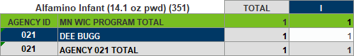
Columns: TOTAL, WIC Type.
Rows: MN WIC PROGRAM TOTAL (if 0 entered into prompt) or TOTAL, agency ID + staff name, agency ID + AGENCY ID TOTAL.
Grouped by: Food/formula item description.
Tab 9 – Staff Count-All Items
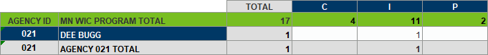
Columns: TOTAL, WIC Type.
Rows: MN WIC PROGRAM TOTAL (if 0 entered into prompt) or TOTAL, agency ID + staff name, agency ID + AGENCY ID TOTAL.
Tab 10 – Staff List
Columns: Agency ID, Staff Issued Benefits, Household ID, State WIC ID, WIC Type, Issued Date, PFDTU, Qty., ID, Food/Formula Item.

Medical Formulas & Staff Who Created Rx
Revised Sept 16, 2025

Overview
A list of participants issued medical formula by the specified agency for the specified participation month. Also provides a detailed list of each participant’s prescriptions, including the staff who created them, and a total count by clinic.

Some uses
Identify staff who are creating special formula prescriptions.

Prompts
- Agency ID – agency where the benefits were issued.
- Participation Month – the month and year for which the benefits were issued.

Report outputs
Tab 1 – Participant List
Columns: Household ID, State WIC ID, DOB (date of birth), WIC Type, Cert Date, Last LDTU, Benefit Dates, Special Formula Issued, Clinic ID.
Counts: Participants.
Grouped by: Clinic ID (where benefits were issued).
Tab 2 – Details
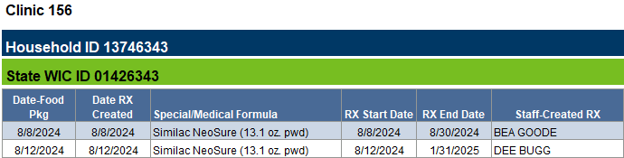
Columns: Date-Food Pkg (package), Date RX Created, Special/Medical Formula, RX Start Date, RX End Date, Staff-Created Rx.
Grouped by: Clinic ID, Household ID, State WIC ID.
Tab 3 – Staff
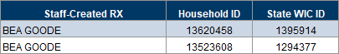
Columns: Staff-Created Rx, Household ID, State WIC ID.

Medical Formula by RX End Date
Revised June 6, 2025

Overview
A list of participants who belong to the specified agency and have a food prescription for a medial formula that ends during the specified time period. In order for participants to be included in the report output, they must have been issued the medical formula on their last set of benefits. An OPTIONAL input control allows the report user to filter the report by the clinic where the participant belongs.

Some uses
Identify participants whose medical formula prescription is ending for outreach (inform participants they will need a new prescription to receive the same formula the next time benefits are issued).

Prompts
- Agency ID – agency where the participants currently belong.
- Start Date – the first date in the time period during which the medical formula prescription expires.
- End Date – the last date in the time period during which the medical formula prescription expires.

Report outputs
Tab 1 – List
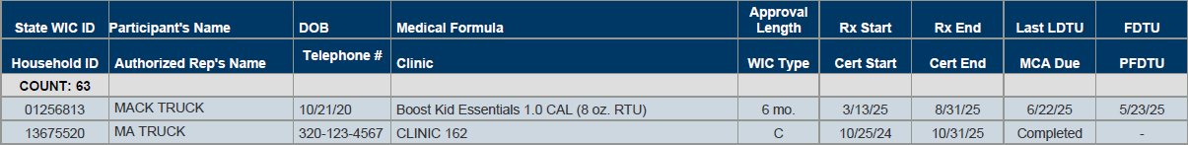
Columns: Row 1 – State WIC ID, Participant’s Name, DOB (date of birth), Medical Formula, Approval Length, Rx Start, Rx End, Last LDTU, FDTU. Row 2 – Household ID, Authorized Rep’s Name, Telephone #, Clinic, WIC Type, Cert Date, Cert End, MCA Due, PFDTU.
Counts: Participants.
Tab 2 – Simple List
Columns: State WIC ID, Participant’s Name, DOB (date of birth), Medical Formula, Approval Length, Rx Start, Rx End, FDTU, Last LDTU.
Counts: Participants.

Height/Weight/Blood

Hemoglobin Measurements
Revised June 2, 2025

Overview
A list of participants who belong to the specified agency and had a hemoglobin measurement during the specified dates. The report output includes the measurement date, whether a referral date was entered, the staff person who performed the hemoglobin test, and whether it was performed during an MCA. The counts tab provides a total count of participants with hemoglobin measurements, total count and percentage of low measurements (based on assignment of risk factor 201), total within normal limits (WNL), total performed at an MCA, unduplicated number of participants with measurements, and an unduplicated number of participants with measurement at MCA.

Some uses
- Obtain a general number of cuvettes used.
- Obtain the number of hemoglobin measurements performed at a clinic.
- Obtain the number of participants with hemoglobin measurements performed at a clinic or during an MCA.
- Identify staff who performed hemoglobin measurements (for chart audits, etc.).

Prompts
- Agency ID – agency where the participant currently belongs.
- Start Date – the first date in the time period during which a hemoglobin measurement was entered, a risk factor record was created, an MCA or cert was completed, or a pseudo-cert was created.
- End Date – the last date in the time period during which a hemoglobin measurement was entered, a risk factor record was created, an MCA or cert was completed, or a pseudo-cert was created.

Report outputs
Tab 1 – Participant List
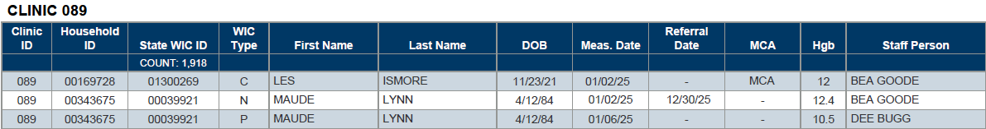
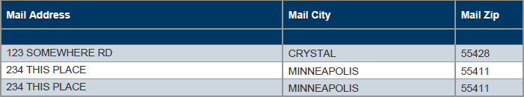
Columns: Clinic ID, Household ID, State WIC ID, WIC Type, First Name, Last Name, DOB (date of birth), Meas. (measurement) Date, Referral Date, MCA, Hgb (hemoglobin), Staff Person.
Counts: Participants.
Grouped by: Clinic ID.
Tab 2 – Counts
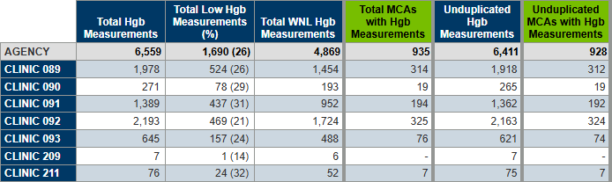
Columns: Total Hgb Measurements, Total Low Hgb Measurements (%), Total WNL (within normal limits) Hgb Measurements, Total MCAs with Hgb Measurements, Unduplicated Hgb Measurements, Unduplicated MCAs with Hgb Measurements.
Rows: AGENCY, CLINIC ID.

Low Hemoglobin
Revised March 6, 2025

Overview
A list of participants, based on their WIC Type at the time of measurement, who belong to the specified agencies and have had a hemoglobin measurement taken during the specified dates that is less than or equal to the specified hemoglobin value.
The report output includes three different lists: 1) A list and count of all participants with a low hemoglobin; 2) A list of all hemoglobin records for those participants; and 3) A list of the most recent hemoglobin measurements that have occurred since the Start Date entered into the prompt.

Some uses
- Identify participants with low hemoglobin for chart audits or follow-up.
- Review all hemoglobin records to determine impact of WIC intervention.

Prompts
- Agency ID(s) – agency where the participants currently belong.
- Hemoglobin – the upper limit for the hemoglobin value.
- Start Date – the first date in the time period during which the participants have a low hemoglobin measurement or all measurements on or after this date.
- End Date – the last date in the time period during which the participants have a low hemoglobin measurement.
- WIC Type(s) – the WIC type at the time of the hemoglobin measurement.

Report output
Tab 1 – Low Hgb
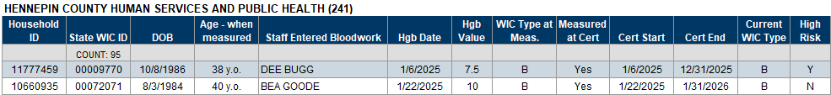
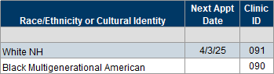
Columns: Household ID, State WIC ID, DOB (date of birth), Age – when measured, Staff Entered Bloodwork, Hgb (hemoglobin) date, Hgb value, WIC Type at Meas. (measurement), Measured at Cert, Cert Start, Cert End, Current WIC Type, High Risk, Race/Ethnicity or Cultural Identity, Next Appt Date, Clinic ID,
Counts: Participants.
Grouped by: Agency ID.
Tab 2 – All Hgb Records
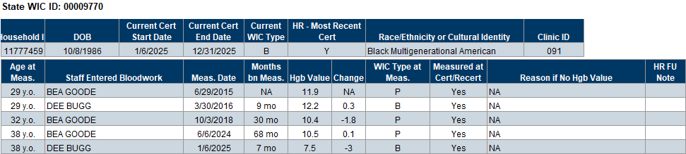
Columns: Table 1 – Household ID, DOB (date of birth), Current Start Date, Current Cert End Date, Current WIC Type, HR (high risk) – Most Recent Cert, Race/Ethnicity or Cultural Identity, Clinic ID. Table 2 – Age at Meas. (measurement), Staff Entered Bloodwork, Meas. Date, Months bn Meas., Hgb Value, Change, WIC Type at Meas., Measured at Cert/Recert, Reason if No Hgb Value, HR Fu Note.
Grouped by: State WIC ID.
Tab 3 – Recent Hgb Records
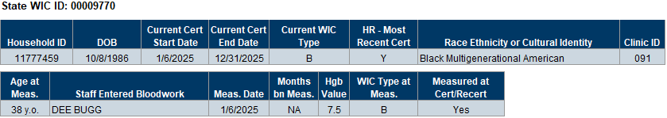
Columns: Table 1 – Household ID, DOB, Current Cert Start Date, Current Cert End Date, Current WIC Type, HR – Most Recent Cert, Race/Ethnicity or Cultura Identity, Clinic ID. Table 2 – Age at Meas., Staff Entered Bloodwork, Meas. Date, Months bn Meas., Hgb Value, WIC Type at Meas., Measured at Cert/Recert.
Grouped by: State WIC ID.

High Risk

High Risk at Certs & MCAs by Staff
Revised Jan. 28, 2025

Overview
A list and count by certifier, based on the specified agencies during the specified time period, of participants assigned high risk at their certification or Mid-Certification Assessment (MCA).

Some uses
- Monitoring high-risk participants’ INCPs and follow-up.
- Identify staff who may require more education re: following correct procedures and documentation for high-risk participants.

Prompts
- Agency ID(s) – agency where the participant was certified or the MCA was performed.
- Start Date – the first date in the time period during which participants were certified or the MCA was performed, and high risk was assigned.
- End Date – the last date in the time period during which participants were certified or the MCA was performed, and high risk was assigned.

Report outputs
Tab 1 – Certs
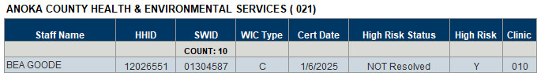
Columns: Staff Name, HHID (household ID), SWID (state WIC ID), WIC Type, Cert Date, High Risk Status, High Risk, Clinic.
Tab 2 – MCAs
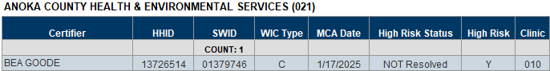
Columns: Certifier, HHID (household ID), SWID (state WIC ID), WIC Type, MCA Date, High Risk Status, High Risk, Clinic.

High Risk Certs and MCAs with and without Follow-up Documented within 30-120 Days
Revised Sept. 17, 2026

Overview
Four lists and a cross-tab count of high-risk participants with and without a specific documented follow-up (Additional Education, High Risk: Follow-up, SOAP, and SOAP Follow-up notes) within 30-120 days of their certification or Mid-certification Assessment (MCA). The participants belong to the specified agencies and were certified or had an MCA completed during the specified dates. Participants are only included in the output if they’ve been issued subsequent benefits within 30-120 days after their cert or MCA. All lists include a distinct count of participants and households. The cross-tab count provides agency and clinic total counts and percentages. The agency totals also break down the follow-up documentation into categories based on the number of days between the contact and the follow-up (0-45, 46-90, and 91-120 days). An optional input control allows you to filter all tabs by the type of follow-up note. (Previous title: HIGH RISK & FOLLOW-UP NOTE.)

Some uses
- Audit whether high risk follow-up documentation has been completed for high-risk participants who have subsequently returned for services.
- Identify staff who have written high risk follow-up notes in order to audit documentation.
- Ascertain the percentage of follow-up visits (based on when the note was written) occurring between 0-45, 46-90 and 91-120 days from the cert/MCA.

Prompts
- Agency ID(s) – agency where the participant was certified or the MCA was performed. Can enter 0 for all.
- Start Date – the first date in the date range during which participants were certified or the MCA was completed.
- End Date – the last date in the date range during which participants were certified or the MCA was completed.

Report outputs
Tab 1 – Cert Note
Page 1
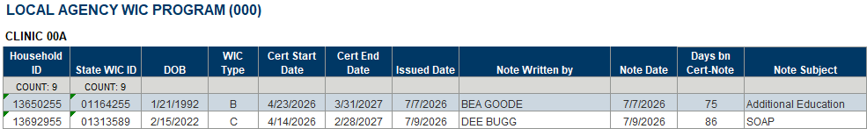
Columns: Household ID, State WIC ID, DOB, WIC Type, Cert Start Date, Cert End Date, Issued Date, Note Written by, Note Date, Days bn Cert-Note, Note Subject.
Page 2
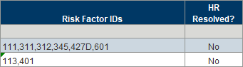
Columns: Risk Factor IDs, HR Resolved?
Counts: Household and participant.
Grouped by: Agency name and clinic ID.
Tab 2 – Cert No Note
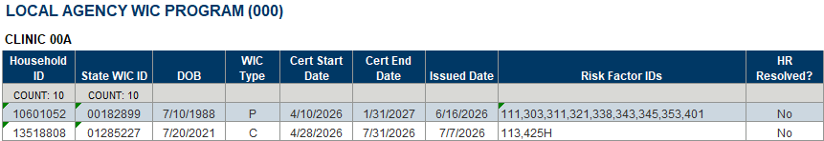
Columns: Household ID, State WIC ID, DOB, WIC Type, Cert Start Date, Cert End Date, Issued Date, Risk Factor IDs, HR Resolved?
Counts: Household and participant.
Grouped by: Agency name and clinic ID.
Tab 3 – MCA Note
Page 1
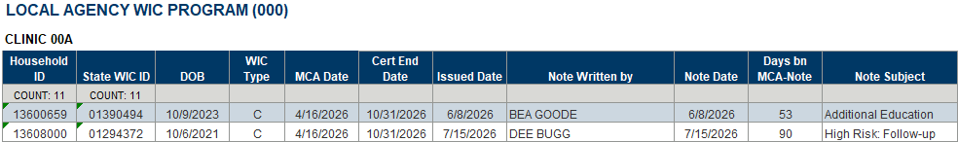
Columns: Household ID, State WIC ID, DOB, WIC Type, MCA Date, Cert End Date, Issued Date, Note Written by, Note Date, Days bn MCA-Note, Note Subject.
Page 2
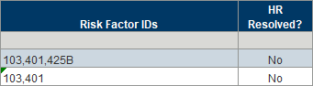
Columns: Risk Factor IDs, HR Resolved?
Counts: Household and participant.
Grouped by: Agency name and clinic ID.
Tab 4 – MCA No Note
Columns: Household ID, State WIC ID, DOB, WIC Type, Cert Start Date, Cert End Date, Issued Date, Risk Factor IDs, HR Resolved?
Counts: Household and participant.
Grouped by: Agency name and clinic ID.
Tab 5 – Counts
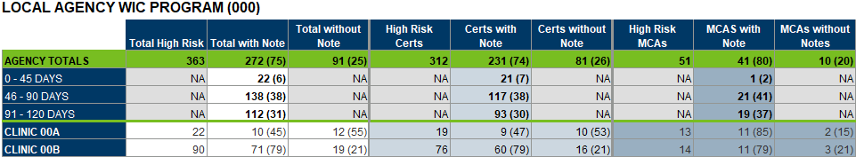
Columns: Total High Risk, Total with Note, Total without Note, High Risk Certs, Certs with Note, Certs without Note, High Risk MCAs, MCAs with Note, MCAs without Note.
Rows: AGENCY TOTALS, 0 – 45 DAYS, 46 – 90 DAYS, 91 – 120 DAYS, CLINIC <ID>

High Risk Contacts without Specified Note(s)
Created July 1, 2025
Overview
Provides a list and count of high-risk participants who have had a contact at the specified agency during the specified dates and haven’t had the specified type of note(s) written. Contacts include new certs, recerts, VOCs, Mid-certification Assessments (MCA) and Nutrition Education Contacts (NEC). Notes can be written within 8 days of the contact for certs, recerts, VOCs, and MCAs or between the specified dates for NECs. The Reference tab provides the Note Subject IDs necessary to identify the type of note(s).

Some uses
- Assess documentation for high-risk participants.
- Identify staff who may need more training.

Prompts
- Agency ID (where contact occurred)
- Start Date (first date in time period during which contact occurred)
- End Date (last date in time period during which contact occurred)

Report outputs:
Tab 1 – Reference
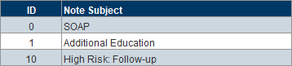
Columns: ID, Note Subject.
Tab 2 – Participant List
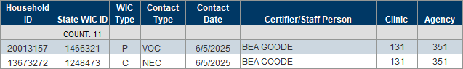
Columns: Household ID, State WIC ID, WIC Type, Contact Type, Contact Date, Certifier/Staff Person, Clinic, Agency.
Counts: Participants.
Tab 3 – Counts
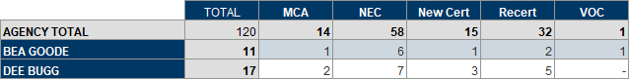
Columns: TOTAL, MCA, NEC, New Cert, Recert, VOC.
Rows: AGENCY TOTAL, staff person.

High Risk Participants Due for Additional Education Contact with Optional Local Use Answer
Revised March 5, 2025

Overview
List of high-risk participants who currently belong to the specified agency and are due for an additional education contact based on their last Last Date to Use (LDTU) falling within the specified dates. Participants are excluded from the output if they’ve had a High Risk or High-Risk Follow-up Note documented since their most recent certification. The report output also displays selected answers to a local use question (agencies do not have to use local use questions to use this report).
Do you want answers to a local use question to display?
- YES - If you want answers to a local use question to display, you will need to enter the Answer IDs. To do this, enter the Agency ID into the prompt, leaving the rest of the prompts as-is, and run the report. Refer to the Reference-Answer IDs tab for the Answer IDs. All Answer IDs must be 4 digits and entered as they are listed in this tab (with preceding 0s).
- NO - If you do not want answers to a local use question to display, the “Enter Answer ID(s)” prompt is still required. Enter 9999999 (7 nines) into the prompt. This will meet the prompt requirement and ensure no answers are pulled into your output.

Some uses
Identify high risk participants due for an additional education contact.

Prompts
- Agency ID – agency where the participant currently belongs.
- Start Date – the first date in the time period during which the last LDTU falls.
- End Date – the last date in the time period during which the last LDTU falls.
- Answer ID(s) – the codes associated with specific answers to a local use question. 9999999 is the code if not using local use questions.

Report outputs
Tab 1 – Reference-Answer IDs
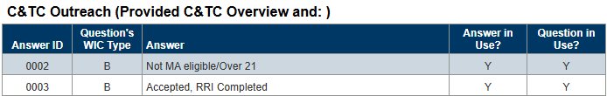
Columns: Answer ID, Question’s WIC Type, Answer, Answer in Use?, Question in Use?
Grouped by: Local use question.
Tab 2 – High Risk
Columns: Household ID, State WIC ID, Telephone #, Last Set LDTU, Cert End Date, Local Use Answer.

Income

Income and Adjunctive Eligibility
Revised August 10, 2026

Overview
A list of currently certified participants who belong to the specified agencies with either itemized income entered and/or adjunctive programs selected for the most recent income record entered between 21 days before and 14 days after their most recent certification. The output also includes a statewide count and count by agency by each type of adjunctive program and infants, children, children by age (12-23 months, 24-25, 36-47, and 48-60), pregnant, postpartum breastfeeding, and postpartum non-breastfeeding women. Totals are provided for infants and children (combined) and women. The last output is a statewide count by agency of currently certified participants, those certified with income records, and those certified with adjunctive records. A percentage of the total is also provided. The default is to run the report for all agencies. Three optional input controls allow you to filter the outputs by WIC Type, Adjunctive Programs, and agencies. (This report was previously titled CURRENTLY CERTIFIED & ADJUNCTIVE PROGRAMS.)

Some uses
- Obtain a count of currently certified participants.
- Determine income vs. adjunctive eligibility for currently certified participants.
- Identify types of income proof used.
- Provide an overview of the types of adjunctive programs most commonly used to determine eligibility.
- Provide a general idea of participation in adjunctive programs.

Prompts
- Agency ID(s) or enter 0 for ALL – agency where the participant currently belongs.

Report outputs
Tab 1 – Adjunctive List
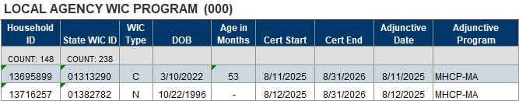
Columns: Household ID, State WIC ID, WIC Type, DOB, Age in Months, Cert Start, Cert End, Adjunctive Date, Adjunctive Program.
Grouped by: Agency name.
Tab 2 – Income List
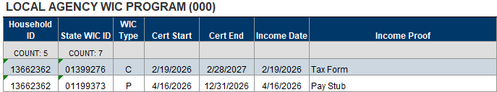
Columns: Household ID, State WIC ID, WIC Type, Cert Start, Cert End, Income Date, Income Proof.
Grouped by: Agency name.
Tab 3 – Adjunctive Count
Page 1
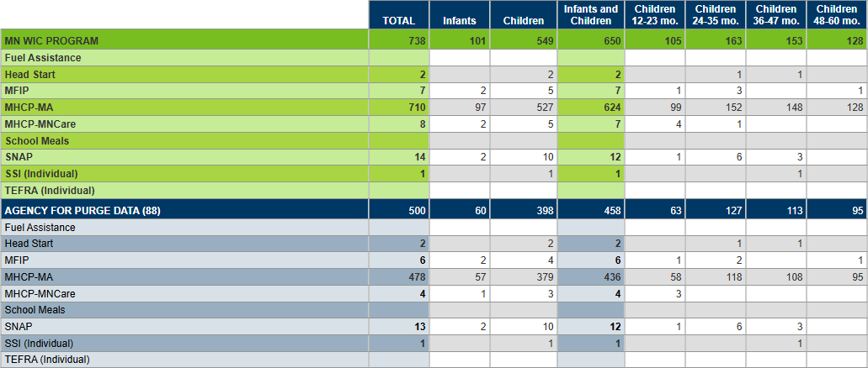
Page 2
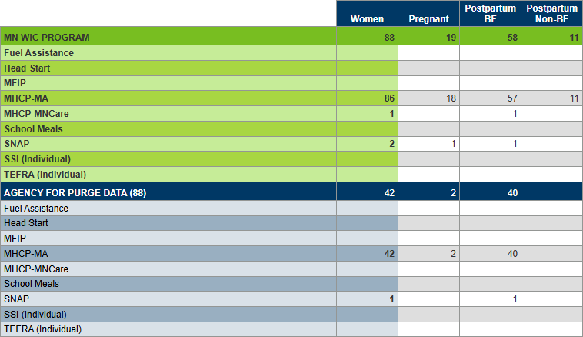
Columns: TOTAL, Infants, Children, Infants and Children, Children 12-23 mo., Children 24-35 mo, Children 36-47 mo., Children 48-60 mo., Women, Pregnant, Postpartum BF, Postpartum Non-BF.
Rows: MN WIC PROGRAM, Agency name (ID), Fuel Assistance, Head Start, MFIP, MHCP-MA, MHCP-MNCare, School Meals, SNAP, SSI (Individual), TEFRA (Individual).
Tab 4 – Statewide Count
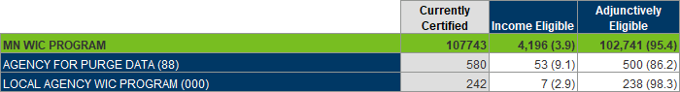
Columns: Currently Certified, Income Eligible, Adjunctively Eligible.
Rows: MN WIC PROGRAM, Agency name (ID).

Pending Proof Not Toggled On
Revised July 23, 2026

Overview
A list and count of participants that belong to the specified agencies with a last set’s Last Date to Use (LDTU) during the specified date range whose most recent income record (itemized or adjunctive) does not have the Pending Proof toggled on but has one of the following proofs selected:
- Itemized Income: Other-Write Note or **PENDING PROOF**
- Adjunctive Income: Pending Proof – 30 Day
The default is to run the report for all agencies. An optional input control allows you to filter all outputs by agency and proofs.

Some uses
- Identify pending income records missing the Pending Proof flag, which is used by the system to limit benefit issuance to one set (per policy requirements) until the pending income record is resolved.
- Identify specific staff or agencies that may require more training on how to indicate an income record is pending.
- Identify participants who are still pending income proof and have a last set’s LDTU that may indicate benefits have been incorrectly issued.

Prompts
- Agency ID(s) or enter 0 for ALL – agency where the participant currently belongs.
- Start Date – the first date in the date range during which the participant was most recently certified.
- End Date – the last date in the date range during which the participant was most recently certified.

Report outputs
Tab 1 – List
Columns: Household ID, State WIC ID, WIC Type, Cert Start Date, Last Set’s LDTU, Income Type, Income Date, Staff Entered Income, Proof, Pending Proof, Clinic ID, Agency ID.
Grouped by: Agency name.
Tab 2 – Count
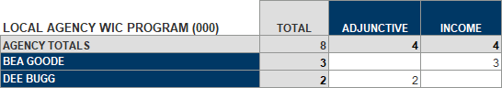
Columns: TOTAL, ADJUNCTIVE, INCOME.
Rows: AGENCY TOTALS, Staff (entered Income).
Tab 3 – Statewide Count
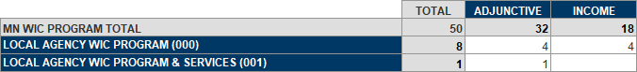
Columns: TOTAL, ADJUNCTIVE, INCOME.
Rows: MN WIC PROGRAM TOTAL, Agency Name (ID)

Presumptive Eligibility
Revised July 30, 2026

Overview
A list and statewide count of participants who belong to the specified agencies and had “Presumptive Eligibility – 90 days” selected for an income record entered during the specified date range. The default is to run the report for all agencies. An optional input control allows you to filter the List tab by agency and proofs.

Some uses
- Identify presumptively eligible participants for outreach or audit.
- Obtain a count of presumptively eligible participants statewide or per agency.

Prompts
- Agency ID(s) or enter 0 for ALL – agency where the participants currently belong.
- Start Date – the first date in the time period during which PE – 90 days was selected.
- End Date – the last date in the time period during which PE – 90 days was selected.

Report outputs
Tab 1 – List
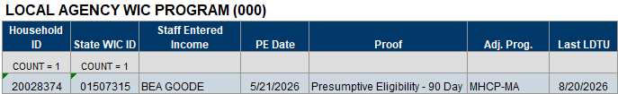
Columns: Household ID, State WIC ID, Staff Entered Income, PE Date, Proof, Adj. Prog., Last LDTU.
Counts: Households and participants.
Grouped by: Agency ID.
Tab 2- Statewide Count
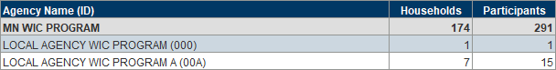
Columns: Agency Name and ID, Participants, Households.
Rows: STATEWIDE TOTAL, AGENCY NAME (ID).

Proof of Income
Revised July 29, 2026

Overview
A list of participants certified at the specified agencies during the specified date range who had an income record created between 21 days before and 14 days after the certification with the specified proofs of income. A reference tab provides proof of income IDs and their descriptions. The default is to run the report for all agencies. An optional input control allows you to filter the list by agency.
NOTE! This report uses the Completed Web User ID, a new field identifying the certifier in WINNIE, and will not pull data prior to your agency’s WINNIE roll-out (Oct. 2024 – April 2025).

Some uses
- Identify participants with specific types of income proof in order to ensure appropriate documentation is being completed.

Prompts
- Agency ID(s) or enter 0 for ALL – agency where the participant was certified.
- Start Date – the first date in the date range during which the participant was certified.
- End Date – the last date in the date range during which the participant was certified.

Report outputs
Tab 1 – Reference
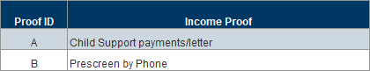
Columns: Proof ID, Income Proof
Tab 2 – List 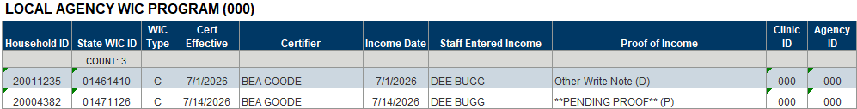
Columns: Household ID, State WIC ID, WIC Type, Cert Effective, Certifier, Income Date, Staff Entered Income, Proof of Income, Clinic ID, Agency ID.
Grouped by: Agency name.

Initial Contacts

Incomplete Initial Contacts
Revised Oct 22, 2024

Overview
Provides a list and count of participants certified at the specified agency during the specified dates who have an Initial Contact (IC) record that has not been completed based on both the First Appointment Offered Date and the Comments field being blank (excluding those with Initial Contacts due to VOCs). Tab 2 includes a total count of incomplete ICs by staff. The report output also includes a total count by staff.
NOTE: This report does not assess whether the Initial Contact was required for the participant; only that an Initial Contact was created and not completed.

Some uses
- Identify participants for whom an Initial Contact was created but never completed.
- Identify staff who may need additional training in how to complete an Initial Contact correctly.

Prompts
- Agency ID – agency where the participants were certified.
- Start Date – the first date in the time period during which participants were certified.
- End Date – the last date in the time period during which participants were certified.

Report outputs
Tab 1 – Incomplete ICs
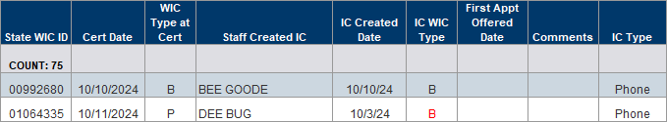
Columns: State WIC ID, Cert Date, WIC Type at Cert, Staff Created IC (initial contact), IC Created Date, IC WIC Type, First Appt Offered Date, Comments, IC Type.
Counts: Particpants.
Tab 2 – Counts by Staff
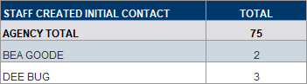
Columns: TOTAL.
Rows: AGENCY TOTAL, staff names.

Initial Contact Requirements Not Met
Revised Sept. 10, 2026

Overview
Two lists of participants, pregnant and others, who were certified at the specified agency during the specified dates and do not have an initial contact record associated with the certification, even though an initial contact was required. For both lists, the most recent appointment on or before the cert, when it was created, and who created it display in the output. They also include a distinct count of participants and of participants without appointments. The Counts tab is a vertical table by staff that scheduled an appointment. It counts the pregnant and other participants who did not have the required initial contact and provides a total. The table also has an agency total including the total number of certs and the percentage of missed required initial contacts for the agency. All outputs are grouped by agency name.

Some uses
- Monitor whether initial contacts are being created for participants that require initial contacts.
- Identify staff creating appointments and not creating the required initial contact who may require more guidance or training.

Prompts
- Agency ID – agency where the certification was performed.
- Start Date – the first date in the date range during which participants were certified.
- End Date – the last date in the date range during which participants were certified.

Report outputs
Tab 1 – Pregnant
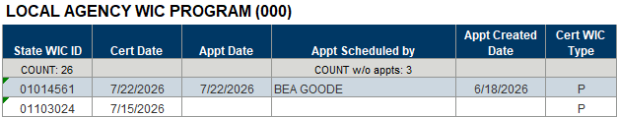
Columns: State WIC ID, Cert Start Date, Appt Date, Appt Scheduled by, Appt Created Date, WIC Type at Cert.
Counts: Participants and participants without appointments
Grouped by: Agency name
Tab 2 – Others
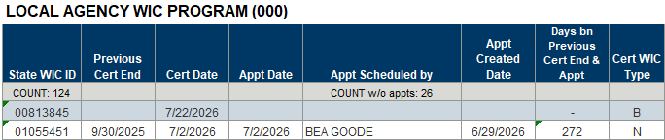
Columns: State WIC ID, Previous Cert End, Cert Date, Appt Date, Appt Scheduled by, Appt Created Date, Days bn Previous Cert End & Appt Created, Cert WIC Type.
Counts: Participants and participants without appointments.
Grouped by: Agency name.
Tab 3 – Counts
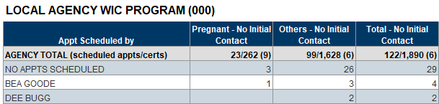
Columns: Appt Scheduled by, Pregnant – No Initial Contact, Others – No Initial Contact, Total – No Initial Contact.
Rows: AGENCY TOTAL (scheduled appts/certs), NO APPTS SCHEDULED, staff schedule appt.
Grouped by: Agency name.

Initial Contacts
Revised Sept. 9, 2026

Overview
A list of participants who belong to the specified agency and had an Initial Contact created during the specified dates. The output includes the names of the staff who created and modified the initial contact. The list includes a distinct count of participants and households. Optional input controls allow you to filter the list by the clinic name and WIC type.

Some uses
- Identify agencies and/or clinics that may require more appointments or staff if not meeting processing standards.
- Identify staff who may require more training on how to complete initial contacts.

Prompts
- Agency ID – agency where the participants currently belong.
- Start Date – the first date during which the initial contact occurred.
- End Date – the last date during which the initial contact occurred.

Report output
Tab 1 – List
Page 1
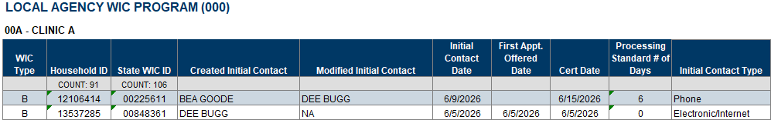
Page 2
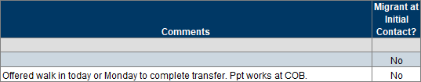
Columns: WIC Type, Household ID, State WIC ID, Contact Created by Staff Name, Contact Modified by Staff Name, Initial Contact Date, First Appt Offered Date, Cert Date, Processing Standard # of Days, Initial Contact Type, Comments, Migrant at Initial Contact?
Counts: Participants and households.

Local Use Questions

Due for Additional Education Contact with Local Use Answer
Revised Feb. 3, 2025
Overview
A list of participants who currently belong to the specified agency, whose Last Date to Use (LDTU) occurs during the specified time period, and who have specified answers to a Local Use Question. The output also provides household labels. The intent is to identify households that may be eligible for alternative forms of nutrition education.
The report output displays selected answers to a local use question based on the Answer IDs entered into the “Enter Answer ID(s)” prompt. Participants will only display in the output if a specified answer is selected. To obtain a list of your agency’s Answer IDs, enter the Agency ID into the prompt, leaving the rest of the prompts as-is, and run the report. Refer to the Reference-Answer IDs tab for the Answer IDs.

Some uses
Identify households and participants, with a specified answer for a local use question, that may be eligible to receive alternate forms of additional nutrition education.

Prompts
- Agency ID – where the participants currently belong.
- Start Date – first date in time period during which the participant’s last LDTU falls.
- End Date – last date in time period during which the participant’s last LDTU falls.
- Answer ID(s) – the codes associated with specific answers to a local use question.

Report outputs
Tab 1 – Reference-Answer IDs
Columns: Answer ID, Question’s WIC Type, Answer, Answer in Use?
Grouped by: Local use question.
Tab 2 – List
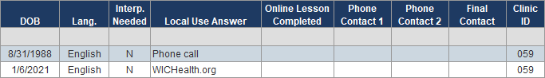
Columns: Household ID, State WIC ID, Last Set’s LDTU, High Risk, Participant’s Name, Authorized Rep’s Name, Telephone #, MCA Due Date, Cert Start Date, Cert End Date, Next Appt, WIC Type, DOB, Language, Interpreter Needed, Local Use Answer, Online Lesson Completed, Phone Contact 1, Phone Contact 2, Email Contact, Clinic ID.
Counts: Households and participants.
Tab 3 – Household Labels
Columns: Clinic ID, Household ID, Authorized Rep’s Name, Mailing Address, City, State, Zip Code.

Household List with Local Use Answers Selected during Same Time Period as Cert or MCA
Revised Dec. 3, 2024

Overview
A list of households with at least one member who currently belongs to the specified agency and has been certified or had a Mid-certification Assessment (MCA) completed and has a specified answer selected during the specified time period.
This provides a list of households with updated, or new answers, instead of all households with a selected answer.
The report output displays selected answers to a local use question based on the Answer IDs entered into the “Enter Answer ID(s)” prompt. Participants will only display in the output if a specified answer is selected. To obtain a list of your agency’s Answer IDs, enter the Agency ID into the prompt, leaving the rest of the prompts as-is, and run the report. Refer to the Reference-Answer IDs tab for the Answer IDs.

Some uses
Obtain a list of households with updated or new answers for a local use question that were selected during the same time period specified for completed certs or MCAs.

Prompts
- Agency ID – where the participants currently belong.
- Start Date – first date in time period during which participants were certified, had an MCA completed, and had an answer selected for a local use question.
- End Date – last date in time period during which participants were certified, had an MCA completed, and had an answer selected for a local use question.
- Answer ID(s) – the codes associated with specific answers to a local use question
- WIC Type(s) – the WIC type at the time the participants were certified.

Report outputs
Tab 1 – Reference-Answer IDs
Columns: Answer ID, Question’s WIC Type, Answer, Answer in Use?, Question in Use?
Grouped by: Local use question.
Tab 2 – Household List
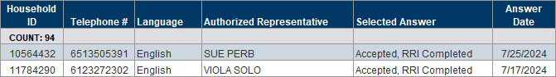
Columns: Household ID, Telephone #, Language, Authorized Representative, Selected Answer, Answer Date.
Counts: Participants.

Notes

No Note Written for Participants Issued Benefits
Revised Nov. 5, 2024

Overview
A list and count of participants issued benefits at the specified agency during the specified time period who have not had a note written within 8 days of the issuance.

Some uses
Audit/monitor staff to ensure notes are written with each contact where benefits are issued if required by agency.

Prompts
- Agency ID – agency where the participants were issued benefits.
- State Date – the first date in the time period during which the participants were issued benefits.
- End Date – the last date in the time period during which the participants were issued benefits.

Report outputs
Tab 1 – List
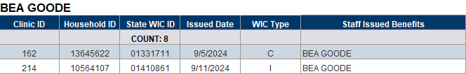
Columns: Clinic ID, Household ID, State WIC ID, Issued Date, WIC Type, Staff Issued Benefits.
Counts: Participants.
Grouped by: Staff name.
Tab 2 – Count
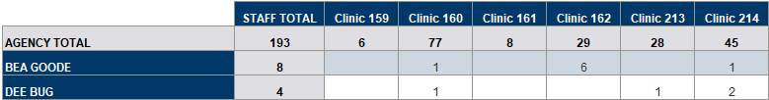
Columns: STAFF TOTAL, Clinic IDs.
Rows: AGENCY TOTAL, staff name.

Notes and Documentation
Revised June 3, 2026

Overview
A list and count of participants who belong to the specified agencies and have notes written for the specified note subject during the specified time period. The output includes the note text. The count is grouped by agency and by staff who wrote the note and note subject(s). An optional input control allows the report user to filter Tab 1 – Reference by whether the note subjects are active and Tab 2 – List by staff who created the notes.

Some uses
Identify participants with specific notes and easily review the note text.

Prompts
- Agency ID(s) – agencies where the participants currently belong.
- Note Subject ID(s) – the unique ID associated with a specific note subject.
- State Date – the first date in the time period during which a note was created.
- End Date – the last date in the time period during which a note was created.

Report outputs
Tab 1 – Reference
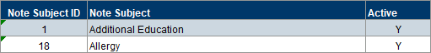
Columns: Note Subject ID, Note Subject, Active.
Tab 2 – List
Page 1
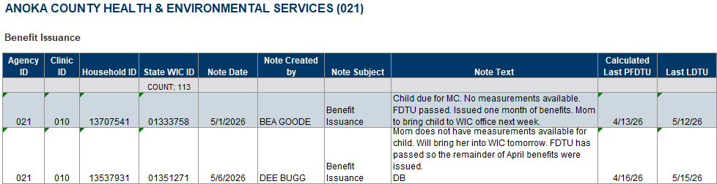
Page 2
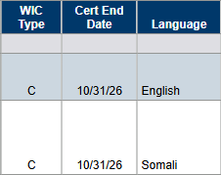
Columns: Agency ID, Clinic ID, Household ID, State WIC ID, Note Date, Note Created by, Note Subject, Note Text, Calculated Last PFDU, Last LDTU, WIC Type, Cert End Date, Language.
Counts: Participants.
Tab 3 – Counts-Staff
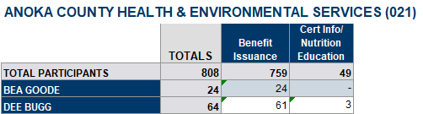
Columns: Clinic ID, Household ID, State WIC ID, Issued Date, WIC Type, Staff Issued Benefits.
Rows: TOTAL PARTICIPANTS, staff first and last name.
Grouped by: Agency name.

Notes by Subject with Optional Local Use Answer
Revised July 30, 2025

Overview
A list of participants who belong to the specified agencies and have one of the specified types of notes written during the specified dates. It also provides a simplified output for texting outreach and counts by specified notes, participant, household, language, staff, and (optionally) local use answers are included. An optional report input control allows the user to filter Tab 7 – Texting Output by Clinic ID since it is not included as a column in the output. There are two reference tabs: the first provides a list of note IDs and subjects; the second provides a list of local use questions, answers, and answer IDs.
The report output also displays selected answers to a local use question (agencies do not have to use local use questions to use this report).
Do you want answers to a local use question to display?
- YES - If you want answers to a local use question to display, you will need to enter the Answer IDs. To do this, enter the Agency ID(s) into the prompt, leaving the rest of the prompts as-is, and run the report. Refer to the Reference-Answer IDs tab for the Answer IDs. All Answer IDs must be 4 digits and entered as they are listed in this tab (with preceding 0s).
- NO - If you do not want answers to a local use question to display, the “Enter 4-digit Answer ID(s)” prompt is still required. Enter 9999999 (7 nines) into the prompt. This will meet the prompt requirement and ensure no answers are pulled into your output.

Some uses
- Identify participants with specific types of notes and the staff person who wrote them for documentation review of chart audits.
- Obtain a count by type of note during specified dates or by WIC type.
- Obtain a list of all note subjects and their IDs.
- Obtain a list with specified local use answers for texting outreach (example: Farmers’ Market notes).

Prompts:
- Agency ID(s) – agency where participants currently belong.
- Note Subject ID(s) – ID associated with note subject.
- Start Date – the first date in time period during which the notes were written.
- End Date – the last date in time period during which the notes were written.
- Answer ID(s) – the code associated with specific answers to a local use question. 9999999 is the code if not using local use questions.

Report outputs
Tab 1 – Reference-Notes
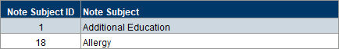
Columns: Note Subject ID, Note Subject.
Tab 2 – Reference-Answer IDs
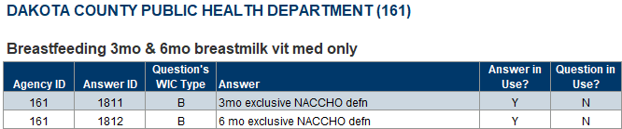
Columns: Agency ID, Answer ID, Question’s WIC Type, Answer, Answer in Use?, Question in Use?
Grouped by: Local use question.
Tab 3 – Participant List
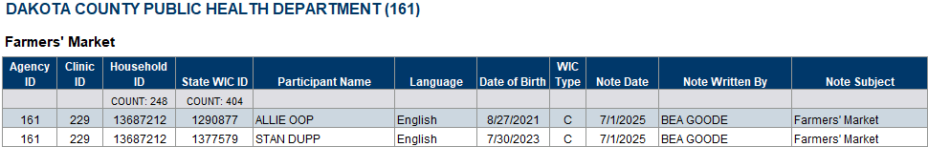
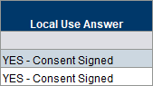
Columns: Agency ID, Clinic ID, Household ID, State WIC ID, Participant Name, Language, Date of Birth, WIC Type, Note Date, Note Written by, Note Subject, Local Use Answer.
Counts: Households and participants.
Grouped by: Agency ID and note subject(s).
Tab 4 – Counts-WIC Type
Table 1 – WIC Type and Table 2 – Participants and Households
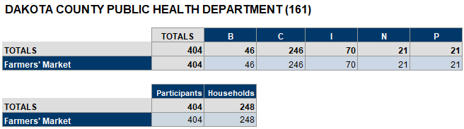
Table 1
Columns: TOTALS, WIC types (B, C, I, N, P).
Rows: TOTALS, note subject(s).
Table 2
Columns: TOTALS, Participants, Households.
Rows: TOTALS, note subject(s).
Tab 5 – Counts-Staff
Table 1 – Participants and Table 2 - Households
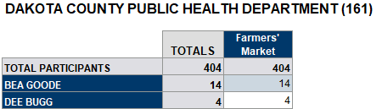
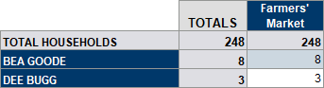
Table 1
Columns: TOTALS, note subject(s).
Rows: TOTAL PARTICIPANTS, staff names.
Table 2
Columns: TOTALS, note subject(s).
Rows: TOTAL HOUSEHOLDS, staff names.
Tab 6 – Counts-Staff & Language
Table 1 – Participants and Table 2 - Households
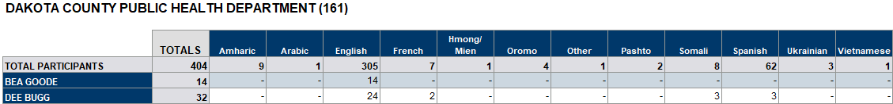
Table 1
Columns: TOTALS, race/ethnicity or cultural identity.
Rows: TOTAL PARTICIPANTS, staff names.
Table 2
Columns: TOTALS, race/ethnicity or cultural identity.
Rows: TOTAL HOUSEHOLDS, staff names.
Tab 7 – Texting Output
Columns: Agency ID, Household ID, State WIC ID, First Name, Last Name, DOB (date of birth), WIC Type, Language, Telephone 1, Email, Local Use Answer.
Tab 8 – Counts-Local Use Answer
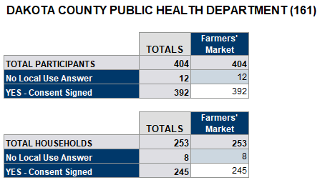
Table 1
Columns: TOTALS, note subject(s).
Rows: TOTAL PARTICIPANTS, local use answers.
Table 2
Columns: TOTALS, note subject(s).
Rows: TOTAL HOUSEHOLDS, local use answers.

Nutrition Education

Additional Nutrition Education Contacts
Revised Nov. 13, 2025

Overview
Provides lists and counts of participants who had a certification or mid-certification (MCA) during the specified date range and were subsequently issued benefits between 90 and 120 days of their cert/MCA at the specified agency. The lists are based on whether or not a Nutrition Education Contact (NEC) was provided (including individual contact, goal contact or material given contact) and documented in the Nutrition Education (NE) Tab at, or within 45 days of, the first subsequent benefit issuance. It also provides counts and percentages of completed NECs by the staff person that issued the benefits.

Some uses
- Assess whether staff are completing NECs at subsequent benefit issuance after certs or MCAs.
- Determine a percentage of additional NECs being documented at subsequent benefit issuance after certs or MCAs.

Prompts
- Agency ID – agency where the benefits were subsequently issues.
- Start Date - the first date in the time period during which participants were certified or had an MCA completed.
- End Date - the last date in the time period during which participants were certified or had an MCA completed.

Report outputs
Tab 1 – NECs
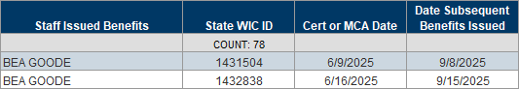
Columns: Staff Issued Benefits, State WIC ID, Cert or MCA Date, and Date Subsequent Benefits Issued.
Sorted by: Staff Issued Benefits (asc); Cert or MCA Date (asc).
Counts: State WIC ID (distinct).
Tab 2 – No NECs
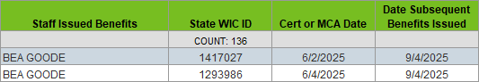
Columns: Staff Issued Benefits, State WIC ID, Cert or MCA Date, and Date Subsequent Benefits Issued.
Sorted by: Staff Issued Benefits (asc); Cert or MCA Date (asc).
Counts: State WIC ID (distinct).
Tab 3 – Counts
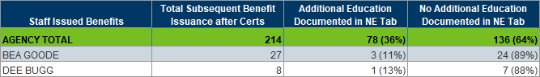
Columns: Staff Issued Benefits, Total Subsequent Benefit Issuance after Certs, Additional Education Documented in NE Tab, and No Additional Education Documented in NE Tab
Rows: AGENCY TOTAL, staff names.
Sorted by: First Name of staff who issued benefits.
Counts: Agency and by staff name (counts and percentages).

Nutrition Education Topics List
Created March 2, 2026

Overview
A list of primary and secondary Nutrition Education topics grouped by WIC type.

Some uses
Reference for hot key use in Information System dropdowns.

Prompts
None.

Report outputs
Tab 1 – PRIMARY
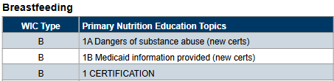
Columns: WIC Type, Primary Nutrition Education Topics.
Sorted by: WIC Type (asc).
Tab 2 – SECONDARY
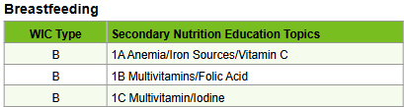
Columns: WIC Type, Secondary Nutrition Education Topics.
Sorted by: WIC Type (asc).

One Call

One Call: Children Who Haven’t Returned to WIC
Revised Dec. 2, 2024

Overview
This report provides a list of children, between 1 and 5 years old as of the current date, who belong to the specified agency, are no longer certified (Cert End Date within last 8 months), haven’t received benefits in more than 3 months, and who have a specified Local Use answer.
This report was originally developed for agencies participating in the One Call automated messaging project and using a Local Use Question to record whether the participant is opting in. Some of the output formatting is specific to One Call. However, technically, it can be used for any Local Use Question since it is based on the Answer IDs and no longer on the position of the question.
NOTE! Agencies must use local use questions to use this report.

Some uses
Provide a list of children for outreach, in order to improve retention, who have an answer selected for a specific local use question (and potentially using the One Call automated notification system).

Prompts
- Agency ID – agency where the participants currently belong.
- Answer ID(s) – the code associated with answers to a specific local use question.

Report outputs
Tab 1 – Reference – Child Only
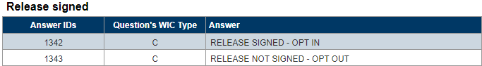
Columns: Answer IDs, Question’s WIC Type, Answer.
Grouped by: Local use question.
Tab 2 – One Call
Columns: Firstname, Lastcheckldtu, Certificationduedate, Servicesiteid, Telephone1, Telephone, Comment2, Emailaddress, Language1, Language2, Statewicid, Householdid, Authrepfirstname.

One Call: Future Appointments
Revised Oct. 26, 2026

Overview
Two lists, with simple outputs by participant and authorized representative, based on participants who belong to the specified agency, have a specified answer for a Local Use question, and have an appointment scheduled during the specified time period. An optional input control allows you to filter the list by appointment types. (NOTE: In February 2026 the following reports were combined: ONE CALL: FUTURE APPOINTMENTS BY PARTICIPANT’S FIRST NAME and ONE CALL: FUTURE APPOINTMENTS BY AUTH REP’S FIRST NAME.)

Some uses
Identify participants who have an answer selected for a Local Use Question (One Call) and a future appointment scheduled for outreach.

Prompts
- Agency ID – agency where the participant currently belongs.
- Start Date – the first date in the time period during which the appointments are scheduled.
- End Date – the last date in the time period during which the appointments are scheduled.
- Answer ID(s) – the codes associated with answers to a specific local use question.

Report outputs
Tab 1 – Reference-Answer IDs
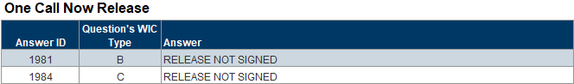
Columns: Answer ID, Question’s WIC Type, Answer.
Grouped by: Local use question.
Tab 2 – Reference-Appt Types
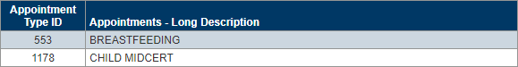
Columns: Appointment Type ID, Appointments – Long Description.
Tab 3 – Future Appts-Participant
Columns: Firstname, Appointmentdate, Appointmenttime, Servicesiteid, Telephone1, Telephone2, Comment2, Emailaddress, Language2 (description), Language2 (code), Statewicid, Householdid, Appointmenttypeid, Description (appointment), Language1 (description), Language1 (code), Authrepfirstname.
Tab 4 – Future Appts-Auth Rep
Columns: Authrepfirstname, Appointmentdate, Appointmenttime, Servicesiteid, Telephone1, Telephone2, Comment2, Emailaddress, Language2 (description), Language2 (code), Statewicid, Householdid, Appointmenttypeid, Description (appointment), Language1 (description), Language1 (code), Authrepfirstname.

One Call: Missed Appointments
Revised Feb. 18, 2026

Overview
This report provides a list of participants who belong to the specified agency, have a specified response for a local use question, and missed an appointment scheduled during the specified time period. An OPTIONAL input control allows the report user to filter the report for specific types of appointments.
This report was originally developed for agencies participating in the One Call automated messaging project and using a local use question to record whether the participant is opting in. Some of the output formatting is specific to One Call. However, technically, it can be used for any local use question since it is based on the answer IDs and no longer on the position of the question.

Some uses
Identify participants who have an answer selected for a local use question and a future appointment scheduled for outreach.

Prompts
- Agency ID – agency where the participant currently belongs.
- Start Date – the first date in the time period during which the appointments are scheduled.
- End Date – the last date in the time period during which the appointments are scheduled.
- Answer ID(s) – the codes associated with answers to a specific local use question.

Report outputs
Tab 1 – Reference-Answer IDs
Columns: Answer ID, Question’s WIC Type, Answer.
Grouped by: Local use question.
Tab 2 – Reference-Appt Types
Columns: Appointment Type ID, Appointments – Long Description.
Tab 3 – Missed Appts
Columns: Firstname, Appointmentdate, Appointmenttime, Servicesiteid, Telephone1, Telephone2, Comment2, Emailaddress, Language2 (description), Language2 (code), Statewicid, Householdid, Appointmenttypeid, Description (appointment), Language1 (description), Language1 (code), Authrepfirstname.

One Call: Roster
Revised April 2, 2026

Overview
This report provides four lists of participants who belong to the specified agency and have a specified response for a local use question that was answered during the specified dates. The Roster lists include all participants; the CurrentCert lists only include participants in a current certification as of today’s date. The two Roster and CurrentCert lists are the same except for each has a tab with Comment 1 and Comment 2. An OPTIONAL input control allows the report user to filter all tabs by clinic.
This report was originally developed for agencies participating in the One Call automated messaging project and using a local use question to record whether the participant is opting in. Some of the output formatting is specific to One Call. However, technically, it can be used for any local use question since it is based on the Answer IDs and no longer on the position of the question.

Some uses
Contact participants who have an answer selected for a local use question.

Prompts
- Agency ID – agency where the participant currently belongs.
- Start Date – the first date in the time period during which a specified answer was selected.
- End Date – the last date in the time period during which a specified answer was selected.
- Answer ID(s) – the codes associated with answers to a specific local use question.

Report outputs
Tab 1 – Reference-Answer IDs
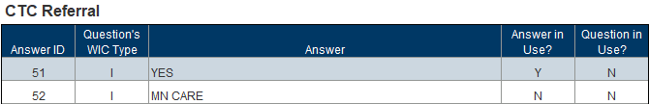
Columns: Answer ID, Question’s WIC Type, Answer, Answer in Use, Question in Use.
Grouped by: Local use question.
Tabs 2 and 4-Roster-Comment2 and CurrentCert-Comment2
Columns: Firstname, Servicesiteid, Telephone1, Telphone2, Comment2, Emailaddress, Language1, Language1, Statewicid, Householdid, Wicstatus, Answer Date, Authrepfirstname.
Tabs 3 and 5-Roster-Comment1 and CurrentCert-Comment1
Columns: Firstname, Servicesiteid, Telephone1, Telphone2, Comment1, Emailaddress, Language1, Language1, Statewicid, Householdid, Wicstatus, Answer Date, Authrepfirstname.

Outreach & Retention

Count of Infants Recertified at One Year
Revised June 3, 2025

Overview
A count and percentage of infants originally certified before 7 months at the specified agency who were recertified at one year. The output includes basic lists of infants certified before 7 months, not recertified, and infants certified at or after 7 months of age (who are excluded from the counts).

Some uses
- Performance measures.
- Obtain count/percentage of infants being recertified as a child.
- Identify infants not recertified as a child.
- Identify infants certified on or after 7 months of age.

Prompts
- Agency ID – agency where the infants were originally certified.
- Start Date – the first date in the time period during which the infants were certified.
- End Date – the last date in the time period during which the infants were certified.

Report outputs
Tab 1 – Counts
Columns: Total Infants Certified (before 7 months old), Total Infants Recertified at One Year, Total Infants Not Recertified at One Year, Percentage Recertified.
Tab 2 – Certified LT 7 MO
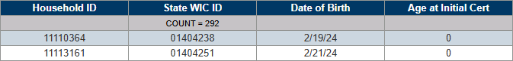
Columns: Household ID, State WIC ID, Date of Birth, Age at Initial Cert (in months).
Tab 3 – Not Recertified
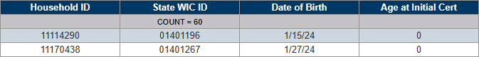
Columns: Household ID, State WIC ID, Date of Birth, Age at Initial Cert (in months).
Tab 4 – Certified GTE 7 MO
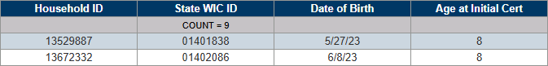
Columns: Household ID, State WIC ID, Date of Birth, Age at Initial Cert (in months).

Participants

Certified Participants
Revised May 29, 2025

Overview
A list and count of participants certified at the specified agency and clinics during the specified dates. The output includes a list of all certifications (new and recerts), new certs, and recerts. Counts are provided by WIC type and race/ethnicity or cultural identity by clinic. An optional input control allows the user to filter the participant lists by WIC type.

Some uses
- Identity participants certified during a specific time period.
- Obtain a list and count of participants by WIC Type, race/ethnicity or cultural identity, and clinic.
- Obtain a list of certifications, new certifications, and recertifications performed by staff.
- Provide a list of participants that can be used for a texting platform.

Prompts
- Agency ID – agency where the participants were certified.
- Clinic ID(s) – clinic where the participants were certified.
- Start Date – the first date in the time period during which the participants were certified.
- End Date – the last date in the time period during which the participants were certified.

Report outputs
Tab 1 – All Certs
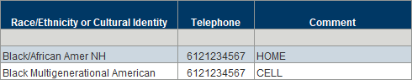
Columns: Clinic ID, Household ID, State WIC ID, First Name, Last Name, DOB (date of birth), M/F (gender), Prescreen Date, Cert Date, New or Recert?, WIC Type, High Risk, Certifier, Race/Ethnicity or Cultural Identity, Telephone, Comment.
Counts: Participants.
Tab 2 – New Certs
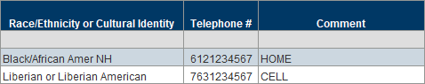
Columns: Clinic ID, Household ID, State WIC ID, First Name, Last Name, DOB (date of birth), M/F (gender), Prescreen Date, Cert Date, New or Recert?, WIC Type, High Risk, Certifier, Race/Ethnicity or Cultural Identity, Telephone, Comment.
Counts: Participants.
Tab 3 – Recerts
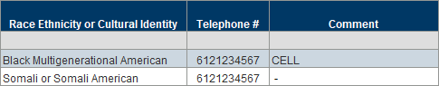
Columns: Clinic ID, Household ID, State WIC ID, First Name, Last Name, DOB (date of birth), M/F (gender), Prescreen Date, Cert Date, New or Recert?, WIC Type, High Risk, Certifier, Race/Ethnicity or Cultural Identity, Telephone, Comment.
Counts: Participants.
Tab 4 – Counts-WIC Type
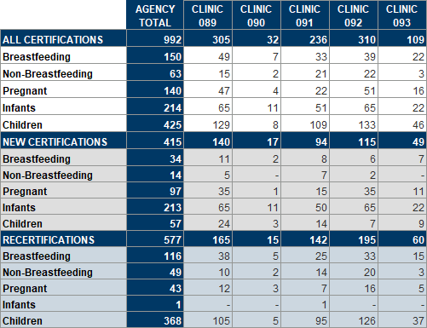
Columns: AGENCY TOTAL, CLINIC ID(s).
Rows: ALL CERTIFICATIONS, Breastfeeding, Non-Breastfeeding, Pregnant, Infants, Children; NEW CERTIFICATIONS, Breastfeeding, Non-Breastfeeding, Pregnant, Infants, Children; RECERTIFICATIONS, Breastfeeding, Non-Breastfeeding, Pregnant, Infants, Children
Tab 5 – Counts-Race
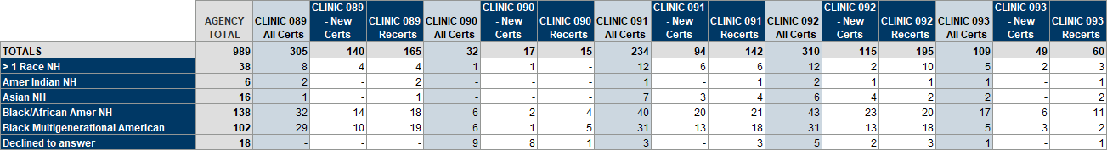
Columns: AGENCY TOTAL, CLINIC ID – All Certs, Clinic ID – New Certs, Clinic ID – Recerts.
Rows: TOTALS, race/ethnicity or cultural identity.

Currently Certified
Revised Oct. 20, 2026

Overview
A list, and 6 cross-tab counts, of participants who belong to the specified agencies and are in a current cert. The list includes a distinct count of participants and households and demographic information. All outputs are grouped by agency. The cross-tab counts provide a total count by agency and a household count by clinic, WIC type by clinic, language by clinic, race ethnicity and/or cultural identity by clinic, race ethnicity and/or cultural identity by WIC type, and age categories by WIC type. There are 8 optional input controls that allow you to filter the report outputs by: clinic, age (in years), WIC type, cert end date, last set’s Last Date to Use (LDTU), language, and race ethnicity and cultural identity. (Previously title CURRENTLY CERTIFIED PARTICIPANTS BY WIC TYPE.)

Some uses
- Outreach for participants currently certified for the WIC program.
- Obtain counts of currently certified participants by clinic, WIC type, language, age, and race.
- Obtain a count of currently certified households for the agency and clinics.

Prompts
- Agency ID – agency where the participants currently belong.

Report outputs
Tab 1 – List
Page 1
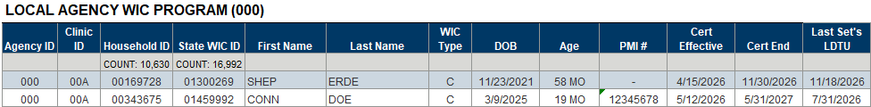
Page 2
Page 3
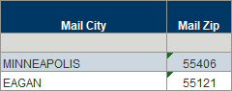
Columns: Page 1 – Agency ID, Clinic ID, Household ID, State WIC ID, First Name, Last Name, WIC Type, DOB (date of birth), Age, PMI #, Cert Effective, Cert End, Last Set’ LDTU. Page 2 – Authorized Representative, Telephone #, Comments, Language, Interp?, Race Ethnicity or Cultural Identity, Mail Address. Page 3 – Mail City, Mail Zip.
Counts: Households and participants.
Tab 2 – Counts
Table 1: Households
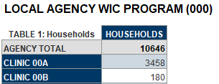
Columns: HOUSEHOLDS.
Rows: AGENCY TOTAL, CLINIC <ID>
Table 2: Clinics and WIC Type
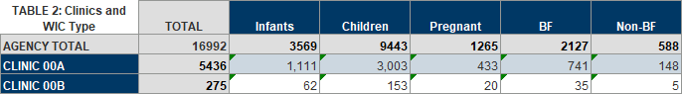
Columns: TOTAL, WIC Type.
Rows: AGENCY TOTAL, CLINIC <ID>
Table 3: Language and Clinics
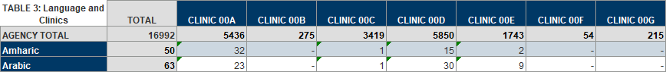
Columns: TOTAL, CLINIC <ID>
Rows: AGENCY TOTAL, Language
Table 4: Race Ethnicity/Cultural Identity and Clinics
Columns: TOTAL, CLINIC <ID>
Rows: AGENCY TOTAL, race ethnicity and cultural identity
Table 5: Race Ethnicity/Cultural Identity and WIC Types
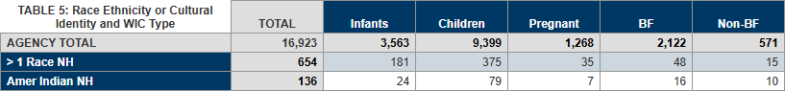
Columns: TOTAL, WIC Type
Rows: AGENCY TOTAL, race ethnicity and cultural identity
Table 6: Age and WIC Type
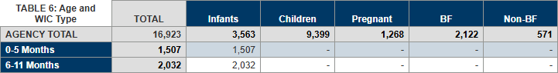
Columns: TOTAL, WIC Type
Rows: AGENCY TOTAL, age categories

Participants >> Breastfeeding

Currently Certified BF Women
Revised April 25, 2025

Overview
A list of currently certified breastfeeding women who belong to the specified agencies. The output includes their breastfeeding amount (some, mostly, or fully), ethnicity, race/ethnicity, cultural identity (if selected), and address information for labels.

Some uses
- Obtain a list of currently certified breastfeeding women.
- Identify currently breastfeeding women by breastfeeding amount (some, mostly, or fully).
- Identify currently breastfeeding women by ethnicity, race, or cultural identity.
- Obtain a total count of currently certified breastfeeding women.
- Create labels for outreach/congrats postcards, identifying potential peers, etc.

Prompts
Agency ID(s) – agency where the participant currently belongs.

Report outputs
Tab 1 – List
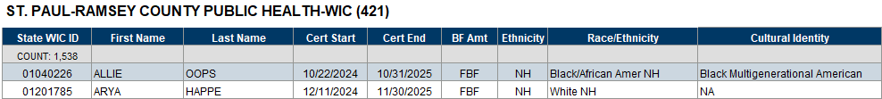
Columns: State WIC ID, First Name, Last Name, Cert Start, Cert End, BF Amt, Ethnicity, Race/Ethnicity, Cultural Identity.
Counts: Participants.
Grouped by: Agency ID.
Tab 2 – Labels
Columns: BF Amt, State WIC ID, First Name, Last Name, Mail Address, Mail City, State, Zip Code, Agency ID.

Participants >> Infants and Children

Currently Certified Infants and Children by Age
Revised Nov. 26, 2025

Overview
Lists and counts of currently certified infants and children by age for the specified agency and clinics and statewide. Agency and clinic counts are broken down by 1-month and 6-month increments. Age is based on the difference between the date of birth and the current date. There optional input control allows the report user to filter the age range between 0 and 61 months for infants and children included in the output and impacts all tabs.

Some uses
- Obtain a list of infants and children by specific age for outreach for the specified agency or statewide.
- Obtain a count of currently certified infants and children by age for the specified agency or statewide for distribution of outreach products.

Prompts
- Agency ID – agency where the infants and children currently belong.
- Clinic ID(s) – clinic(s) where the infants and children currently belong.

Report outputs
Tab 1 – Agency
Page 1
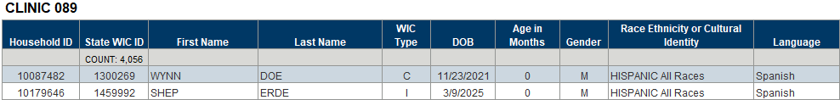
Page 2
Page 3
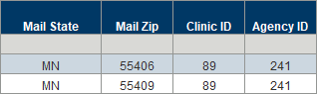
Columns: Household ID, State WIC ID, First Name, Last Name, WIC Type, DOB, Age in Months, Gender, Race Ethnicity or Cultural Identity, Language, Cert Start, Cert End, Auth Rep First Name, Auth Rep Last Name, Telephone 1, Comment 1, Mail Address, Mail City, Mail State, Mail Zip, Clinic ID, Agency ID.
Counts: Participants.
Grouped by: Clinic ID.
Tab 2 – Agency Count
Table 1
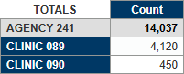
Columns: Count.
Rows: AGENCY ID, CLINIC IDs.
Counts: Participants.
Table 2
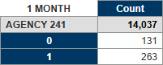
Columns: Count.
Rows: AGENCY ID, 1-month increments.
Counts: Participants.
Table 3
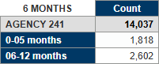
Columns: Count.
Rows: AGENCY ID, 6-month increments.
Counts: Participants.
Tab 3 – Clinic Count
Table 1
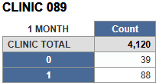
Columns: Count.
Rows: CLINIC TOTAL, 1-month increments.
Counts: Participants.
Table 2
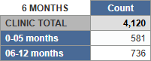
Columns: Count.
Rows: CLINIC TOTAL, 6-month increments.
Counts: Participants.
Tab 4 – State
Page 1
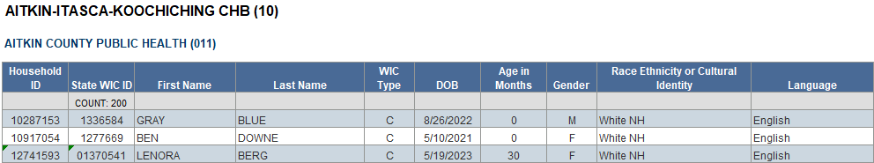
Page 2
Page 3
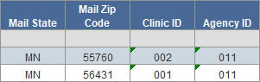
Columns: Household ID, State WIC ID, First Name, Last Name, WIC Type, DOB, Age in Months, Gender, Race Ethnicity or Cultural Identity, Language, Cert Start, Cert End, Auth Rep First Name, Auth Rep Last Name, Telephone 1, Comment 1, Mail Address, Mail City, Mail State, Mail Zip, Clinic ID, Agency ID.
Counts: Participants.
Grouped by: Grantee name, agency name.
Tab 5 – State Count-Agency
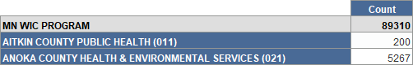
Columns: Count.
Rows: MN WIC PROGRAM, AGENCY NAME (ID)
Counts: Participants.
Tab 6 – State Count-Grantee
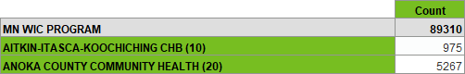
Columns: Count.
Rows: MN WIC PROGRAM, GRANTEE NAME (ID)
Counts: Participants.

Participants >> Pregnant

Pregnant by Expected Delivery Date
Revised Jan. 5, 2026

Overview
A list and count of pregnant participants who belong to the specified agencies and whose Expected Delivery Date (EDC) is during the specified date range. An optional input controls allows you to filter all outputs by clinic ID. The report also provides a list for mailing labels and a count of pregnant participants by clinic.
Some uses
- Obtain a list of pregnant participants for outreach by EDC.
- Create mailing labels.

Prompts
- Agency ID(s) – agency where the participant currently belongs.
- Start Date – the first date in the time period during which the EDC falls.
- End Date – the last date in the time period during which the EDC falls.

Report outputs
Tab 1 – List
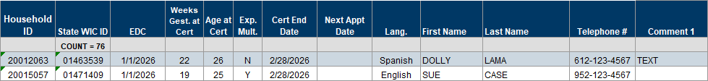
Columns: Household ID, State WIC ID, EDC, Week Gest. at Cert, Age at Cert, Exp. Mult., Cert End Date, Next Appt Date, Lang. First Name, Last Name, Telephone #, Comment 1.
Counts: Participants.
Grouped by: Agency name (ID) then Clinic ID (asc).
Tab 2 – Labels
Columns: Agency ID, Clinic ID, Household ID, State WIC ID, EDC, First Name, Last Name, Mail Address, Mail City, Mail State, Mail Zip Code.
Sorted by: Agency ID, Clinic ID, EDC (asc).
Tab 3 - Counts
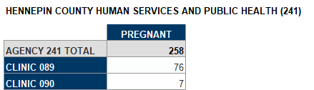
Columns: PREGNANT.
Rows: AGENCY <ID> TOTAL, CLINIC ID.
Counts: Pregnant participants.

Referrals

Certs and MCAs and Specified Referral(s) Never Given
Revised August 26, 2026
Previous title: No Record of Specified Referrals

Overview
A list and cross-tab count of participants, based on WIC Type, that were certified, recertified, or had a Mid-certification Assessment (MCA) at the specified agencies during the specified dates who have NEVER been given the specified referral(s). The list includes a distinct count of participants and households. The cross-tab count is by contact type (New Cert, Cert/Recert, or MCA), certifier, and clinic. Both outputs are grouped by agency, and optional input controls allow you to filter both the list and cross-tab count by clinic ID and certifier, the list by contact type, and the reference by whether the referral is currently active.

Some uses
- Identify participants who have never received required referral(s).
- Identify staff who didn’t provide required referral(s) at a contact (cert/recert/MCA) for audit or training purposes.
- Obtain count of participants by clinic and certifier who had contacts during the specified date, but don’t have any record of the specified referral(s).

Prompts
- %AgencyID% - the agency found in the referral name (since not unique between agencies).
- Agency ID(s) – agency where the cert, recert or MCA occurred.
- Start Date – the first date in the time period during which the cert, recert or MCA occurred.
- End Date – the last date in the time period during which the cert, recert or MCA occurred.
- Referral ID – the unique ID associated with specific referrals.
- WIC Type(s) – the WIC type at the time the participant was certified, or the certification associated with the MCA.

Report outputs
Tab 1 – Reference
Columns: Referral ID, Referral Name, Active.
Tab 2 – List
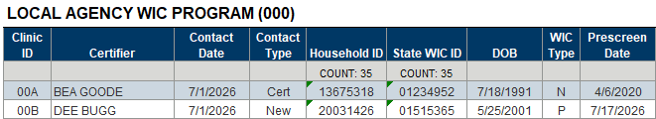
Columns: Clinic ID, Certifier, Contact Date, Contact Type, Household ID, State WIC ID, DOB, WIC Type, Prescreen Date.
Grouped by: Agency name.
Counts: Participants and households.
Tab 3 – Counts
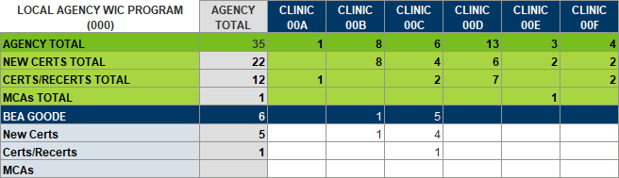
Columns: AGENCY ID, CLINIC ID(s).
Rows: AGENCY ID TOTAL, NEW CERTS TOTAL, CERTS/RECERTS TOTAL, MCAs TOTAL; certifier’s name, New Certs, Certs/Recerts, MCAs.

Certs and MCAs with Specified Referral(s) Given
Revised August 26, 2026
Previous title: Participants with Cert or MCA and Specified Referral.

Overview
A list of participants, based on WIC Type, that were certified, recertified, or had a Mid-certification Assessment (MCA) at the specified agencies during the specified dates who were given the specified referral(s) on the same date as their cert or MCA. The output is grouped by agency and referral and includes a distinct count of participants and households. An optional input control allows you to filter the list by contact type and the reference by whether the referral is currently active.

Some uses
- Identify participants given a specific referral during their cert or MCA.

Prompts
- %AgencyID% - the agency found in the referral name (since not unique between agencies).
- Agency ID(s) – agency where the cert, recert or MCA occurred.
- Start Date – the first date in the time period during which the cert, recert or MCA occurred.
- End Date – the last date in the time period during which the cert, recert or MCA occurred.
- Referral ID – the unique ID associated with specific referrals.
- WIC Type(s) – the WIC type at the time the participant was certified, or the certification associated with the MCA.

Report outputs
Tab 1 – Reference
Columns: Referral ID, Referral Name, Active.
Tab 2 – List
Page 1
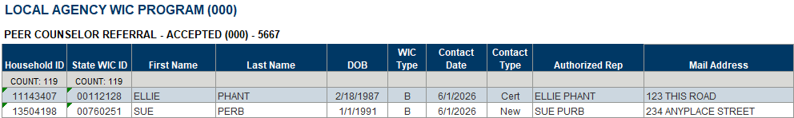
Columns: Household ID, State WIC ID, First Name, Last Name, DOB, WIC Type, Contact Date, Contact Type, Authorized Rep, Mail Address.
Grouped by: Agency name.
Counts: Participants and households.
Page 2
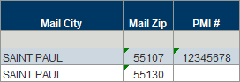
Columns: Mail City, Mail Zip, PMI #.

Certs and MCAs without Any Referrals Given
Created August 25, 2026

Overview
A list and cross-tab count of participants with a completed certification, recertification or Mid-certification Assessment (MCA) at the specified agencies during the specified dates who were NOT given ANY referrals at their Cert/MCA. The list includes a distinct count of participants and households. The cross-tab count is by certifier and contact type (New, Cert, MCA). Both outputs are grouped by agency, and optional input controls allow you to filter both the list and cross-tab count by WIC type and the list by contact type.

Some uses
- Identify staff who may need further guidance if your agency requires some sort of referral at contacts.
- Ascertain how often no referrals are provided at different types of appointments.

Prompts
- Agency ID(s) – agency where the cert, recert or MCA occurred.
- Start Date – the first date in the time period during which the cert, recert or MCA occurred.
- End Date – the last date in the time period during which the cert, recert or MCA occurred.

Report outputs
Tab 1 – List
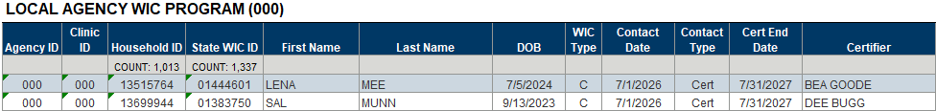
Columns: Agency ID, Clinic ID, Household ID, State WIC ID, First Name, Last Name, DOB, WIC Type, Contact Date, Contact Type, Cert End Date, Certifier.
Grouped by: Agency name.
Counts: Participants and households.
Tab 2 – Counts
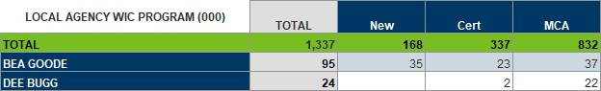
Columns: TOTAL, New, Cert, MCA.
Rows: TOTAL, Certifier.

Certs and MCAs without Specified Referral(s) Given
Revised August 26, 2026
Previous title: No Referrals at Cert or MCA

Overview
A list and cross-tab count of participants, based on WIC Type, that were certified, recertified, or had a Mid-certification Assessment (MCA) at the specified agencies during the specified dates who were NOT given the specified referral(s) on the same date as their cert or MCA. The list includes a distinct count of participants and households. The cross-tab count is by contact type (New Cert, Recert, or MCA), certifier, and clinic. Both outputs are grouped by agency, and optional input controls allow you to filter both the list and counts by clinic ID and certifier, the list by contact type, and the reference by whether the referral is currently active.

Some uses
- Identify staff who may need further guidance if your agency requires certain referrals at contacts.
- Identify participants who didn’t receive specific referral(s) at a contact.
- Obtain count of participants by clinic and staff who had contacts but did not receive the specified referrals.

Prompts
- %AgencyID% - the agency found in the referral name (since not unique between agencies).
- Agency ID(s) – agency where the cert, recert or MCA occurred.
- Start Date – the first date in the time period during which the cert, recert or MCA occurred.
- End Date – the last date in the time period during which the cert, recert or MCA occurred.
- Referral ID – the unique ID associated with specific referrals.
- WIC Type(s) – the WIC type at the time the participant was certified, or the certification associated with the MCA.

Report outputs
Tab 1 – Reference
Columns: Referral ID, Referral Name, Active.
Tab 2 – List
Columns: Clinic ID, Certifier, Contact Date, Contact Type, Household ID, State WIC ID, DOB, WIC Type, Prescreen Date.
Grouped by: Agency name.
Counts: Participants and households.
Tab 3 – Counts
Columns: AGENCY ID, CLINIC ID(s).
Rows: AGENCY ID TOTAL, NEW CERTS TOTAL, CERTS/RECERTS TOTAL, MCAs TOTAL; certifier’s name, New Certs, Certs/Recerts, MCAs.

Certs With and Without Specified Referral(s) Given
Revised August 26, 2026
Previous title: Certified Participants Referred and Not Referred

Overview
Two lists, referred and not referred, and cross-tab counts of participants, based on WIC Type, who were certified at the specified agencies during the specified dates and were or were not given the specified referral(s) on the same date as their cert. Both list outputs (referred and not referred) are grouped by agency; the referred list is also grouped by referral. Both lists include a distinct count of participants and households. Cross-tab counts include total counts by referral, total referred, total not referred, and total certified by race ethnicity or cultural identity, WIC type, certifier, and clinic. Percentages referred and not referred are also provided. An optional input control allows you to filter the reference list by whether the referral is currently active.

Some uses
- Identify participants who were referred, or not, and staff who provided the referral, or didn’t.
- Identify similarities or differences in referrals based on Race Ethnicity/Cultural Identity.
- Identify types of participants receiving referrals or not.

Prompts
- %AgencyID% - the agency found in the referral name (since not unique between agencies).
- Agency ID(s) – agency where the cert, recert or MCA occurred.
- Start Date – the first date in the time period during which the cert, recert or MCA occurred.
- End Date – the last date in the time period during which the cert, recert or MCA occurred.
- Referral ID – the unique ID associated with specific referrals.
- WIC Type(s) – the WIC type at the time the participant was certified, or the certification associated with the MCA.

Report outputs
Tab 1 – Reference
Columns: Referral ID, Referral Name, Active.
Tab 2 – Referred List
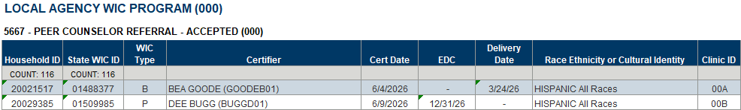
Columns: Household ID, State WIC ID, WIC Type, Certifier, Cert Date, EDC, Delivery Date, Race Ethnicity or Cultural Identity, Clinic ID.
Grouped by: Agency name and referral name.
Counts: Participants and households.
Tab 3 – Not Referred List
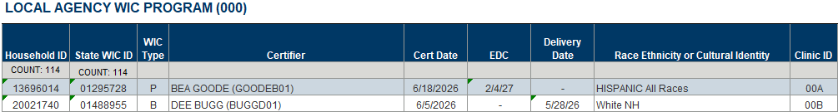
Columns: Household ID, State WIC ID, WIC Type, Certifier, Cert Date, EDC, Delivery Date, Race Ethnicity or Cultural Identity, Clinic ID.
Grouped by: Agency name.
Counts: Participants and households.

Tab 4 - Race
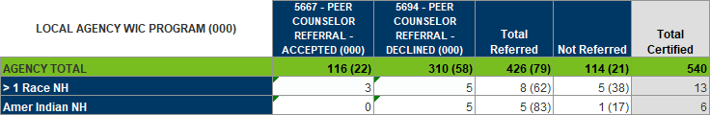
Columns: Referral ID – Name, Total Referred, Not Referred, Total Certified.
Rows: AGENCY TOTAL, Race ethnicity or cultural identity.
Grouped by: Agency name.
Tab 5 – WIC Type
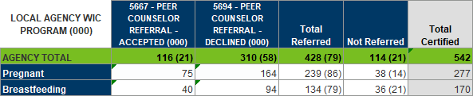
Columns: Referral ID – Name, Total Referred, Not Referred, Total Certified.
Rows: AGENCY TOTAL, WIC Type.
Grouped by: Agency name.
Tab 6 - Certifier
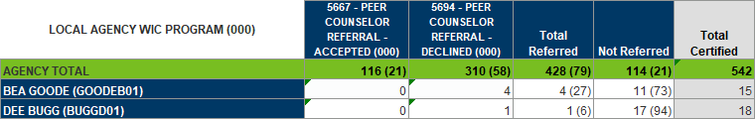
Columns: Referral ID – Name, Total Referred, Not Referred, Total Certified.
Rows: AGENCY TOTAL, Certifier.
Grouped by: Agency name.
Tab 7 - Clinic
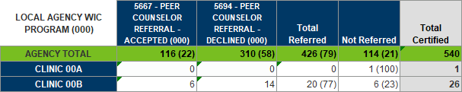
Columns: Referral ID – Name, Total Referred, Not Referred, Total Certified.
Rows: AGENCY TOTAL, CLINIC <ID>
Grouped by: Agency name.

Child Recerts by Age at Recert and Specified Referral Given at Least Once
Revised August 26, 2026
Previous title: Child Recertifications by Age & Specific Referral Provided at Least Once – WINNIE Only

Overview
A list of children who were recertified during the specified dates at the specified agency and were given the specified referral at least once while participating in the WIC Program. The list includes a distinct count of participants and households. The output is ordered by the child’s age in years at the time of the recert. An optional input control allows you to filter the list by whether the referral is currently active.
Some uses
Identify number of child recertifications completed monthly to see if outreach efforts have increased for children of specific ages.

Prompts
- Agency ID – agency where the children were certified.
- Start Date – the first date in the time period during which the children were certified.
- End Date – the last date in the time period during which the children were certified.
- Referral ID – the code associated with specific referrals.
- %AgencyID% - the agency found in the referral name (since not unique between agencies).

Report outputs
Tab 1 – Reference
Columns: Referral ID, Referral.
Tab 2 – Agency
Columns: Agency ID, Clinic ID, Household ID, State WIC ID, First Name (ppt), Last Name (ppt), DOB, WIC Type, Cert Start Date, Cert End Date, Age in Years, Age in Months, Residential City.
Counts: Participants and households.
Grouped by: Age in years (table breaks occur at change in age in years).

Referrals by Topic – Agency and State
Revised August 20, 2026

Overview
This report has two lists by agency and for all agencies (state):
- A list of all referral IDs, referrals, and whether active for the specified agency.
- A list of all referral IDs, referrals, and whether active by topic for all agencies (statewide).
An optional input control allows you to filter all tabs by active or inactive referrals.

Some uses
- Obtain a list of referrals for the specified agency or for all agencies (statewide).
- Obtain a list of referrals by topic for the specified agency or for all agencies (statewide).

Prompts
- %AgencyID% - the agency found in the referral name (since not unique between agencies).

Report outputs
Tab 1 – Referrals
Columns: Referral ID, Referral, Active.
Tab 2 – Topics
Page 1
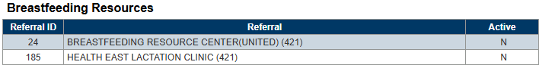
Columns: Referral ID, Referral, Active.
Grouped by: Topic.
Tab 3 – Statewide-Referrals
Columns: Referral ID, Referral, Active.
Tab 4 – Statewide-Topics
Page 1
Columns: Referral ID, Referral, Active.
Grouped by: Topic.

Specified Referral(s) Given at Least Once with Current Age
Revised August 24, 2026
Previous title: REFERRAL CONTACT(S) AT ANY TIME & CURRENT AGE

Overview
Two lists, infants/children and women, of participants who belonged to the specified agencies when they were given the specified referral(s) at some point while participating in the WIC Program. Both lists include a distinct count of participants and households. Optional input controls allow you to filter list of infants and children by current age in months, the list of women by current age in years, and the Reference tab by whether the referrals are currently active.

Some uses
- Identify participants who are of a certain age and have been given a specific referral at some point while on the WIC Program.
- School district geo-coding.

Prompts
- %AgencyID% - the agency found in the referral name (since not unique between agencies).
- Agency ID(s) – agencies where the referral contact was documented.
- Referral ID(s) – the unique IDs associated with a specific referral.

Report outputs
Tab 1 – Reference
Columns: Referral ID, Referral Name, Active.
Tab 2 – Infants and Children List
Page 1
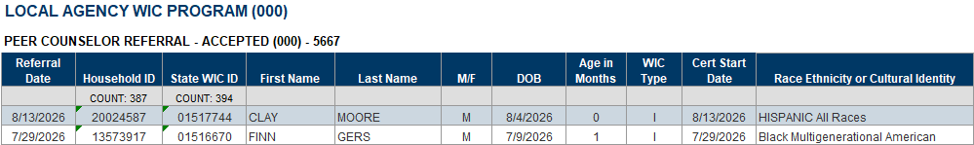
Page 2
Columns – Page 1: Referral Date, Household ID, State WIC ID, First Name, Last Name, M/F, DOB, Age in Months, Cert Start Date, Race Ethnicity or Cultural Identity.
Columns – Page 2: Language, Auth Rep FN, Auth Rep LN, Relationship, Telephone, Clinic ID, Address, City, State, Zip Code.
Counts: Households and participants.
Grouped by: Agency name and referral name.

Specified Referral(s) Given during Specified Dates with Age at Referral
Revised August 24, 2026
Previous title: REFERRAL CONTACT(S)

Overview
Two lists, detailed and simple, and cross-tab counts of participants who belonged to the specified agencies when they were given the specified referral(s) during the specified dates. The detailed list includes a distinct count of participants and households. The cross-tab counts are by race ethnicity or cultural identity, referring staff, WIC type, household and clinic (where referral was given), and age category when the referral was given by specified referral(s). Optional input controls allow you to filter all tabs by referring staff person and the Reference tab by whether the referrals are active.

Some uses
- Identify participants given specific referrals (ex: peer breastfeeding or farmers’ market).
- Create labels for referred participants.
- Identify staff who gave referrals.
- Obtain counts of participants given specific referrals by race, staff, type, clinic, and age when referral was given.
- Obtain a count of households given specific referrals.

Prompts
- %AgencyID% - the agency found in the referral name (since not unique between agencies).
- Agency ID(s) – agencies where the referral contact was documented.
- Start Date – the first date in the time period during which the referral was documented.
- End Date – the last date in the time period during which the referral was documented.
- Referral ID(s) – the unique IDs associated with a specific referral.

Report outputs
Tab 1 – Reference
Columns: Referral ID, Referral Name, Active.
Tab 2 – List
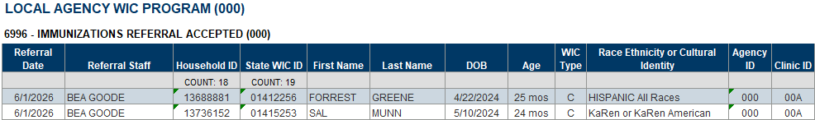
Columns: Referral Date, Referral Staff, Household ID, State WIC ID, First Name, Last Name, DOB, Age, WIC Type, Race Ethnicity or Cultural Identity, Agency ID, Clinic ID.
Counts: Households and participants.
Grouped by: Agency name and referral name.
Tab 3 – Race
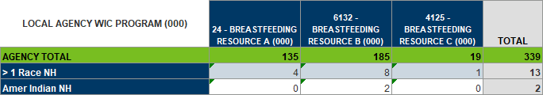
Columns: Referral name (HIDDEN), referral ID – referral name, TOTAL.
Rows: AGENCY TOTAL, race ethnicity or cultural identity.
Grouped by: Agency name.
Tab 4 - Staff
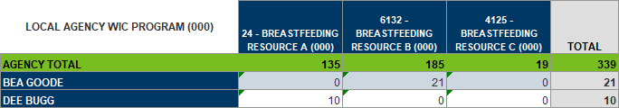
Columns: Referral name (HIDDEN), referral ID – referral name, TOTAL.
Rows: AGENCY TOTAL, staff name.
Grouped by: Agency name.
Tab 5 – WIC Type
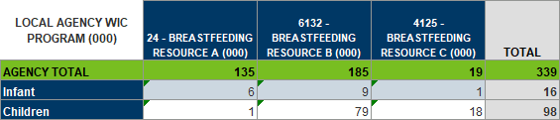
Columns: Referral name (HIDDEN), referral ID – referral name, TOTAL.
Rows: SORT (HIDDEN), AGENCY TOTAL, WIC Type.
Grouped by: Agency name.
Tab 6 – HH/Clinic
Table 1
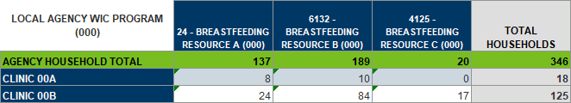
Columns: Referral name (HIDDEN), referral ID – referral name, TOTAL HOUSEHOLDS.
Rows: AGENCY HOUSEHOLD TOTAL, clinic.
Grouped by: Agency name.
Table 2
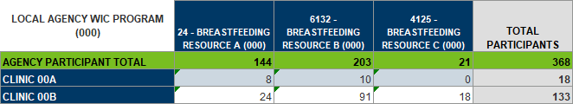
Columns: Referral name (HIDDEN), referral ID – referral name, TOTAL PARTICIPANTS.
Rows: AGENCY PARTICIPANTS TOTAL, WIC Type.
Grouped by: Agency name.
Tab 7 - Age
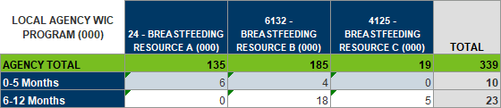
Columns: Referral name (HIDDEN), referral ID – referral name, TOTAL.
Rows: SORT (HIDDEN), AGENCY TOTAL, age category.
Grouped by: Agency name.
Tab 8 – Simple Output
Columns: Agency ID, Household ID, First Name, Last Name, Mail Address, Mail City, Mail State, Mail Zip.

Specified Referral(s) Given during Specified Dates with Current Age
Revised August 24, 2026
Previous title: REFERRAL CONTACT(S) DURING SPECIFIED TIME PERIOD AND CURRENT AGE

Overview
Two lists, infants/children and women, and a cross-tab count of participants who belonged to the specified agencies when they were given the specified referral(s) during the specified dates. Both lists include a distinct count of participants and households. The cross-tab count provides total participant and household counts by agency and referral, as well as counts by “WIC week”. Optional input controls allow you to filter the list of infants/children by current age in months, the list of women by current age in years, the cross-tab counts by current age and WIC Type, and Reference tab by whether the referral is currently active.

Some uses
- Identify infants/children and women who are of a certain age given specific referrals during a specific date range for outreach.
- Obtain a count of participants and households given specific referrals by agency or WIC week.

Prompts
- %AgencyID% - the agency found in the referral name (since not unique between agencies).
- Agency ID(s) – agencies where the referral contact was documented.
- Start Date – the first date in the time period during which the referral was documented.
- End Date – the last date in the time period during which the referral was documented.
- Referral ID(s) – the unique IDs associated with a specific referral.

Report outputs
Tab 1 – Reference
Columns: Referral ID, Referral Name, Active.
Tab 2 – Infants and Children List
Page 1
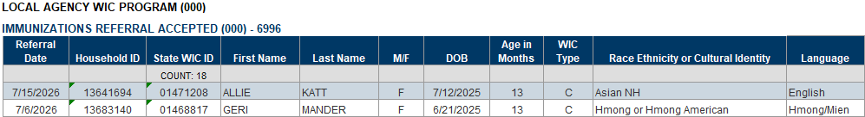
Page 2
Page 3
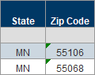
Columns – Page 1: Referral Date, Household ID, State WIC ID, First Name, Last Name, M/F, DOB, Age in Months, WIC Type, Race Ethnicity or Cultural Identity, Language
Columns – Page 2: Auth Rep FN, Auth Rep LN, Relationship, Auth Rep DOB, Telephone 1, Telephone 2, Comment 2, Clinic ID, Address, City.
Columns – Page 3: State, Zip Code.
Counts: Participants.
Grouped by: Agency name and referral name.
Tab 3 – Women List
Page 1
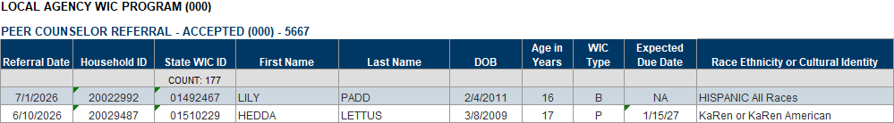
Page 2
Columns – Page 1: Referral Date, Household ID, State WIC ID, First Name, Last Name, DOB, Age in Year, WIC Type, Expected Due Date, Race Ethnicity or Cultural Identity.
Columns – Page 2: Language, Telephone 1, Telephone 2, Comment 2, Clinic ID, Address, City, State, Zip Code.
Counts: Participants.
Grouped by: Agency name and referral name.
Tab 4 - Counts
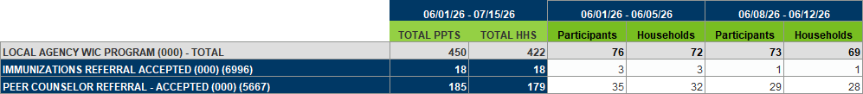
Columns: WIC week (variable – HIDDEN), start date – end date, WIC week dates, TOTAL PPTS, TOTAL HHS, Participants, Households.
Rows: Agency name (ID) and referral names (ID).
Grouped by: Agency name.

Risk Factors

Risk Factor Assigned at Certification
Revised Feb. 20, 2025

Overview
A list and counts of participants who were certified at the specified agency during the specified dates and assigned the specified risk factor (RF) at the time of the certification. The agency counts include counts by clinic(s) and: by certifier and households with members assigned the risk factor; by WIC type and total certs with percentage; cultural identity and race ethnicity. The state counts include counts by agency and: WIC type and total certs with percentage; cultural identity and race ethnicity; and household. Tab 1 – Reference-Risk Factors provides a list of risk factor Ds and risk factors.

Some uses
- Identify participants assigned a specific RF at a specific agency.
- Identify VOC (out-of-state transfers are assigned RF 502).
- Obtain a count and percentage of participants assigned a RF by clinic, agency, and state.
- Obtain a count of households with a member assigned a specific RF by clinic, agency, and state.
- Identify staff assigning a RF to help assess staff understanding and potential training needs.
- Compare agency totals by WIC type and race/ethnicity across the state.

Prompts
- Agency ID – agency where the participants currently belong.
- Start Date – the first date in the time period during participants were certified.
- End Date – the last date in the time period during which participants were certified.
- Risk Factor ID – the code associated with the risk factor assigned during the certification.

Report outputs
Tab 1 – Reference-Risk Factors
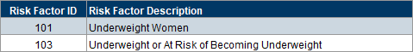
Columns: Risk Factor ID, Risk Factor Description.
Tab 2 – Agency-Participant List
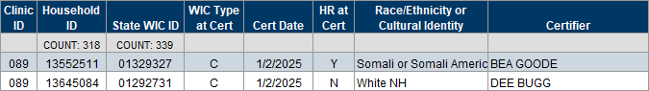
Columns: Clinic ID, Household ID, State WIC ID, WIC Type at Cert, Cert Date, HR (high risk) at Cert, Race/Ethnicity or Cultural Identity, Certifier.
Counts: Households and participants.
Tab 3 – Agency-Counts Certifier
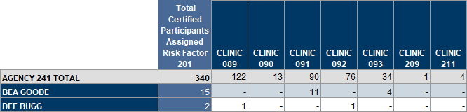
Columns: Total Certified Participants Assigned Risk Factor <ID>, CLINIC ID(s).
Rows: AGENCY ID TOTAL, staff names (certifiers).
Tab 4 – Agency-Counts PPTs & HHs
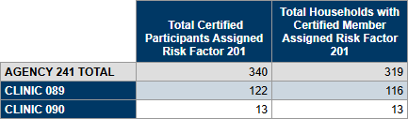
Columns: Total Certified Participants Assigned Risk Factor <ID>, Total Households with Certified Member Assigned Risk Factor <ID>.
Rows: AGENCY ID TOTAL, CLINIC ID(s).
Tab 5 – Agency-Counts WIC Type
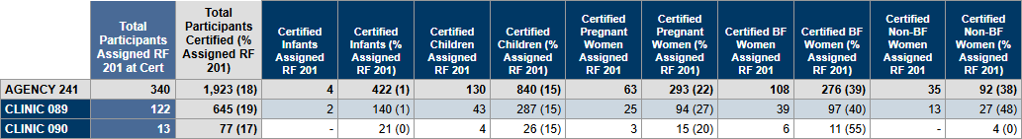
Columns: Total Participants Assigned Risk Factor <ID> at Cert, Total Participants Certified (% Assigned RF <ID>, Certified Infants Assigned RF <ID>, Certified Infants (% Assigned RF <ID>), Certified Children Assigned RF <ID>, Certified Children (% Assigned RF <ID>), Certified Pregnant Women Assigned RF <ID>, Certified Pregnant Women (% Assigned RF <ID>), Certified BF Women Assigned RF <ID>, Certified BF Women (% Assigned RF <ID>), Certified Non-BF Women Assigned RF <ID>, Certified Non-BF Women (% Assigned RF <ID>).
Rows: AGENCY ID, CLINIC ID(s).
Tab 6 – Agency-Counts Race or CI
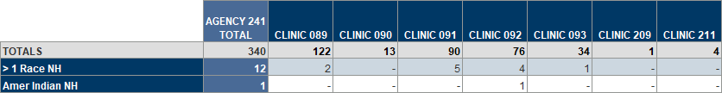
Columns: AGENCY ID TOTAL, CLINIC ID(s).
Rows: TOTALS, race/ethnicity or cultural identity.
Tab 7 – State-Counts PPTs & HHs
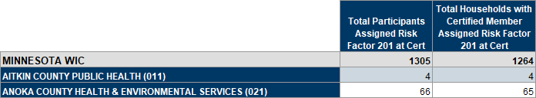
Columns: Total Participants Assigned Risk Factor <ID> at Cert, Total Households with Certified Member Assigned Risk Factor <ID> at Cert.
Rows: MINNESOTA WIC, AGENCY NAMES <ID>.
Tab 8 – State Counts WIC Type
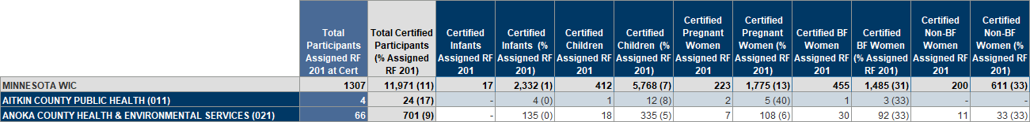
Columns: Total Participants Assigned Risk Factor <ID> at Cert, Total Participants Certified (% Assigned RF <ID>, Certified Infants Assigned RF <ID>, Certified Infants (% Assigned RF <ID>), Certified Children Assigned RF <ID>, Certified Children (% Assigned RF <ID>), Certified Pregnant Women Assigned RF <ID>, Certified Pregnant Women (% Assigned RF <ID>), Certified BF Women Assigned RF <ID>, Certified BF Women (% Assigned RF <ID>), Certified Non-BF Women Assigned RF <ID>, Certified Non-BF Women (% Assigned RF <ID>).
Rows: MINNESOTA WIC, AGENCY NAMES <ID>.
Tab 9 – State-Counts Race or CI
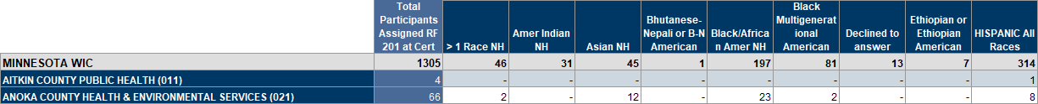
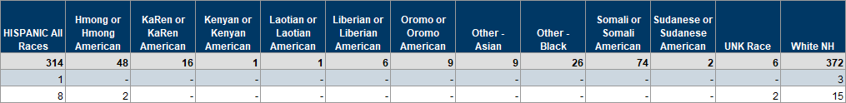
Columns: Total Participants Assigned RF <ID> at Cert, race/ethnicity or cultural identity.
Rows: MINNESOTA WIC, AGENCY NAMES <ID>.

Staff Management

Active WIC Staff
Revised July 29, 2026

Overview
A statewide list and count of active users grouped by agency name. Provides the user ID, username, last name, first name, and last login. An input control allows the user to filter by agency. (Previous title: STAFF IDS AND NAMES)

Some uses
- Identify staff based on user IDs or usernames.
- Determine last login for active WIC staff.
- Identify staff who should be deactivated.

Prompts
None. Click the Refresh icon to update the report.

Report output
Tab 1 – List
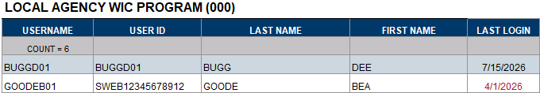
Columns: USERNAME, USER ID, LAST NAME, FIRST NAME, LAST LOGIN
Counts: Username.
Grouped by: Agency name.
Tab 2 – Statewide Count
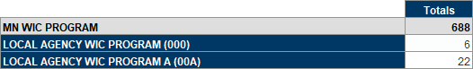
Columns: Totals
Rows: MN WIC PROGRAM, Local Agency Name (ID).

Certs & MCAs Completed by the Specified Staff Person
Revised Oct. 27, 2025

Overview
A list and count of certifications/recertifications and Mid-certification Assessments completed by the specified staff person at the specified agency during the specified time period.

Some uses
Obtain list of certs/recerts and MCAs completed by a specific staff person for auditing purposes.

Prompts
- Agency ID – agency where the participants were certified or had a MCA completed.
- Staff’s First Name – the first name of the staff person who completed the certs and MCAs.
- Staff’s Last Name – the last name of the staff person who completed the certs and MCAs.
- Start Date – the first date in time period during which the certs or MCAs were completed.
- End Date – the last date in time period during which the certs or MCAs were completed.

Report output
Tab 1 – Certs & MCAs
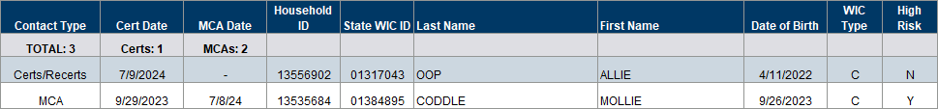
Columns: Contact Type. Cert Date, MCA Date, Household ID, State WIC ID, Last Name (ppt), First Name (ppt), Date of Birth, WIC Type, High Risk.
Counts: Total Contacts, Total Certs, Total MCAs.

Interpreter Needed Certs & MCAs Completed by Specified Staff Person
Created March 12, 2025

Overview
A list and count of certifications and MCAs completed by the specified staff person for households/participants with Interpreter Needed selected in Household Demographics. The count is by language and clinic. The report output on both tabs can be filtered by language using an optional Input Control.

Some uses
Identify certifications or MCAs completed by staff providing translation services during appointments.

Prompts
- Agency ID – agency where the participants currently belong.
- Start Date – the first date in time period during which the certs or MCAs were completed.
- End Date – the last date in time period during which the certs or MCAs were completed.

Report outputs
Tab 1 – Participant List
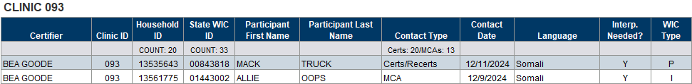
Columns: Certifier, Clinic ID, Household ID, State WIC ID, Participant First Name, Participant Last Name, Contact Type, Contact Date, Language, Interp. (interpreter) Needed?, WIC Type.
Counts: Households and participants.
Grouped by: Clinic ID.
Tab 2 – Count
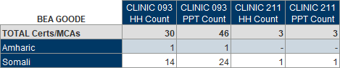
Columns: CLINIC ID HH Count, CLINIC ID PPT Count.
Rows: TOTAL Certs/MCAs, language.
Grouped by: Staff name (certifier).

Daily Staff Productivity
Revised Feb. 3, 2025

Overview
List of contacts - New Cert, Recerts, Mid-Certification Assessments (MCAs), and Nutrition Education Contacts (NECs) – performed by staff based on the specified agency and time period. The output provides a listing of contacts by staff name and date, including the start time of the contact (NECs are based on when benefits were issued). Total counts are provided by Contact Type and staff name for the specified time period and by individual date. The output has an OPTIONAL input control to filter the report by staff name.

Some uses
- Assess a staff person’s productivity.
- Compare productivity of staff people during a time period.

Prompts
- Agency ID – agency where the contact occurred.
- Start Date – the first date in the time period during which the contact occurred.
- End Date – the last date in the time period during which the contact occurred.

Report outputs
Tab 1 – Daily Contacts
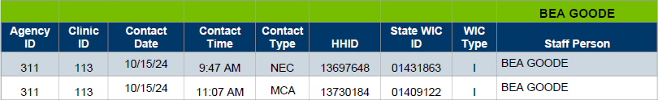
Columns: Agency ID, Clinic ID, Contact Date, Contact Time, Contact Type, Household ID, State WIC ID, WIC Type, Staff Person.
Grouped by: Staff name.
Tab 2 – Total Counts
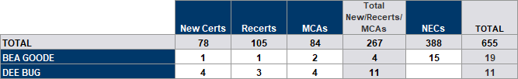
Columns: New Certs, Recerts, MCAs, Total New/Recerts/MCAs, NECs, Total.
Rows: Total, staff name.
Tab 3 – Daily Counts
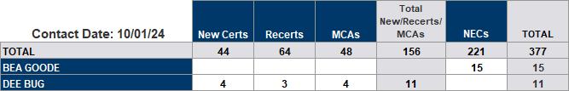
Columns: New Certs, Recerts, MCAs, Total New/Recerts/MCAs, NECs, Total.
Rows: Total, staff name.
Grouped by: Contact date.
Tab 3 – No Signature Captured
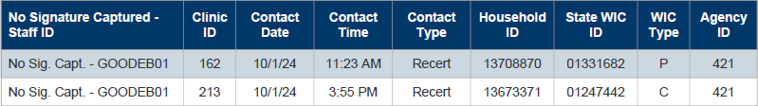
Columns: No Signature Captured – Staff ID (legacy user ID format), Clinic ID, Contact Date, Contact Time, Contact Type, Household ID, State WIC ID, WIC Type, Agency ID.

Staff & Clinic Productivity
Revised April 16, 2025

Overview
Lists of participants who were certified, had an MCA completed or were issued benefits at the specified clinics during the specified time period. The report also provides: 1) counts by staff person and clinic where the services were performed, including new certs, recerts, MCAs, total appointments, and nutrition education contacts (NECs); and 2) time the cert/MCA was started, time the benefits were issued, and the amount of time between the two. Counts are provided by clinic and staff, by clinic, by staff and by staff and language.

Some uses
- Identify participants who’ve had services performed by a specific staff person for chart/staff audits.
- Assess a staff person’s or clinic’s productivity.
- Compare productivity of staff or clinics during the specified time period.
- Assess length of certs and MCAs based on when the cert or MCA was started and when the benefits were issued.
- Assess distribution of interpreter-needed appointments among staff.

Prompts
- Clinic ID(s) – clinic where the contact occurred.
- Start Date – the first date in the time period during which the contact occurred.
- End Date – the last date in the time period during which the contact occurred.

Report outputs
Tab 1 – New Certs
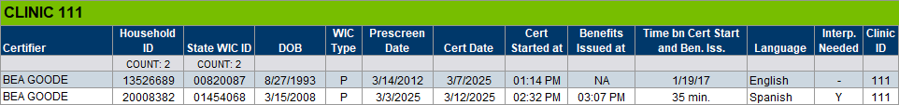
Columns: Certifier, Household ID, State WIC ID, DOB, WIC Type, Prescreen Date, Cert Date, Cert Started at, Benefits Issued at, Time bn Cert Start and Ben. Iss. (benefit issuance), Language, Interp. (interpreter) Needed, Clinic ID.
Counts: Households and participants.
Grouped by: Clinic ID.
Tab 2 – Certs & Recerts
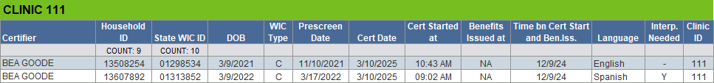
Columns: Certifier, Household ID, State WIC ID, DOB, WIC Type, Prescreen Date, Cert Date, Cert Started at, Benefits Issued at, Time bn Cert Start and Ben. Iss., Language, Interp. Needed, Clinic ID.
Counts: Households and participants.
Grouped by: Clinic ID.
Tab 3 – MCAs
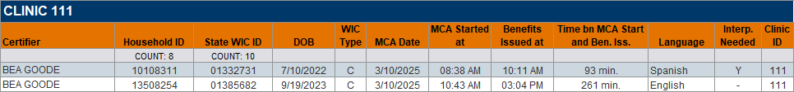
Columns: Certifier, Household ID, State WIC ID, DOB, WIC Type, Prescreen Date, MCA Date, MCA Started at, Benefits Issued at, Time bn MCA Start and Ben. Iss., Language, Interp. Needed, Clinic ID.
Counts: Households and participants.
Grouped by: Clinic ID
Tab 4 – NECs
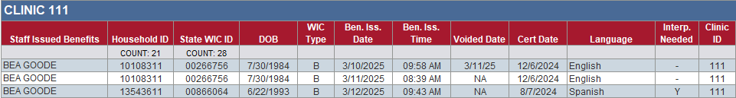
Columns: Staff Issued Benefits, Household ID, State WIC ID, DOB, WIC Type, Ben. Iss. Date, Voided Date, Cert Date, Language, Interp. Needed, Clinic ID.
Counts: Households and participants.
Grouped by: Clinic ID.
Tab 5 – Counts by Clinic & Staff
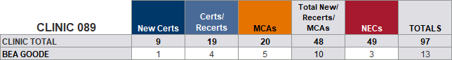
Columns: New Certs, Certs/Recerts, MCAs, Total New/Recerts/MCAs, NECs, TOTALS.
Rows: CLINIC TOTAL, staff name.
Grouped by: Clinic ID.
Tab 6 – Counts by Clinic
Columns: New Certs, Certs/Recerts, MCAs, Total New/Recerts/MCAs, % TOTAL APPTS, NECs, % NECs, TOTALS, % TOTAL.
Rows: ALL CLINICS TOTAL, clinic ID(s).
Tab 7 – Counts by Staff
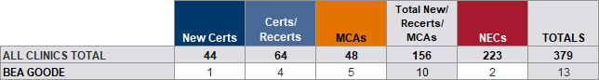
Columns: New Certs, Certs/Recerts, MCAs, Total New/Recerts/MCAs, NECs, TOTALS.
Rows: ALL CLINICS TOTAL, staff name.
Tab 7 – Counts by Staff
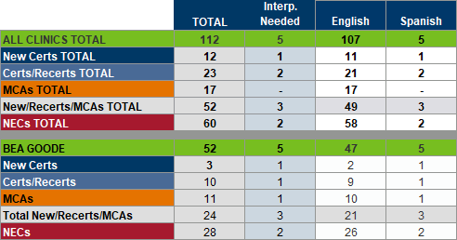
Columns: TOTAL, Interp. Needed, Language.
Rows: ALL CLINICS TOTAL, New Certs TOTAL, Certs/Recerts TOTAL, MCAs TOTAL, New/Recerts/MCAs TOTAL, NECs TOTAL; staff name, New Certs, Certs/Recerts, MCAs, Total New/Recerts/MCAs, NECs
Grouped by: Staff name.

State Use Questions >> Cultural Identity

Participation Month with Race/Ethnicity or Cultural Identity and Optional Local Use Answer
Revised Aug. 28, 2025

Overview
This report provides a list and count of participants counted during the specified participation month and their race/ethnicity or cultural identity. The report output also displays specified answers to a local use question if selected before the last date of the participation month (agencies do not have to use local use questions to use this report).
There are two different list tabs: Tab 2-List-Answer displays participants with the specified local use answer(s) and Tab 3-List-No Answer displays participants without an answer. If no local use answers are specified in the prompts, and 9999999 is entered instead, only Tab 3-List-No Answer will display participants and both columns in Tab 4-Count will display the same total count.
Do you want answers to a local use question to display?
- YES - If you want answers to a local use question to display, you will need to enter the Answer IDs. To do this, enter the Agency ID into the prompt, leaving the rest of the prompts as-is, and run the report. Refer to the Reference-Answer IDs tab for the Answer IDs. All Answer IDs must be 4 digits and entered as they are listed in this tab (with preceding 0s).
- NO - If you do not want answers to a local use question to display, the “Enter 4-digit Answer ID(s)” prompt is still required. Enter 9999999 (7 nines) into the prompt. This will meet the prompt requirement and ensure no answers are pulled into your output.

Some uses
- Obtain a list and count by participation month and race/ethnicity and/or cultural identity.
- Obtain a list and count of participants with specified local use answers and those without an answer.

Prompts
- Agency ID – agency where the participants were counted for the specified participation month.
- PPTN Mo (YYYYMM) – the participation month the participants were counted for.
- Last Date of PPTN Mo – the last date of the participation month, which is the max date of the most recent local use answer selected.
- Answer ID(s) – the code associated with answers to a specific local use questions. 9999999 is the code if not using local use questions.

Report outputs
Tab 1 – Reference-Answer IDs
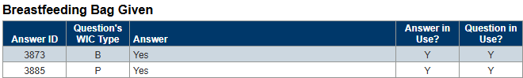
Columns: Answer ID, Question’s WIC Type, Answer, Answer is Use?, Question in Use?
Grouped by: Local use question.
Tab 2 – List-Answer
Columns: Agency ID, Household ID, State WIC ID, Answer Date, Answer, WIC Type, Race/Ethnicity or Cultural Identity, Language.
Counts: Participants.
Tab 3 –List-No Answer
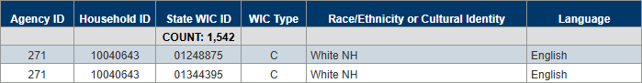
Columns: Agency ID, Household ID, State WIC ID, WIC Type, Race/Ethnicity or Cultural Identity, Language.
Counts: Participants.
Tab 4 – Count
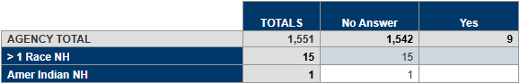
Columns: TOTALS, local use answers.
Rows: AGENCY TOTAL, race/ethnicity or cultural identity.

Cultural Identity – Height/Weight and Completed Cert or MCA
Revised April 22, 2025

Overview
List and count of Asian Non-Hispanic and Black African American Non-Hispanic participants who belong to the specified agency and had a height/weight measurement and a certification or mid-certification assessment (MCA) completed during the specified dates. The output includes the selected Cultural Identity, indicates if an answer wasn’t selected, and provides the total numbers and percents answered.

Some uses
- Identify Asian or Black participants who do not have an answer selected for Cultural Identity.
- Identify staff who performed the contact during the specified dates who may need further training to ensure the Cultural Identity question is answered.
- Obtain a count of participants by Cultural Identity answer and those without an answer.
- Obtain a percentage of participants with answers (and without).
- Identify participants with an incorrect Cultural Identity selected based on Race/Ethnicity.

Prompts
- Agency ID – agency where the participants currently belong.
- Clinic ID(s) – clinic where the participants currently belong.
- Start Date – the first date in the time period during which participants had a height/weight measurement and either a cert or MCA completed.
- End Date – the last date in the time period during which participants had a height/weight measurement and either a cert or MCA completed.

Report outputs
Tab 1 – Participant List
Table 1
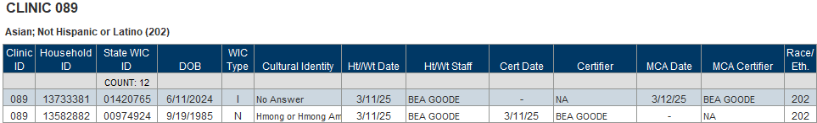
Table 2
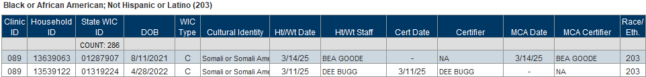
Columns: Clinic ID, Household ID, State WIC ID, DOB (date of birth), WIC Type (at cert/MCA), Cultural Identity (or No Answer), Ht/Wt Date, Ht/Wt Staff, Cert Date, Certifier, MCA Date, MCA Certifier, Race/Eth (ethnicity).
Counts: Participants.
Grouped by: Clinic ID, table 1 – Asian; Not Hispanic or Latino (202); table 2 – Black or African American; Not Hispanic or Latino (201).
Tab 2 – Counts-Clinic
Table 1
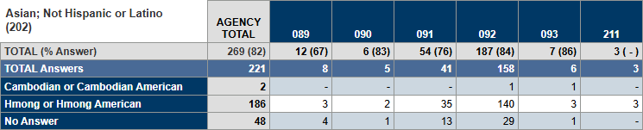
Table 2
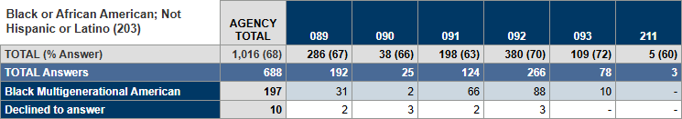
Columns: AGENCY TOTAL, Clinic ID(s).
Rows: TOTAL (% Answer), TOTAL Answers, cultural identity.
Grouped by: Table 1 – Asian; Not Hispanic or Latino (202); table 2 – Black or African American; Not Hispanic or Latino (201).
Tab 3 – Counts-Staff
Table 1
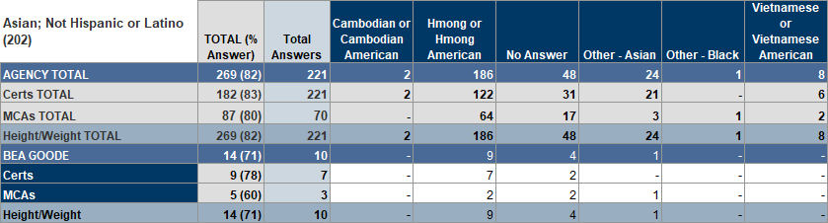
Table 2
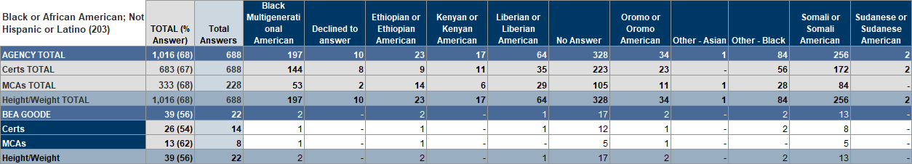
Columns: TOTAL (% Answer), TOTAL Answers, cultural identity.
Rows: AGENCY TOTAL, Certs TOTAL, MCAs TOTAL, Height/Weight TOTAL; staff name, Certs, MCAs, Height/Weight.
Grouped by: Table 1 – Asian; Not Hispanic or Latino (202); table 2 – Black or African American; Not Hispanic or Latino (201).

Cultural Identity – New Participants
Revised Jan. 21, 2025

Overview
A list and count of new participants with a race ethnicity of Asian Non-Hispanic or Black African American certified during the specified time period at the specified agency. Participants are included in the output regardless of whether an answer is selected for the cultural identity state use question. Counts are provided by clinic and certifier and include percentage with cultural identity collected.

Some uses
- Assess whether Cultural Identity is being collected for new participants.
- Identify staff who may need more training to ensure Cultural Identity is collected.

Prompts
- Agency ID – agency where the participants were certified.
- Start Date – the first date in the time period during which participants were certified.
- End Date – the last date in the time period during which participants were certified.

Report outputs
Tab 1 – Participant List
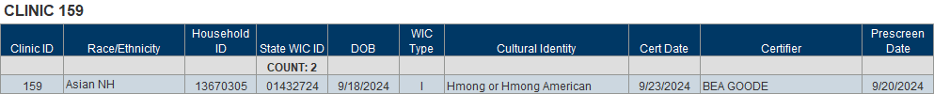
Columns: Clinic ID, Race/Ethnicity, Household ID, State WIC ID, DOB (date of birth), WIC Type, Cultural Identity, Cert Date, Certifier, Prescreen Date.
Counts: Participants.
Grouped by: Clinic ID, Table 1- Asian Non-Hispanic; Table 2 – Black African American Non-Hispanic.
Tab 2 – Count by Clinic
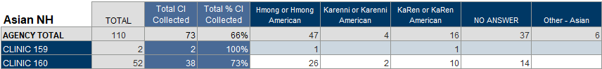
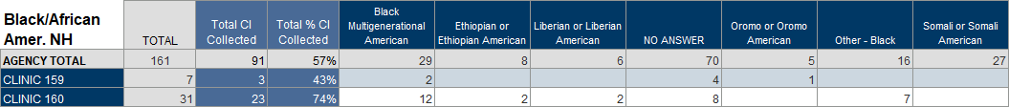
Columns: TOTAL, Total CI (cultural identity) Collected, Total % CI Collected, cultural identity.
Rows: AGENCY TOTAL, clinic ID(s).
Grouped by: Table 1- Asian Non-Hispanic; Table 2 – Black African American Non-Hispanic.
Tab 3 – Count by Certifier
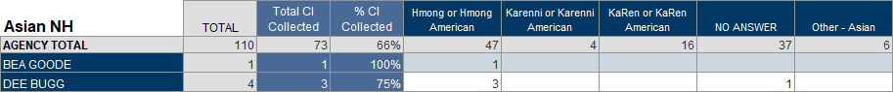
Columns: TOTAL, Total CI Collected, Total % CI Collected, cultural identity.
Rows: AGENCY TOTAL, staff name.
Grouped by: Table 1- Asian Non-Hispanic; Table 2 – Black African American Non-Hispanic.

State Use Questions >> Breastfeeding Exclusivity

No Answer to Breastfeeding & Formula Supplementation State Use Question
Revised March 17, 2025

Overview
List and count (and percentage) of certified participants who do not have an answer to the “First time formula/other given to infant (meds OK)” state use question. Participants are included if they currently belong to the specified agency and were born during the specified dates. Participants are listed by the most recent certifier if without an answer. Counts and percentages are provided by certifier (no answer) and by answers (including no answer).

Some uses
- Identify participants needing the State Use Question to be completed.
- Identify staff who may require further training to ensure the question is answered.

Prompts
- Agency ID – agency where the participants currently belong.
- Start Date – the first date in the time period during which participants were born.
- End Date – the last date in the time period during which participants were born.

Report outputs
Tab 1 – Participant List
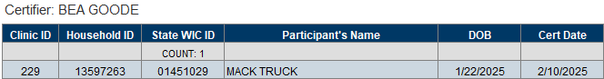
Columns: Clinic ID, Household ID, State WIC ID, Participant’s Name, DOB (date of birth), Cert Date.
Counts: Participants.
Grouped by: Staff name.
Tab 2 – Count-Certifier
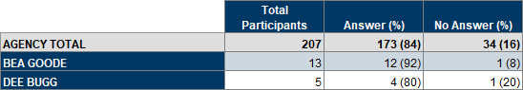
Columns: Total Participants, Answer (%), No Answer (%).
Rows: AGENCY TOTAL, staff name.
Tab 3 – Count-Answer
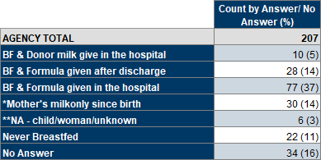
Columns: Count by Answer/No Answer (%).
Rows: AGENCY TOTAL, state use answers.

Terminated/Ineligible

Terminated for Failure to Pick Up
Revised Oct. 14, 2024

Overview
A list and count of participants who belong to the specified agency and whose most recent certification was auto-terminated for “failure to pick-up” during the specified time period. This report also provides a count by race/ethnicity and cultural identity by WIC type for the specified agency, its clinics and the state. A percentage of the total is provided for each race/ ethnicity and cultural identities for the specified Agency and State. There are four tabs that can be used to create mailing labels. Tab 4 is to create labels for the household by authorized rep, Tab 5 by participant, Tab 6 is for children only and can be filtered by age in months using an optional input control, and Tab 7 lists only women. Another optional input control allows you to filter Tab 1 – List for all, multiple or specific race ethnicities or cultural identities.

Some uses
- Improve retention by identifying participants who haven’t returned to pick up benefits.
- Identify specific race ethnicities or cultural identities that may be failing to pick up benefits.
- Obtain a count of participants terminated for failure to pick-up by race/ethnicity and cultural identity, and WIC Type for the specified agency, its clinics, and the state.
- Create mailing labels for outreach.

Prompts
- Agency ID – agency where the participants currently belong.
- Start Date – the first date in the time period during which participants were terminated for failure to pick-up.
- End Date – the last date in the time period during which participants were terminated for failure to pick-up.

Report outputs
Tab 1 – List
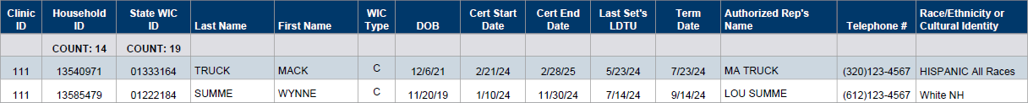
Columns: Clinic ID, Household ID, State WIC ID, Last Name, First Name, WIC Type, DOB (date of birth), Cert Start Date, Last Set’s LDTU, Term (termination) Date, Authorized Rep’s Name, Telephone #, Race/Ethnicity or Cultural Identity.
Counts: Households and participants.
Tab 2 – Count
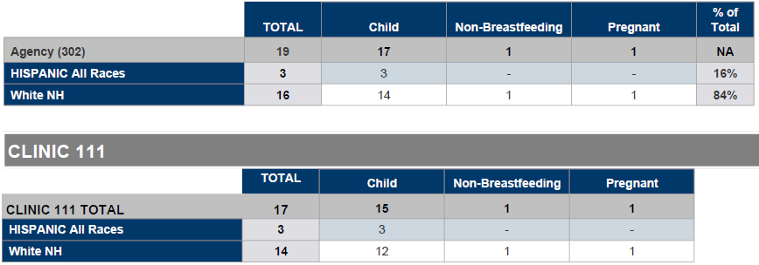
Columns: TOTAL, WIC Type(s), % of Total.
Rows: Table 1 – Agency ID, race/ethnicity or cultural identity; Table 2 – CLINIC ID TOTAL, race/ethnicity or cultural identity.
Grouped by (table 2): CLINIC ID(s).
Tab 3 – State Count
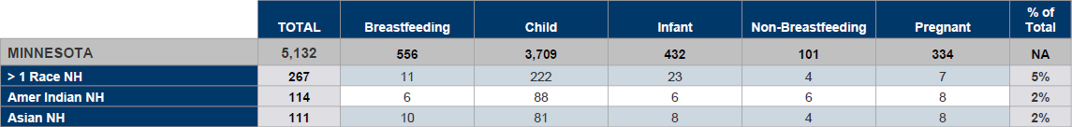
Columns: TOTAL, WIC Type(s), % of Total.
Rows: MINNESOTA, race/ethnicity or cultural identity.
Tab 4 – HH Auth Rep Labels
Columns: Clinic ID, Household ID, Authorized Rep’s Name, Address (Mail), City, State, Zip Code.
Tab 5 – Ppt Labels
Columns: Clinic ID, State WIC ID, Participant’s Name, Address (Mail), City, State, Zip Code.
Tab 6 – Children-Outreach
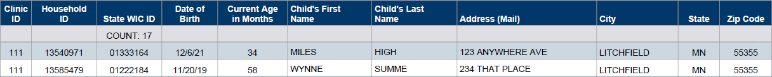
Columns: Clinic ID, Household ID, State WIC ID, Date of Birth, Current Age in Months, Child’s First Name, Child’s Last Name, Address (Mail), City, State, Zip Code.
Tab 7 – Women-Outreach
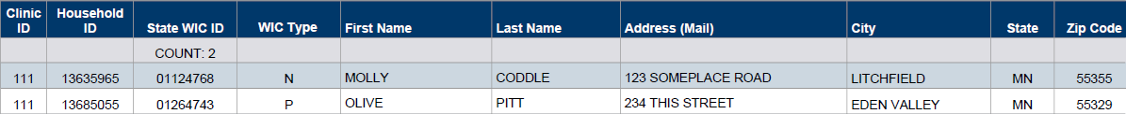
Columns: Clinic ID, Household ID, State WIC ID, WIC Type, First Name, Last Name, Address (Mail), City, State, Zip Code.

Vendor

Stores & Pharmacies by County
Revised April 23, 2025

Overview
Lists of active stores and pharmacies based on specified counties. Lists are provided by name and by city. An OPTIONAL input control filters the output by selected cities.

Some uses
- Obtain a list of WIC-allowed stores in a specific county/city for participants.
- Obtain a list of WIC-allowed pharmacies in a specific county/city for participants.

Prompts
County Name – the county where the stores and pharmacies are located (the county must be spelled correctly).

Report outputs
Tab 1 – Stores by Name
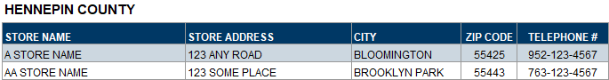
Columns: Store Name, Store Address, City, Zip Code, Telephone #.
Grouped by: County.
Tab 2 – Stores by City
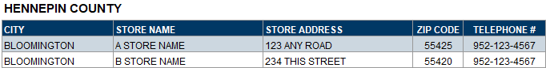
Columns: City, Store Name, Store Address, Zip Code, Telephone #.
Grouped by: County.
Tab 3 – Pharmacies by Name
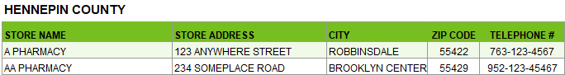
Columns: Store Name, Store Address, City, Zip Code, Telephone #.
Grouped by: County.
Tab 4 – Pharmacies by City
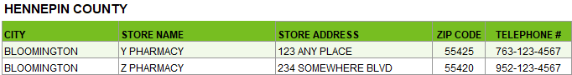
Columns: City, Store Name, Store Address, Zip Code, Telephone #.
Grouped by: County.

WIC App

WIC App & Household Registrations
Revised April 8, 2025

Overview
Lists and counts of households, with at least one currently certified member, that belong to the specified agency and are, or are not, registered for the Minnesota WIC App. The report output has a Not Registered tab for both the specified agency and statewide that includes the household’s auth rep, address, and household language for potential outreach. The Registered tab includes a column for the default language selected for the App and whether the household has opted in for Contact Us. Counts are included by clinic for the specified agency and by agency statewide. An optional input control can be used to filter the agency outputs by clinic.

Some uses
- Identify certified households not registered for the Minnesota WIC App and the household’s primary language for agency or statewide outreach.
- Identify certified households registered for the App and whether they are opted in for Contact Us and the default language for their app.
- Obtain counts of registered, not registered, opted in and households with an app language other than English, as well as percentage of certified households registered for both the specified agency and statewide.

Prompts
Agency ID – agency where the members of the household currently belong.

Report outputs
Tab 1 – Not Registered
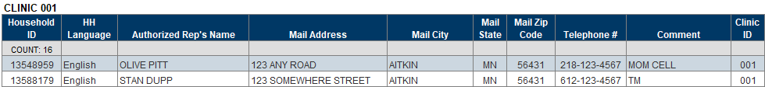
Columns: Household ID, HH (household) Language, Authorized Rep’s Name, Mail Address, Mail City, Mail State, Mail Zip Code, Telephone #, Comment, Clinic ID.
Counts: Households.
Grouped by: Clinic ID(s).
Tab 2 – Registered
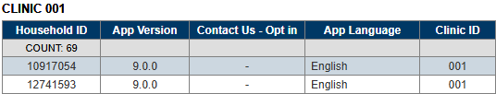
Columns: Household ID, App Version, Contact Us – Opt in, App Language, Clinic ID.
Counts: Households.
Grouped by: Clinic ID(s).
Tab 3 – Counts
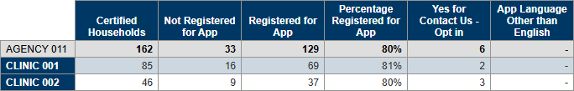
Columns: Certified Households, Not Registered for App, Registered for App, Percentage Registered for App, Yes for Contact Us – Opt in, App Language other than English.
Rows: AGENCY ID, CLINIC ID(s).
Tab 4 – STATE-Not Registered
Columns: Household ID, HH (household) Language, Authorized Rep’s Name, Mail Address, Mail City, Mail State, Mail Zip Code, Agency ID.
Counts: Households.
Tab 5 – STATE-Counts
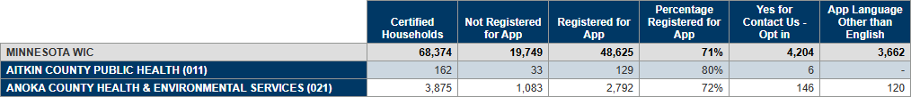
Columns: Certified Households, Not Registered for App, Registered for App, Percentage Registered for App, Yes for Contact Us – Opt in, App Language other than English.
Rows: MINNESOTA WIC, AGENCY NAME (IDs).

WIC App & Counts of Household Registrations by Language
Revised April 8, 2025

Overview
Counts by specified agency and statewide of households, with at least one currently certified member, that are or are not registered for the Minnesota WIC App by language. Includes a percentage of registered households.

Some uses
Obtain counts of registered and not registered households by language (assessment of language barriers for using apps, etc.).

Prompts
Agency ID – agency where the members of the household currently belong.

Report outputs
Tab 1 – AGENCY Counts
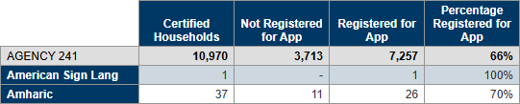
Columns: Certified Households, Not Registered for App, Registered for App, Percentage Registered for App.
Rows: AGENCY ID, language.
Tab 2 – STATE Counts
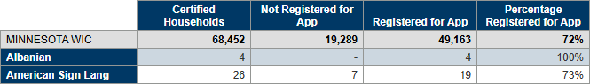
Columns: Certified Households, Not Registered for App, Registered for App, Percentage Registered for App.
Rows: MINNESOTA WIC, language.
Minnesota Department of Health - WIC Program, 625 Robert St N, PO BOX 64975, ST PAUL MN 55164-0975; 1-800-657-3942, health.wic@state.mn.us, www.health.state.mn.us; to obtain this information in a different format, call: 1-800-657-3942.
This institution is an equal opportunity provider.

