

Inspiring Partners to Strengthen Public Health in Minnesota
  - Training workbook

Target Audiences & Objectives
Choose three audiences, note three objectives, and identify three specific partners critical to the success of your strategy.
This exercise isn’t designed to produce an exhaustive list, but to encourage focused thinking and decision-making about target audiences and objectives.
Audiences  Who needs to act? | Objectives  What do they need?

Sample Partners
[enter text here]

Narrative Framework
The core message is organized in a simple but powerful Narrative Framework, based on multicultural studies, motivational psychology, and other field of research. This framework reflets a common way that people across many cultures think about the world and communicate their ideas.
It creates a complete, coherent narrative that motivates people to support our work by putting our audience in the role of the protagonist so they “see themselves” reflected (people). The goals are their aspirations, and the problems are the challenges or needs they face in realizing those aspirations. The solutions are things we do to meet those needs and help people achieve their goals. Defining public health with clear, relevant examples will help make sure that all audiences understand the value of our work.

Value of Public Health: There’s Nothing that Public Health Can’t Positively Impact
Public health experts partner with their communities to overcome all types of barriers people face to living their healthiest lives.


People: A Community of Experts and Leaders
Public health experts, elected officials, and community members are proud of the work they do to keep Minnesotans healthy.


Goal: Help All Minnesotans Live their Healthiest Lives
Everyone in Minnesota should have the opportunity to be healthy, regardless of their age, race, or where they live.


Problem: Minnesota’s Approaches are Out of Date
Minnesota’s approach to public health was designed more than 50 years ago and doesn’t meet today’s funding and resource challenges.


Solution: Invest in a New Approach
It’s time to invest in a new approach that embraces fair funding and creative collaboration to meet today’s complex needs.

Aspirational Narrative Brainstorm
In each section below, write words and phrases that come to mind. You’ll use these notes to craft a narrative about your challenge.

Value of Public Health
How does public health make a positive impact in your community?
[enter text here]

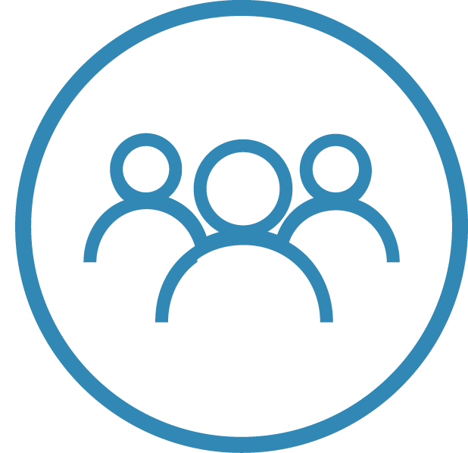 | People  Who are the community experts and leaders that need to work together? What shared values do they hold?
[enter text here]

 | Goal  Our goal is to help all Minnesotans live their healthiest lives. What does that look like in your community?
[enter text here]

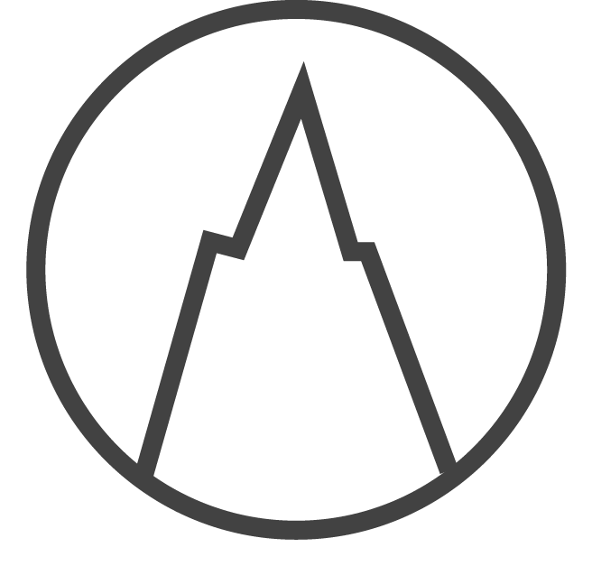 | Problem  What barriers does the current governmental public health system create in your community?
[enter text here]

 | Solution  How can a better public health system help you solve the challenge before you? How does your community benefit?  How do all Minnesotans benefit? What are the tangible and financial benefits?
[enter text here]

Next Steps: One-Minute Message
Drawing ideas from the previous pages, write a One-Minute Message about the challenge you’re facing.
[enter text here]

Minnesota Department of Health
Community Health Division
651-201-3880
health.ophp@state.mn.us
www.health.state.mn.us/systemtransformation
May 2024
To obtain this information in a different format, contact: 651-201-3880 | health.ophp@state.mn.us

