Minnesota’s
most dangerous leftovers
Don’t flush unused or expired medications and don’t throw them in the trash. Safely dispose of them at one of Minnesota’s 240+ disposal drop boxes at no charge.
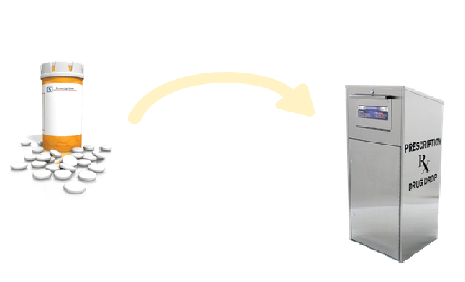
YOUR NEAREST DROP BOX LOCATION is at:
[Address]
FOR MORE INFORMATION:
WWW.HEALTH.STATE.MN.US/OPIOIDDASHBOARD

