

Continuity Completion Guide
  - August 2024
Contents
How to Use this Completion Guide 4
Introduction 5
Continuity Fundamentals 6
Continuity Basics 7
COOP Planning Elements 7
Continuity Terminology 8
Step 1: Prepare 8
Project Management 8
Meeting Facilitation 9
Executive Leadership Engagement 9
Identify Planning Team 9
Formatting and Branding 10
Step 2: COOP 11
Cover Page 11
Promulgation Statement 11
Approval and Implementation 11
Confidentiality Statement 12
Record of Changes 12
Record of Distribution 13
Introduction 14
Operational Profile 15
Essential Functions 15
Supporting Essential Activities 19
Human Resources 21
Communications 22
Continuity Facilities 23
Reconstitution 24
Devolution 25
Step 3: Train and Exercise 25
Step 4: Evaluate and Improve 26
Acknowledgements 27
Attachment A: Project Management Samples 28
Attachment B: Sample Planning Meeting Agendas 30
Continuity Planning Meeting #1 Agenda 30
Continuity Planning Meeting #2 Agenda 31
Continuity Planning Meeting #3 Agenda 32
Attachment C: Maximum Tolerable Downtime (MTD) 33

How to Use this Completion Guide
This Completion Guide provides a planning roadmap to develop and/or revise an organization’s Continuity of Operations (COOP) Plan.
This Completion Guide is formatted to work in conjunction with the COOP plan template found at the Minnesota Department of Health Health Care Business Continuity and Recovery website (https://www.health.state.mn.us/communities/ep/coalitions/coop/index.html). The best practices and activities will form the foundation of an organization’s COOP plan and should be documented in the continuity plan template.
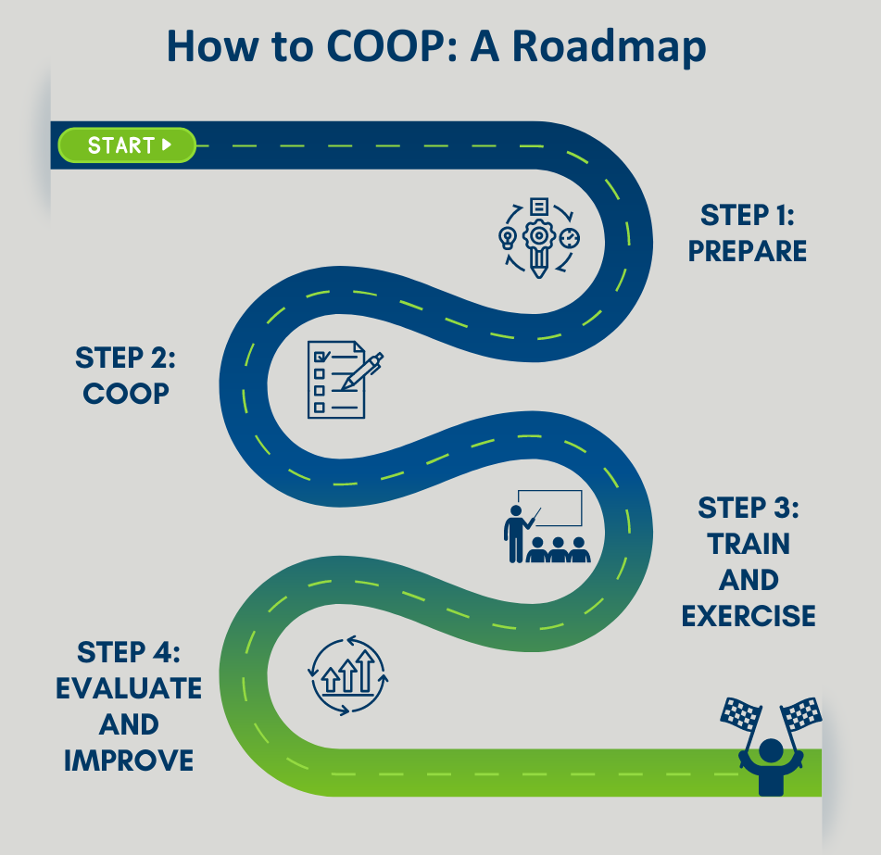
 | Best Practice icon identifies planning considerations and recommendations for continuity planning.

 | Activity icon identifies planning activities to support an organization in developing its individualized continuity plan. The activities should be documented in the organization’s COOP plan template.

Introduction
This Continuity Planning Toolkit for Rural Health Care Completion Guide is intended to inform the development of a health care facility Continuity of Operations (COOP) Plan. Upon completion of this guide a facility or individual department can expect to have a draft COOP plan. For those with an established COOP Plan, this guide may be used as a planning and recommendation checklist for use during a review and revision process.
The intended audience for this document is small, rural health care facilities with limited staff available to support continuity planning. However, any health care facility would likely benefit from the Continuity Planning Toolkit for Rural Health care.
The final Toolkit can be found at the Minnesota Department of Health Health Care Business Continuity and Recovery website (https://www.health.state.mn.us/communities/ep/coalitions/coop/index.html) or by contacting the Regional Health Care Preparedness Coordinator(s) (RHPC). A current list of RHPCs can be found at the Minnesota Department of Health Regional Health Care Preparedness Coordinators (RHPCs) website (https://www.health.state.mn.us/communities/ep/coalitions/rhpc.html).
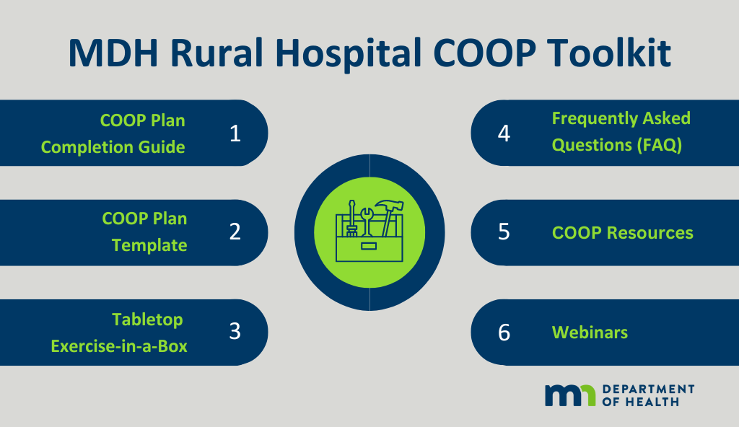
Finally, this completion guide is intended to be used as guidance; as appropriate, utilize the information in this document as it best fits the organization.

Continuity Fundamentals
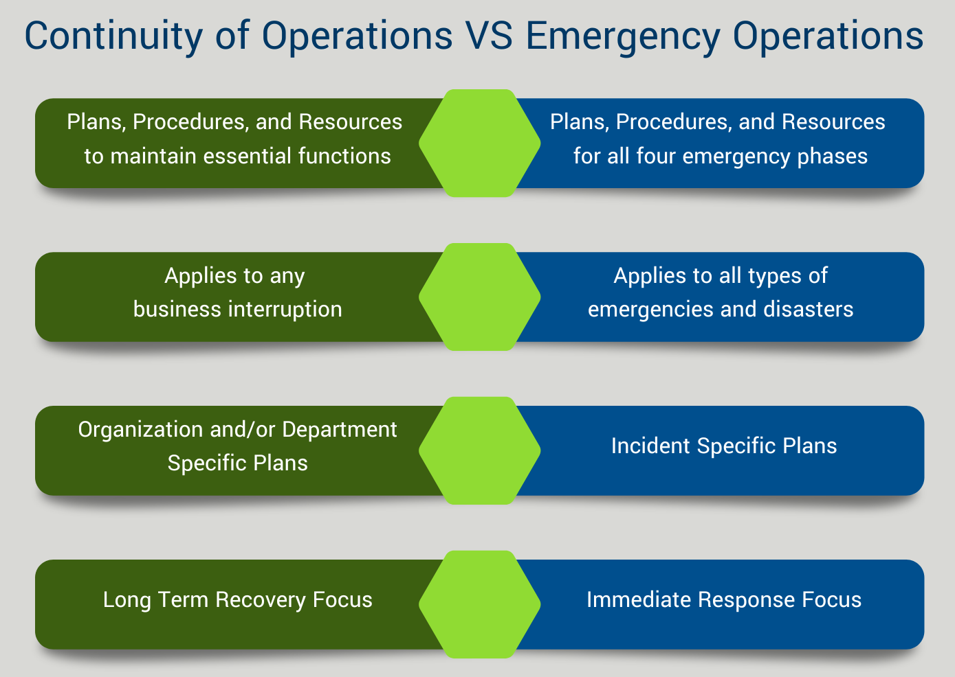Continuity of Operations Planning vs. Emergency Operations Planning
The Continuity of Operations (COOP) Plan is intended to complement the Emergency Operations Plan (EOP) and should be developed in coordination with the EOP. As shown above, the EOP has an emphasis on the four emergency phases (Mitigation, Preparedness, Response, and Recovery), while COOP planning has an intentional focus on essential functions. The COOP Plan may be used for any number of business interruptions, ranging from unforeseen staff absenteeism for one shift to a catastrophic loss of the building. An EOP, however, is intended to address emergencies and disasters, but may not have the same type of application for a business interruption. A COOP Plan may be written for the organization and/or a specific department with the objective of maintaining essential functions for the overall organization and/or department and allowing for scalable application based on the size and scope of the business interruption. An EOP will have incident specific plans that emphasize all-hazards planning. Finally, COOP planning has an inherently long term-recovery focus; an organization may use COOP for a brief period of time but ultimately a COOP Plan is intended to ensure essential functions are viable 12-hours post business interruption, with an objective of up to 30 days. An EOP has more of an immediate response focus, with planning focused on the initial incident response periods.

Continuity Basics
The purpose of COOP is to ensure the continuation of the essential functions, the services or operations that cannot be paused, should an event occur (human-caused or naturally occurring) that would disrupt the organization.
Continuity planning is an effort to document the existence of and seek the capability to continue essential functions during a wide range of potential emergencies.

COOP Planning Elements
The following planning elements are required to ensure a continuity plan is comprehensive and practical:
Essential Functions (EF): A limited set of organization-level functions or duties that should be continued throughout (or resumed rapidly) after a disruptive event.
Orders of Succession: Provisions for re-assigning senior leadership roles during an emergency in the event any of the leaders are unavailable to execute their duties.
Delegations of Authority: Identifying, by position, boundaries for decision making to ensure safeguards are in place for a person operating in a position they may not typically be assigned.
Continuity Facilities: Locations where leadership and critical services may operate during a continuity event. These may include alternate locations or virtual offices from which to continue essential operations.
Continuity Communications: The systems which support full communications among leadership, internal elements, and other organizational entities to perform essential functions during a continuity activation.
Vital Records: Vital records management is the identification, protection, and availability of information systems and applications, electronic and hardcopy documents, references, and records needed to support essential functions during a continuity event.
Human Resources: Involves policies, plans, and procedures which offer guidance on pay, leave, work scheduling, benefits, telework, hiring, authorities, and flexibility during a continuity event.
Devolution: The capability to transfer statutory authority and responsibility for the health care facility’s functions from the primary operating staff and facilities to another organization’s employees and facilities, specifically after a catastrophic event.
Reconstitution: The process by which an organization resumes normal operations from the original and/or replacement of the primary operating site(s).
Training, Exercises, and Review: Provides the skills and familiarizes personnel with procedures and tasks. Tests and exercises serve to assess and validate all the components of continuity, policies, procedures, systems, and facilities.

Continuity Terminology
Business Continuity (BC): The capability of the organization to continue delivery of products or services at acceptable predefined levels following a disruptive incident.
Continuity of Care: Viable as a result of EOP and COOP Planning. Per the World Health Organization (WHO) “Continuity of care is the degree to which a series of discrete health care events is experienced by people as coherent and interconnected over time and consistent with their health needs and preferences.”
Continuity of Operations (COOP): The organizational plan to ensure the performance of essential functions during a wide range of emergencies and events.
Emergency Operations Plan (EOP): Base plan for emergency management planning that is typically activated in response to an incident and covers the first 0-96 hours of an incident. The focus of the EOP is to manage an emergency.
Information Technology Disaster Recovery (IT/DR): The IT plan on how to recover from a disruptive event.

Step 1: Prepare
The following planning strategies are intended to support the development of a COOP plan that has not been updated and/or used in several years. These strategies are also intended to support someone who is new to continuity planning and/or emergency management.

Project Management
It is recommended to pause before a significant planning process is started to ensure a reasonable timeline has been identified. The timeline should account not only the deadline of the plan, but to discuss if there are any other factors to take into consideration with the planning process, such as an upcoming survey, or other external factors.
When creating a project management plan, answer the following questions:
- Is the facility in its Joint Commission, Center for Medicaid, and Medicare Services (CMS), or other accreditation survey window?
- Is the facility required to complete and/or revise a COOP Plan as a part of a plan of correction?
- What date does the draft need to be completed by?
- What date does the final plan need to be completed by?
If this is a new area of planning, please see the sample COOP project management plan in Attachment A: Project Management Samples to help start the process.
Note: The tasks and deadlines are based on a 3-month completion timeline, but a facility can adjust based on their internal timeline.

Meeting Facilitation
Once a strategy has been identified for how to develop a Continuity Plan, the next step is preparing for upcoming meetings.
Please see the sample COOP planning meeting agendas in Attachment B: Sample Planning Meeting Agendas to help prepare for these planning meetings.
This project may be a part of an existing committee and/or workgroup. The most important aspect of project management for this plan is to ensure a project lead(s) has been identified who will be responsible for the completion of the facility COOP Plan.

Executive Leadership Engagement
Depending on the size of the facility, someone from the executive leadership team may already be regularly involved in the development of the emergency management plans. If, however, that is not the case, identifying an executive sponsor to participate in the continuity planning process will be a vital step in the initial planning process.
The executive sponsor effectively serves as the spokesperson for the leadership team and ensures the continuity plan is afforded the appropriate level of review, in alignment with the organization’s mission, vision, and values. This ideally should be a person comfortable advocating on behalf of the continuity planning team regarding plan requirements, funding requests, approval of staff time for planning development efforts, and final plan approval from the highest level of leadership in the organization.
Examples of an executive sponsor are: Chief Operating Officer (COO), Hospital Administrator, Long Term Care Administrator, Chief Medical Officer (CMO), Chief Nursing Officer (CNO), Director of Nursing (DON), Director of Quality, Chief Financial Officer (CFO), and/or Chief Information Officer (CIO).

Identify Planning Team
The most important activity, aside from the actual writing of the plan, is identifying the team to support the plan writing process.
The planning team may shift over time but there are a few key roles which need to be present consistently through the continuity planning process to ensure alignment with the facilities capabilities and capacity.
Writing a COOP Plan should involve an interdisciplinary team with representation from the varying departments which support the organization’s day-to-day operations. However, due to time and staffing constraints, the organization may be looking for the most efficient means of completing a COOP Plan to support the emergency management program.
The key word here is “support” – these department representatives may not necessarily participate in every part of the continuity planning process, but they could be involved in one or more activities as it relates to meetings and document development.
The key partners who should review the continuity plan to ensure deconfliction of resources and other internal plans will be Human Resources (HR), Information Technology (IT), Facilities, and the Executive Sponsor. Don’t forget to identify and document who oversees this process and/or whoever has been assigned to write the continuity plan.
Identify the planning team. At a minimum, identify a continuity planning lead, HR, IT, and facilities representative and an executive sponsor.

Planning Team Identification Table
Planning Team Representative | Name
Continuity Planning Lead(s)
HR
IT
Clinical Lead
Quality
Facilities
Executive Sponsor

Formatting and Branding
Check with the department or person responsible for community relations and/or communications to ensure the document aligns with the facility plan requirements/ templates and meets the correct branding format.
Just get started! Don’t worry too much about the right font or colors but start getting the content onto paper. If no one on the planning team is comfortable with formatting, identify someone to help.

Step 2: COOP
Use the COOP plan template provided in this Toolkit to write the COOP plan. If there is an existing COOP, the following information can still be used to review and update the existing COOP plan.

Cover Page
The cover page should indicate the title of the plan, the date it was issued, and its version. The organization and/or facility logo will typically be on the cover page. Be sure to check with the communication department to ensure the correct branding.
Review an existing plan. Confirm the cover page matches and/or aligns with the organization’s EOP and/or other annexes.

Promulgation Statement
This statement gives the plan official status and explains the authority and responsibility of organizations identified in the plan.
Identify what authority the organization has as it relates to continuity planning and whose responsibility it is.
Ensure a statement of support is included citing the executive leadership team.

Review the promulgation statement in the COOP plan template. Update the language to reflect the organization’s name and other facility specific information.

Approval and Implementation
This section is designed to introduce the continuity plan and provide a high-level outline of what is included. Language related to the most current version and past versions being superseded should be included to support version control. Finally, this section should be where the authorizing signature is documented.
Get it on the schedule! A signature will be needed on the final plan; ask the identified executive sponsor to schedule a meeting two weeks prior to the deadline for whoever is identified as the signatory for the COOP plan.
Policy support. Determine if there is specific language that needs to be included to meet the organization’s policy requirements.

Review the approval and implementation in the COOP plan template. Update the signature line to reflect the correct name and title. Be sure to include a space for the date it is signed and update the cover page with the approval date once this step is complete.

Confidentiality Statement
The COOP plan will have sensitive information, such as location of equipment and contact information, and will need some parameters for who is permitted to access it. A confidentiality statement may serve as a gatekeeper for the document and provide clarity for staff if this is, or is not, a document that should be accessed and/or shared.
Watermark! If this document is “For Official Use Only” be sure to add a watermark (or statement in the header or footer.)
Talk to legal. This may be a quick email with the section language included asking the legal and/or policy department if the statement is appropriate

Review the confidentiality statement in the COOP plan template. Update this section based on the organization’s legal and/or policy department recommendations.

Record of Changes
Each update or change to the plan should be tracked. The record of changes, usually in table format, contains, at a minimum, the date of the change, the name of the person who made the change, the section that was changed, and a summary of the change.
If the organization utilizes a software program to monitor and manage policies and procedures, please reference that in lieu of a record of changes table.
Under “Page # / Section” ensure to put section titles and not simply the page numbers, as page numbers will shift as the document is updated.
These are for larger changes such as changes to annexes or sections. If the change is small, such as changing a word or sentence, those do not need to be documented unless they make a substantiative change to the overall operating procedures of the COOP plan.
Make sure this plan is reviewed at least annually, and that it’s being documented.

Review the record of changes table in the COOP plan template. Update based on the facility requirements and/or preference.

Record of Distribution
The record of distribution, usually in table format, indicates the title and the name of the person receiving the plan, the agency to which the recipient belongs, and the date of delivery. It can be used to prove that tasked individuals and organizations have acknowledged their receipt, review, and/or acceptance of the plan.
Copies of the plan may be made available to the public and media, but all sensitive information should be redacted.
Distribute to partners. While the majority of the plan will only apply to the organization it has been developed for, external partners, such as emergency management, public health, and/or the health care coalition, may benefit from understanding the plan and provide valuable insights into how they might support the facility during a continuity incident.
Track for control. Knowing which departments and/or agencies have received a copy of this plan will support the annual review process and version control practices.

Review the Record of Distribution table in the COOP plan template. Update based on the facility requirements and/or preference.

Introduction
The following sections will introduce the plan background and boundaries.

Purpose
Why a plan has been developed should be one of the first items communicated in a plan. The purpose section lays the foundation for the document, explaining why the document was developed and what it is meant to do. It should also identify, if applicable, which plan(s) and/or annexes it supports.
Elevator pitch. Make the purpose section the “elevator pitch;” it should explain why the plan was developed in 100 words or less.
Cite support. Be sure to include a sentence that explains which plan(s) and/or annexes it supports.
Review the purpose in the COOP plan template. Update the language to reflect the organization name and other facility specific information.

Scope
If we try to accomplish everything in one document, chances are it will be difficult to apply during a real-world response. Boundaries help to establish a manageable span of control, and for planning specifically, ensures the information included applies to the objectives of the plan.
The scope section should clearly identify who the plan does or does not apply to. It also should identify under what conditions it would be activated.
Facility wide or department. Be sure to identify if this continuity plan is for the facility and/or organization, or if it applies to an individual department.
Geography. If the organization operates in different communities, be sure to identify which geographic area this plan applies to.

Review the scope in the COOP plan template. Update the language to reflect the organization name and other facility specific information.

Operational Profile
Understanding the basic operations of a facility and/or organization allows the continuity program to begin to take shape. It also helps whoever is reading the plan to conceptualize how and who this plan would support.
Engage management. Talk with the facility and/or department management to complete this section; this could take as little as 10 minutes and could be completed during an already scheduled meeting.

Review the operational profile table in the COOP plan template. Update to reflect the facility and/or department specific information.

Essential Functions
Essential functions are the activities an organization determines cannot be deferred during an emergency. This should not be an exhaustive list of day-to-day operations, but rather a limited set of functions continued throughout disruption or resumed rapidly. Essential functions are intended to be resumed within 12 hours of a continuity incident, with the continuity plan ensuring 30 days of business continuity.
Mission and Vision. Review the facilities mission and/or vision statements and consider how they should guide the identification of essential functions.
Single Point of Failure. What services does the facility provide that no one else in the community can provide? This may be an essential function(s).
Impact. Consider if there would be an impact to patient and/or staff safety or facility infrastructure.

Identify the essential function(s). The following activities are a multi-step process and intended to build on each other. Upon completion of all activities, essential functions and supporting essential activities will be identified.

To identify Essential Functions, follow this 4-step process. The “Identifying Your Essential Functions” graphic below explains the 4-step process steps, which can be used for an organization or each individual department.
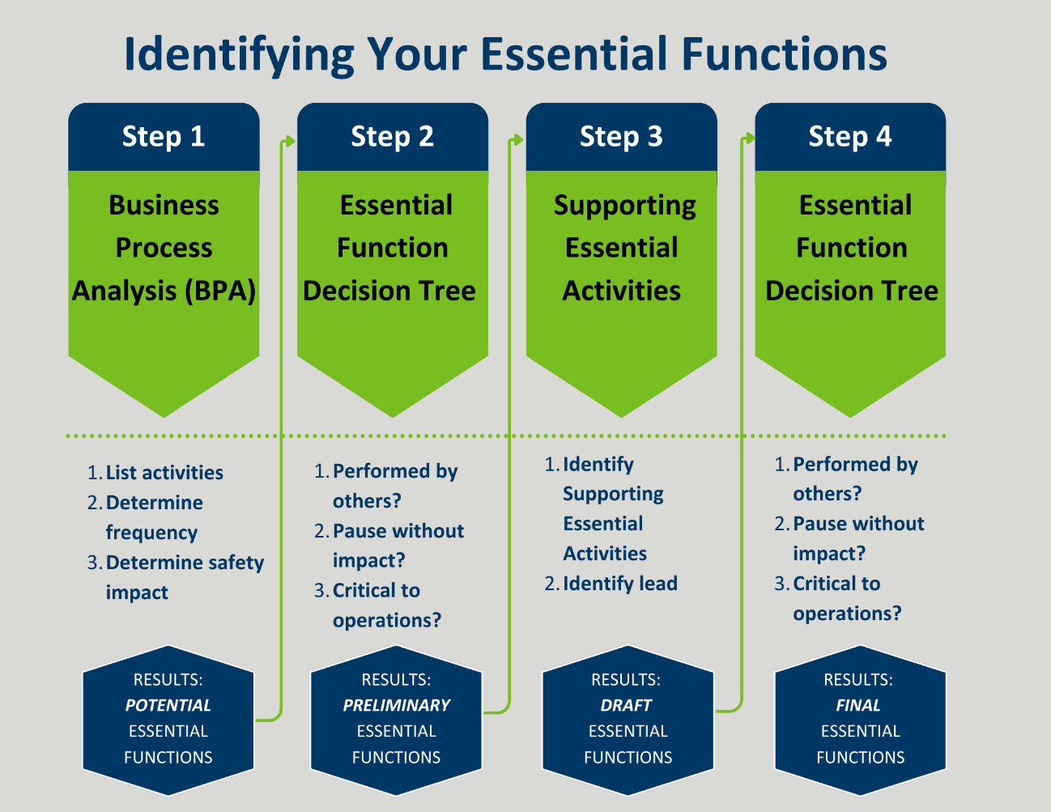

Step 1: Business Process Analysis
Step 1: Hybrid Business Process Analysis (BPA). A BPA identifies the distinct functions and outputs (i.e., business processes) of a facility and/or department. This is the first step in identifying the essential function(s). Complete the table below based on any function or output (service) of the facility or department.

Business Process Analysis Table
Function/Service | Daily? | Weekly? | Monthly? | Patient Impact? | Staff Impact? | Space Impact?
These are the POTENTIAL ESSENTIAL FUNCTIONS.
Look for themes. Review the potential essential functions and look for themes. Can any of these be combined?

Following Step 1 there should be a list of potential essential functions /services for the organization. To begin, use those functions/services which must be performed daily, and move on to Step 2.

Step 2: Essential Functions Decision Matrix
Step 2: Essential function(s) decision matrix. Review the function/services in the completed table above by taking each through the decision tree below. Fill out the table below with the final answers.
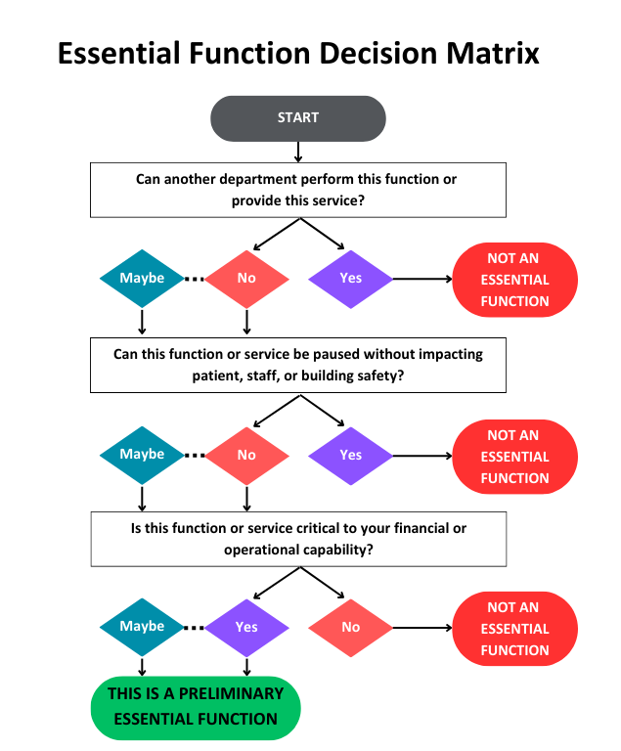
These are the PRELIMINARY ESSENTIAL FUNCTIONS.

Preliminary Essential Function(s)

Step 3: Supporting Essential Activities
Step 3: Identify supporting essential activities. Review the preliminary essential functions and consider what support they would need to be completed. Draft at a minimum one and no more than five supporting essential activities per essential function in the tables below with the lead (department or role) identified.

Supporting essential activities are sub-tasks which are necessary for the success of an essential function. Use the preliminary essential functions and identity supporting essential activities.

Preliminary Essential Function Table: [Preliminary Essential Function]
Supporting Essential Activities: | Lead(s)

Step 4: Essential Function Decision Matrix
Step 4: Finalize the essential function(s). Review the preliminary essential functions and supporting essential functions from above and use the decision matrix again.

Apply the list of supporting essential activities from above to the decision matrix.
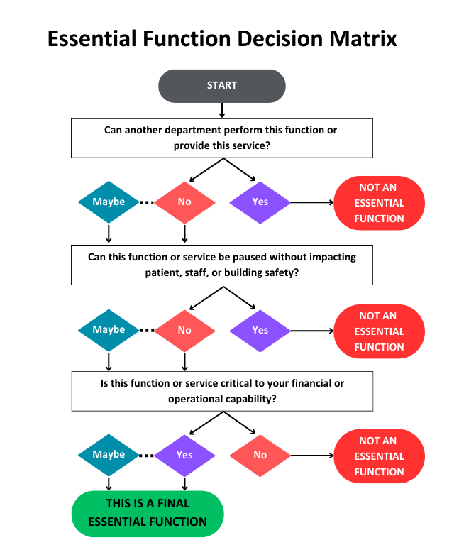
These are the FINAL ESSENTIAL FUNCTIONS.
Document the final essential functions in the COOP Plan Template and identify a lead for each.

Supporting Essential Activities
Now that the Final Essential Functions have been identified, identify their supporting essential activities. Just as Step 3 above, review each essential function and consider what support they would need to be completed.
Add these to the COOP Plan Template and continue the steps below with these Essential Functions and Supporting Essential Activities in mind. Essential Records and IT Functions
As an organization works towards achieving continuity planning the primary considerations for successful completion mean the following have been planned for: identification, protection, and availability of information systems and applications electronic and hardcopy documents, references, and records needed to support essential functions.

Vital Records
Essential Records Packet. This may be both electronic and/or hardcopy documents. The goal is to develop and maintain an essential records packet for each essential function so that when a continuity incident occurs, the guidance documents and forms needed to assure essential function(s) is/are immediately available.

Identify essential records in the COOP plan template. Review the essential function(s) and consider which vital record(s) (i.e., Standard Operating Procedure (SOP), Job Action Sheet (JAS), Emergency Operations Plan (EOP)) would be necessary to support the essential functions and/or supporting essential activities. Document these vital records by essential functions in the COOP plan template.

Databases and IT Systems
The health care system has a heavy reliance on information technology systems; from clinical to maintenance records, the ability to use and access these records is vital to the health and safety of health care facilities. Without access to databases and/or IT systems, a facility is at risk for negative outcome events and significant impact to patient care and outcomes.

Maximum Tolerable Downtime (MTD)
Please see Attachment C: Maximum Tolerable Downtime (MTD) to better understand what MTD means.
Information Technology/ Disaster Recovery (IT/DR) Plan. If the organization has an information technology department, reach out to them! It is likely they have an IT/DR Plan already established and it should be reviewed and support the continuity plan, specifically the Essential Records and IT Functions section.

Identify the Essential Information Technology. Review the essential function(s) and consider which information technology systems would be necessary to support essential function(s) and/or supporting essential activities. Document these information technology systems by essential function(s) in the COOP plan template.

Human Resources
An organization’s essential functions are related to and impacted by the availability of staff members. It is vital to identify by essential function the types of staff members necessary, how many will be needed, and the typical shift worked.
This identification process also includes determining orders of succession and delegation of authority which ensures availability of decision makers who have the approval to make operational and/or financial decisions in the event the primary leader is not available or incapacitated.

Orders of Succession
This is a list of trained and qualified individuals who would sequentially assume responsibility for highest levels of authority and/or leadership positions within the department and/or facility.
3 Deep. It is recommended to try and plan "3 deep" for each position; at a minimum, identify a secondary. If there are not enough staff to identify a tertiary that is OK!
Contact information. Should include title and 24/7 contact information.
Implementation guidance. Rules and procedures for implementation.

Delegation of Authority
Once orders of succession have been identified, it’s important to define what the delegation of authority is for the secondary and tertiary positions. Delegation of authority allows a facility and/or department to pre-determine what is or is not appropriate scope of decision making for someone who is operating outside of their normal scope of work.
Delegation of authority may be a pre-defined list of responsibilities and decision-making authority, or it may be defined in broader terms, such as administrative or emergency.
Typically, once the event and/or incident has concluded or a higher level of authority has been located, the delegation will be returned to the higher level. If a higher level is not readily available after the event, the authority will remain until replacements can be made at the correct level.
There are two typical types of authorities:
- Administrative Authority: Decisions relating to normal operations of the organization such as hiring and firing, payroll, budgets and expenditures, and similar decisions with long-lasting effects.
- Emergency Authority: Decisions to implement or activate emergency actions, such as evacuation, relocation, and personnel recall. This could also include expenditures up to a certain amount that would be authorized in an emergency but not during normal operations.
Define the type of authority. Add the definition and parameters for each type of authority into the COOP Plan. Consider looking at the PTO policy for guidelines on authorities while someone is on leave.

Document the Orders of Succession and Delegations of Authority in the COOP plan template by essential function.

Staffing
This section is intended to identify the minimum staffing requirements to perform and maintain essential functions.
Policies, plans, and procedures that address human capital needs during a continuity incident, such as guidance on pay, leave, work scheduling, benefits, telework, hiring, and authorities may be necessary for quick reference and decision making.
Flexible scheduling. Consider staffing needs to account for the time of day, week, month, and/or season. All of these may impact staffing numbers; try best to plan for the average staffing need.
Progress, not perfection. Staffing is a challenge on the best of days; document what the essential functions would minimally require and document any recommendations for leadership to consider during a continuity incident.

Identify staffing. Review the essential function(s) and supporting essential activities; identify their minimum staffing requirements by essential function in the COOP plan template.

Communications
The objective of discussing communications is to ensure full connectivity among leadership, internal elements, and other organizational entities to perform essential functions during a continuity incident.
While the emphasis of communication planning may be on how internal notification and activation will occur, equally important is considering how external communications will occur within the community the organization serves and how vendors will be communicated with.

Activation
Monitoring criteria for a continuity incident and who has the authority to activate the continuity plan should be clearly identified including the why, when, how, and who of continuity activation.
Internal monitoring. How will essential functions be monitored? Discuss with the planning team how a continuity incident should be monitored for and create thresholds and/ or triggers for activation.

Review the activation section in the COOP plan template. Update the language to reflect the facility’s specific information and/or reference the activation process from the EOP.

Notification
The process for notifying internal and external stakeholder groups, along with who is responsible for performing these notifications, should be identified in this section. If the notification process is the same, regardless of the incident type, be sure to reference the notification process in the EOP.
Communication Strategies. Include information on specific communication systems, management processes, and/or notification/coordination strategies for a continuity incident.

Review the Notification section in the COOP plan template. Update the language to reflect the facility’s specific information and/or reference the notification process from the EOP.

Continuity Facilities
Continuity facilities, or alternate work locations, are locations from which leadership and critical positions may operate during a continuity event. Internal as well as external alternate work locations need to be documented.
Questions to consider when planning to work in an alternate location:
- If the facility needed to relocate and is unable to relocate any equipment during the relocation, what supplies would be needed at an alternate location to ensure essential functions?
- Do these locations need to have generator power?
- What is the minimum amount of square foot required for the facility and/or department to perform its essential functions?
- Is there already have a memorandum of understanding (MOU) in place for an alternate work location?
Continuity facility matrix. It is recommended to build a matrix of all department’s alternate locations as a quick reference document.

Identify internal and external alternate work locations. Review the essential function(s) and supporting essential activities; identify their minimum space requirements by essential function in the COOP plan template.

Reconstitution
Reconstitution is the plan for resuming normal business operations while maintaining essential functions. The overall objective remains to ensure essential functions continue regardless of whether an organization is working towards resuming services and/or is in the middle of a real-world emergency.
This section should identify when and how a return to normal business operations would take place as a result of a continuity incident and how paused services i.e., non-essential functions will be resumed.
Reconstitution vs Recovery Planning. The facility may already have a Recovery Plan as an annex to its EOP. Before writing a reconstitution plan, check with the lead for policy development, emergency management, and/or legal subject matter experts to avoid duplication of effort.

Review the Reconstitution section in the COOP plan template. Update the language to reflect the facility’s specific information and/or reference any recovery planning efforts documented in the EOP.

Devolution
Devolution is the capability to transfer statutory authority and responsibility for the organization’s essential functions from the primary operating staff and facilities to another organization’s employees and facilities.
Devolution is the last resort for maintaining an organization’s essential functions and typically is a result of a catastrophic failure.
Think outside of the box(region). Consider partners outside of the immediate vicinity, and potentially outside of the state.
Collaborate with partners. Talk with local emergency managers, public health, and health care coalition representatives. They have extensive local and state networks which may support the organization’s devolution planning.

Identify devolution of control in the COOP plan template. Review the essential function(s) and supporting essential activities; identify potential devolution partners by each essential function in the COOP plan template.

Step 3: Train and Exercise
Practice makes perfect. The idea behind training and exercise is consistently testing the COOP Plan to ensure familiarity and create “muscle memory” with COOP activation.
Start small. Test one component of the COOP Plan during an existing training or exercise.

Review the training and exercise section in the COOP plan template. Update the language to reflect the facility’s specific information and/or reference any training and exercise planning documented in the EOP.

Step 4: Evaluate and Improve
Review with the EOP. With this plan likely being a major component of the emergency management program, be sure to review and update at the same time of the EOP to ensure alignment with any updates or changes to the overall emergency management program.

Review the plan maintenance and review section in the COOP plan template. Update the language to reflect the facility’s specific information.

Acknowledgements
The Minnesota Department of Health contracted with All Clear Emergency Management Group to review and revise the current Continuity of Operations Planning Toolkit with a primary objective of meeting the needs of rural health care facilities with an emphasis on hospital and long-term care/ skilled nursing facility utilization. This contract went into effect December 19, 2023, and is anticipated to be completed on or before December 31, 2024.
The primary objective of this project was to develop a continuity planning toolkit with an emphasis on hospital and long-term care/ skilled nursing facility utilization. In the previous iteration, a significant amount of continuity planning strategies and tactics were provided but it lacked a road map for implementation. As a result, All Clear reviewed and recommended a full revision and reorganization of the existing Continuity Toolkit developed in 2013-2014.

Attachment A: Project Management Samples

Sample Project Management Plan Template
Task | Participants | Deadline | Notes
Identify the Continuity Planning Team and Executive Sponsor | Emergency Management Lead(s)
Develop Project Management Plan | Emergency Management Lead(s)
Meeting #1 | Emergency Management Lead(s); Department Lead(s); Executive Leadership
1:1 Meetings with Department Leads | Emergency Management Lead(s); Department Lead(s)
Meeting #2 | Emergency Management Lead(s); Department Lead(s)
DRAFT COOP Plan | Emergency Management Lead(s)
Meeting #3 | Emergency Management Lead(s); Department Lead(s); Executive Leadership
Submit Final COOP Plan | Emergency Management Lead(s); Executive Leadership
Test, Train, and Exercise (TT&E) COOP Plan | Emergency Management Lead(s)

Attachment B: Sample Planning Meeting Agendas

Continuity Planning Meeting #1 Agenda
Project Name
Meeting Agenda #1
Month Date, Year / Time
Meeting Link: If applicable
Dial: If applicable
Meeting ID: If applicable
Passcode: If applicable
- Welcome and Planning Team Introductions
- Project Management Plan Review
- Operational Profile Development
- Draft Essential Functions and Supporting Essential Activities
- Next Steps and Action Items
  - Finalize Essential Functions and Supporting Essential Activities
- Adjourn

Continuity Planning Meeting #2 Agenda
Project Name
Meeting Agenda #2
Month Date, Year / Time
Meeting Link: If applicable
Dial: If applicable
Meeting ID: If applicable
Passcode: If applicable
- Welcome and Planning Team Introductions
- Review of Meeting #1 Action Items
- Essential Records and IT Functions Discussion
- Human Resources Development
- Communications Development
- Next Steps and Action Items
- Adjourn

Continuity Planning Meeting #3 Agenda
Project Name
Meeting Agenda #3
Month Date, Year / Time
Meeting Link: If applicable
Dial: If applicable
Meeting ID: If applicable
Passcode: If applicable
- Welcome and Planning Team Introductions
- Review of Meeting #2 Action Items
- Continuity of Facilities Development
- Review of Base EOP to determine next steps for:
  - Reconstitution (Recovery)
  - Devolution (Evacuation)
  - Training and Exercise
  - Plan Maintenance and Review
- Action Items/Adjourn
- Next Steps and Action Items
  - Draft COOP Plan
  - Review and Update
  - Finalize and Approve COOP Plan
- Adjourn

Attachment C: Maximum Tolerable Downtime (MTD)
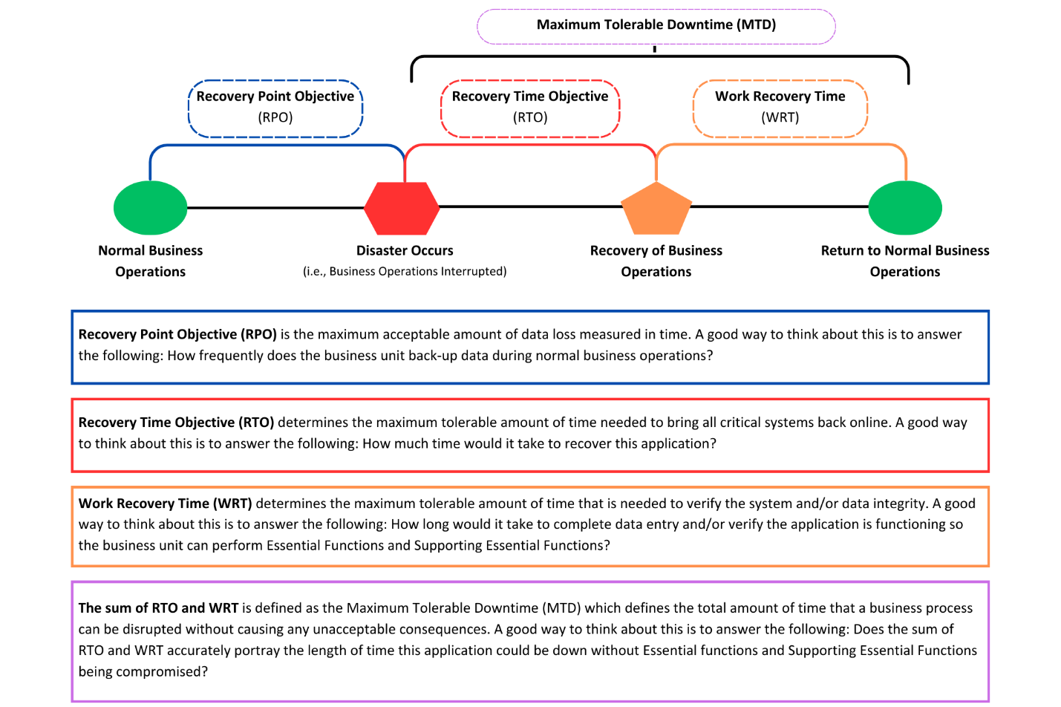
At the top of the diagram there is a dotted lavender box with the words Maximum Tolerable Downtime (MTD). MTD is defined as the greatest amount of a time an organization can handle without having access to a software program or other technology program. This is important when determining prioritization of recovering IT systems during a COOP event and is an important discussion to have ahead of an event to ensure reasonable expectations are managed ahead of time.
The next level of the diagram has a rectangle with a blue dotted outline and has the text Recovery Point Objective (RPO). RPO is the maximum acceptable amount of data loss measured in time. A good way to think about this is to answer the following: How frequently does the business unit back-up data during normal business operations?
The next rectangle has a red dotted outline and has the text Recovery Time Objective (RTO). RTO determines the maximum tolerable amount of time needed to bring all critical systems back online. A good way to think about this is to answer the following: How much time would it take to recover this application?
The final rectangle on this level of the diagram, and the second component to measuring MTD, has an orange dotted outline and has the text Work Recovery Time (WRT). WRT determines the maximum tolerable amount of time that is needed to verify the system and/or data integrity. A good way to think about this is to answer the following: How long would it take to complete data entry and/or verify the application is functioning so the business unit can perform Essential Functions and Supporting Essential Functions?
The sum of RTO and WRT is defined as the MTD which defines the total amount of time that a business process can be disrupted without causing any unacceptable consequences. A good way to think about this is to answer the following: Does the sum of RTO and WRT accurately portray the length of time this application could be down without Essential functions and Supporting Essential Functions being compromised?
The final level of the diagram starts with a green circle with the text normal business operations. The diagram then follows a line to the right to a red hexagon with the text disaster occurs i.e., a business operations interrupted. The blue dotted RPO rectangle spans between the green circle and the red hexagon, showing RPO is typically known prior to a disaster.
Next, the diagram has a black line that moves from the red hexagon to an orange pentagon with the text recovery of business operations. The red dotted RTO rectangle spans between the red hexagon and the orange pentagon, showing RTO occurs during the response period of a business interruption.
Finally, the diagram has a black line that moves from the orange pentagon back to a green circle with the text return to normal business operations. The orange dotted WRT rectangle spans between the orange pentagon and the green circle, showing WRT occurs during the recovery period of a business interruption.

Continuity and coordination of care: a practice brief to support implementation of the WHO Framework on integrated people-centered health services. Geneva: World Health Organization; 2018. License: CC BY-NC-SA 3.0 IGO.

