Public Notice Passage Language Translations
MHD has translated the following passage “This report contains important information about your drinking water. Have someone translate it for you or speak with someone who understands it.” To the following languages listed below. To complete appropriate public notice multi-lingual requirements, you may need to copy and paste the text or image below to include in your public noticing method.

Spanish
Información importante. Si no la entiende, haga que alguien se la traduzca ahora.

Amaric
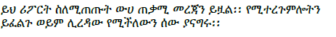

Arabic
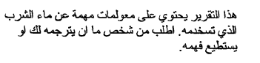

Cambodian (Khmer)
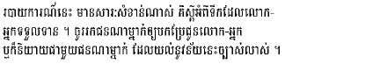

Chinese (Mandarin)
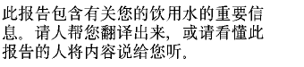

French
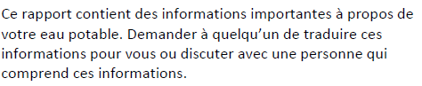

Hmong
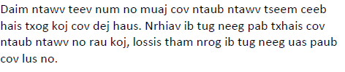

Karen
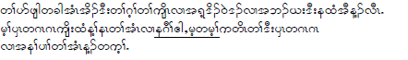

Laotian
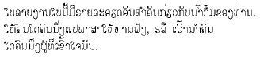

Oromo
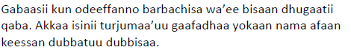

Russian
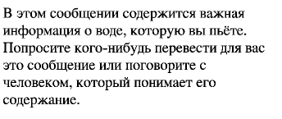

Somali
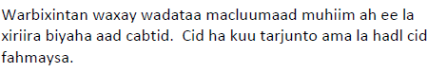

Vietnamese
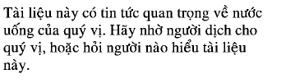
Minnesota Department of Health
Drinking Water Protection Program
651-201-4700
www.health.state.mn.us
June 2023
To obtain this information in a different format, call: 651-201-4700.

